# Summary

Due to malfunction in the gripping system of an expandable downhole offshore tool exposed to high pressures, an accident occurred during prototype testing in one of the test cells at IRIS in October 2009. As a consequence of this malfunction, a high-strength steel pipe with a total mass of 180 kg and an initial impact velocity of 65 m/s was launched out of the test cell. Based on this accident IRIS defined some load cases that are typical during HPHT testing. The worst-case scenario was identified to be a projectile of mass 300 kg and length 2.75 m being launched at an initial velocity of 193 m/s. To prevent similar accidents to take place in the future, the task has been to design a barrier capable of absorbing the impact energy in case of a new accident.

Motivated by the automotive industry, the basic idea has been to design a crash-box system capable of absorbing the kinetic energy from the impacting pipe and to distribute the load in a controlled way to the rear-side wall in a free floating concrete pit. Based on a combination of scaled impact tests, analytical considerations and non-linear finite element simulations, a possible design of a crash-box system has been proposed.

After several numerical optimization steps, a final validation was carried out using 500 mm long AA6060-T6 aluminium profiles with a wedge-shaped mechanical trigger, a reduced quasi-static pressure behind the projectile, and a 300 mm thick front plate consisting of different steel plates, to confirm that the energy during impact could be absorbed. It was found that the force-time curve from this simulation is almost ideal with a very low initial peak force, and always below the design load for the concrete wall in the pit. Based on this a numerically validated design was proposed. However, it should be kept in mind that the crash-box system is solely based on computer aided design, and that experimental validation of the numerical design is lacking.

# Disclaimer

While every reasonable precaution has been taken in the preparation of this document, neither the author nor any of the involved companies take any responsibility for errors or omissions, or for damages resulting from the use of the information contained herein. The information contained in this document is believed to be accurate. However, no guarantee is provided. Use therefore this information at your own risk.

Table of Contents

Summary 1

Disclaimer 2

1. Introduction 4

2. Introductory experimental and numerical validation 6

3. A short state-of-the-art on crash-box design 16

4. Analytical considerations 23

5. Piston-projectile problem 32

6. Simplified design of concrete wall behind the crash-box system 35

7. Alternative design of crash-box system 40

8. Numerical simulations 43

9. Discussion 72

10. Final validation 76

11. Final design 82

12. Concluding remarks 84

References 87

APPENDIX A 89

APPENDIX B 91

APPENDIX C 93

# Introduction

A serious accident occurred during prototype testing in one of the HPHT (high pressure high temperature) test cells at IRIS (International Research Institute of Stavanger) in October 2009. The course of events is described in more detail in [1]-[3], and only the main incident is briefly described below for completeness.

Due to malfunction in the gripping system of an expandable downhole offshore tool exposed to very high pressures, a projectile was launched towards the concrete wall of the test cell (see ). The projectile, having a total mass of 180 kg and an initial impact velocity of 65 m/s, perforated the 20 cm thick concrete wall and was found on the parking lot outside the building. The test pipe, having a mass of 134 kg and an initial impact velocity of 63 m/s, accelerated in the opposite direction and impacted a 20 mm thick steel plate used to protect the concrete wall of the control room. The test pipe did not perforate the steel plate, but the shock waves caused severe concrete spalling inside the control room.



Figure 1: Accident - course of events .



Figure 2: Test rig in concrete pit.

Even though no one was injured in this event, the need for proper and permanent protection during HPHT tests was rather clear. Thus, it was decided to build a new test facility for this type of tests. In this new facility, a concrete pit with proper barriers will be inserted in the floor. The HPHT tests are supposed to be carried out inside this pit in the future. A schematic drawing of the new concrete pit is shown in . Note that one basic idea is that the concrete pit should be free floating so that the surrounding structure should not be affected by a possible accidental impact against the barriers mounted along the short walls.

Based on the accident described above, IRIS defined some load cases that are typical during HPHT testing. In this work, the main focus will be on the worst-case load scenario, i.e. Case-1 in . In this case a projectile with mass 300 kg and length 2.75 m is launched towards the barrier at an impact velocity of 193 m/s. This gives a kinetic energy of almost 5600 kJ, which in most impact scenarios is regarded as a very large load. The objective is then to design a barrier capable of absorbing this amount of energy, simultaneously as the short walls in the pit are able to carry the dynamic loading. When the design of the system for the worst-case scenario is finished, the system will also be validated against the other cases to see if the system works as expected also for smaller loads. This work will be described in the following.

Table 1: Three typical load cases during HPHT testing as defined by IRIS [1].



# Introductory experimental and numerical validation

The first to be determined is whether the appearing loading scenarios should be considered as a penetration/perforation problem or as an impact problem. In the former the projectile (of Incoloy 925 or similar) may perforate the barrier with a residual velocity, while in the latter the projectile will be stopped without significant penetration. The perforation problem is a localised material problem, where the strength and ductility of the material in the barrier are crucial. The impact problem is more of a structural problem, where the kinetic energy of the striker is delivered to the barrier and the surrounding structures. In the latter, the main task is to distribute and absorb the kinetic energy from the striker in a controlled way.

The easiest way to classify the problem is to do some controlled component tests. However, due to the combination of high velocity and mass of the projectile (see ) it is very difficult (and expensive) to do full-scale tests. To the authors’ best knowledge, no laboratories worldwide are today able to carry out such tests, and purpose-made experimental set-ups must therefore be applied. This will both be time and very cost demanding. An alternative approach is to use small-scale replica tests. Based on dimensional analyses, model laws which are used to predict the prototype response for the penetration problem have been established (see ), and the scale factors are given in . As seen, not all variables scale with the scale factor  (such as the fracture toughness, the strain rate and the acceleration), and this may give problems in the geometrical scaling. Also, special care should be taken if the scale factor becomes small (less than 1:4) and if fracture, cracking or other instabilities are likely to arise in the experiments. It will later be shown that in this particular problem scaled experiments of the full system is difficult because too much scaling is required.



Figure 3: Scale factors for a typical penetration problem [1].

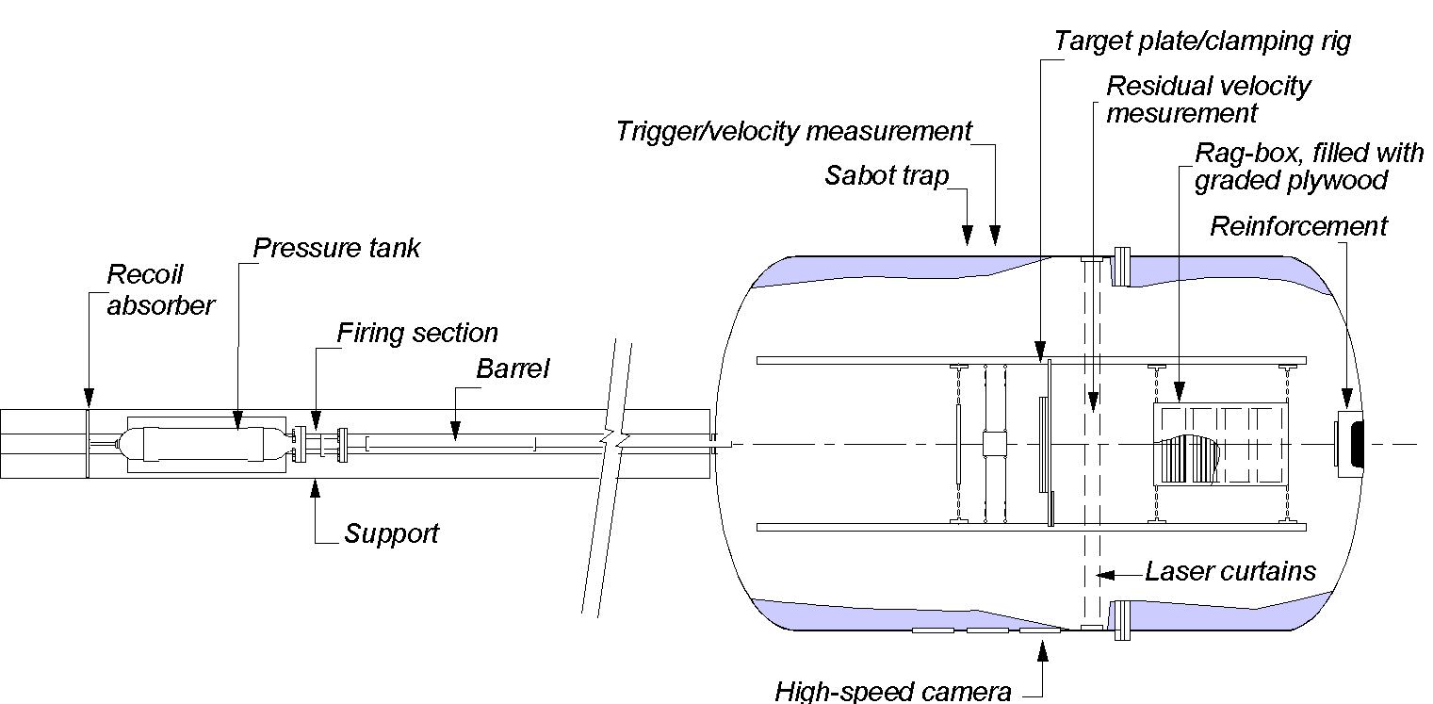

Figure 4: Sketch of compressed gas gun used in the impact tests.

Even so, to understand the underlying physical mechanisms in the studied problem, some scaled impact tests were carried out in a compressed gas gun at SIMLab/NTNU (see ). In these introductory tests the diameter of the steel projectile in Case-1 () was scaled 1:10, while the length was scaled 1:30. Thus, this is not a scaled geometrical replica of the real projectile. The mass of the scaled pipe was about 0.1 kg, which in full-scale gives a mass of 100 kg. As seen, both the mass and the initial kinetic energy  of such a striker is only 1/3 of the Case-1 projectile. A picture of the scaled pipe is shown in . Note that in a real projectile the nose shape may vary, as will be discussed in Chapter 8.

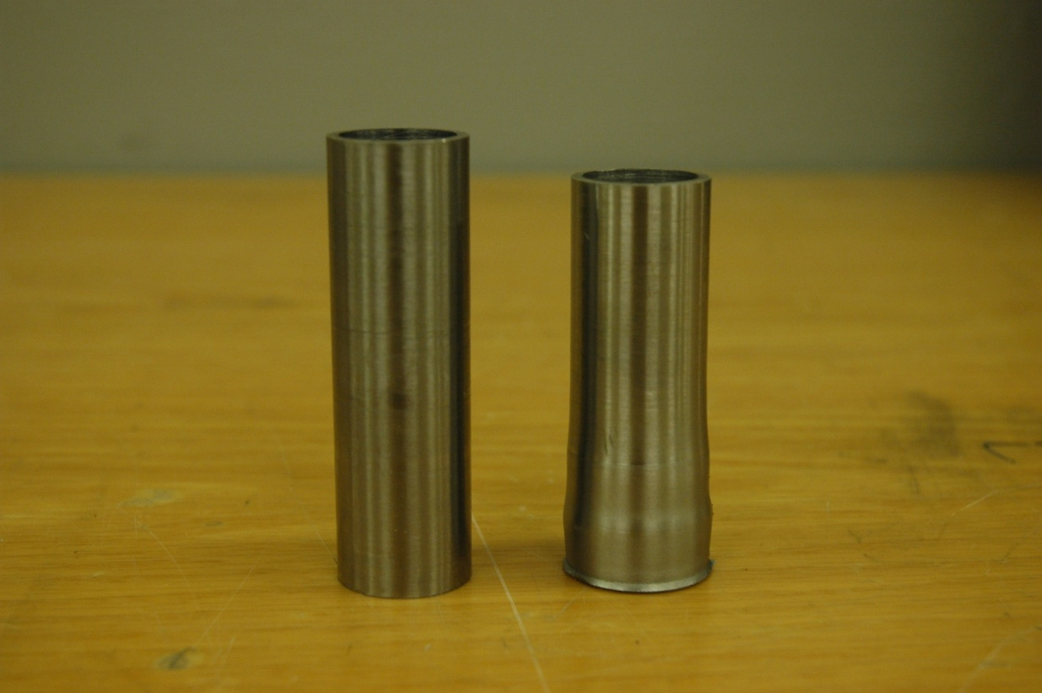 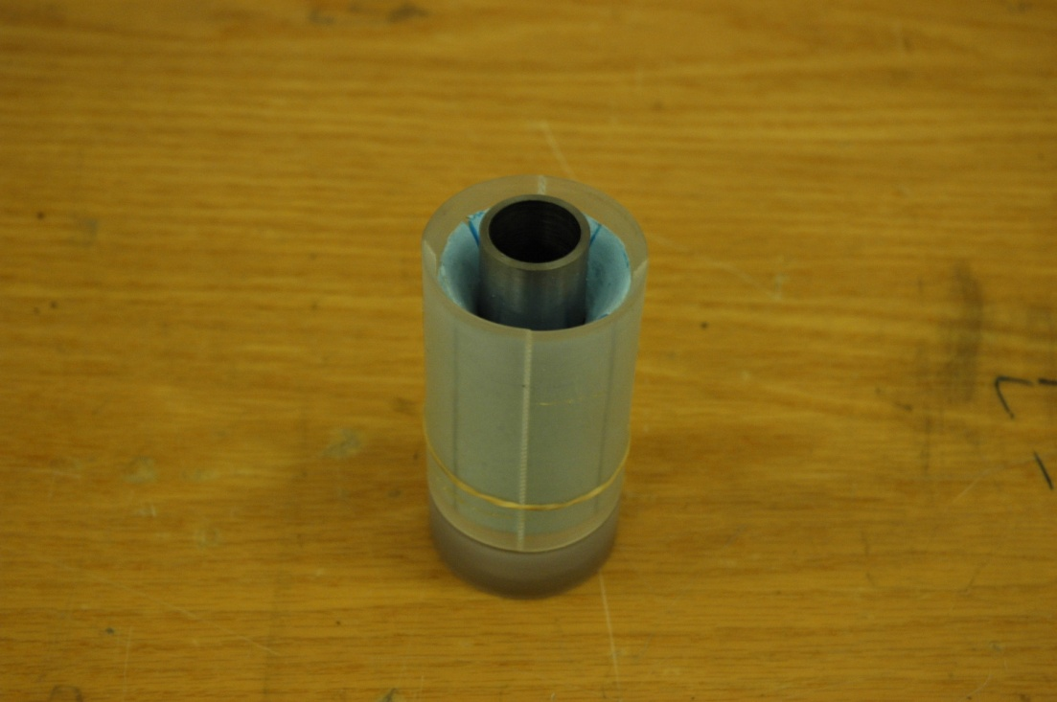

Figure 5: Scaled steel pipe projectile inserted in the sabot.

The projectiles were machined from a steel tube with a yield stress of about 800 MPa. Since no detailed material test data were available for the projectile in these tests, they were only assumed to be similar to Incoloy 925 (MPa), which is a typical projectile material used in HPHT tests at IRIS. The projectile was mounted in a nine-pieced serrated sabot () and launched at an impact velocity  of about 200 m/s, i.e. the impact velocity of Case-1 in , since the impact velocity is not supposed to be scaled according to . The free-flying sabot pieces were stopped by a sabot trap prior to impact (see ).

Two tests with two different target plates were carried out. In the first test a 15 mm thick NVE 36 plate with dimensions 300 x 300 mm was used as target. NVE 36 is a rather soft structural steel with a yield stress of about 350 MPa, which is much less than the yield stress of the projectile. Scaled 1:10 this represents a barrier with a plate thickness of 150 mm. In the second test a 4 mm thick Hardox 450 plates with dimensions 300 x 300 mm was used as target. In contrast to NVE 36, Hardox 450 is a tough wear steel with a yield stress of 1350 MPa, i.e. higher than that of the projectile. Scaled 1:10 this represents a barrier with a plate thickness of only 40 mm.The target plates were clamped between two rigid beams as shown in in these tests. The impact event was captured by a Photron Ultima APX-RS high-speed digital video camera operating at a constant framing rate of 50.000 fps. In addition, the initial velocity was measured using different laser-based optical devices, as well as by the high-speed camera system. More details regarding the experimental set-up and the instrumentation used during testing can be found in [4].

Pictures of the projectiles and targets after the tests are shown in , while and give some high-speed video images of the impact process. The first to notice is that the projectiles are not even close to perforate the targets in any of the tests. In the first test, where a thick and soft NVE 36 steel plate was used as target, hardly any global deformation could be seen. Thus, most of the kinetic energy was absorbed by plastic deformation and local buckling in the projectile (like in the classical Taylor test, where a projectile is fired into a rigid wall and all the energy is absorbed in the projectile). Due to large radial and circumferential stresses in the projectile, it cracked somewhat, and a ring of material was teared off (). The only visible damage in the target plate was a mark (ring) indicating the point of impact. In the second test, the behaviour was slightly different. Here, the thin and tough Hardox 450 steel plate experienced some global deformation due to the reduced

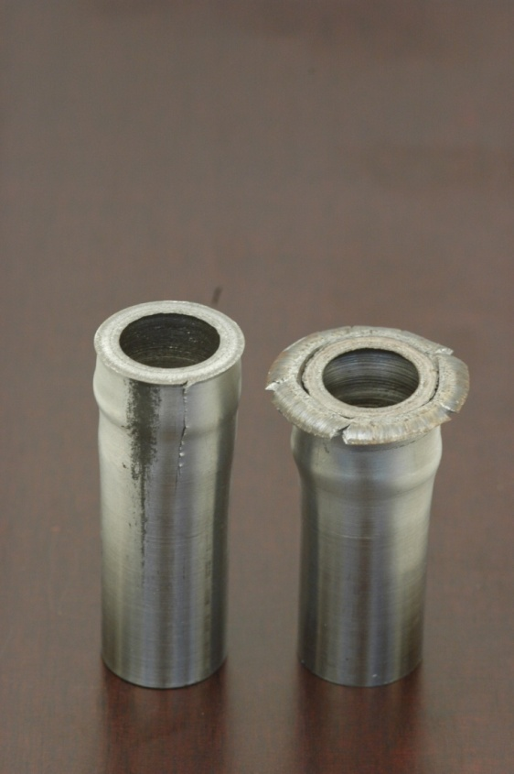 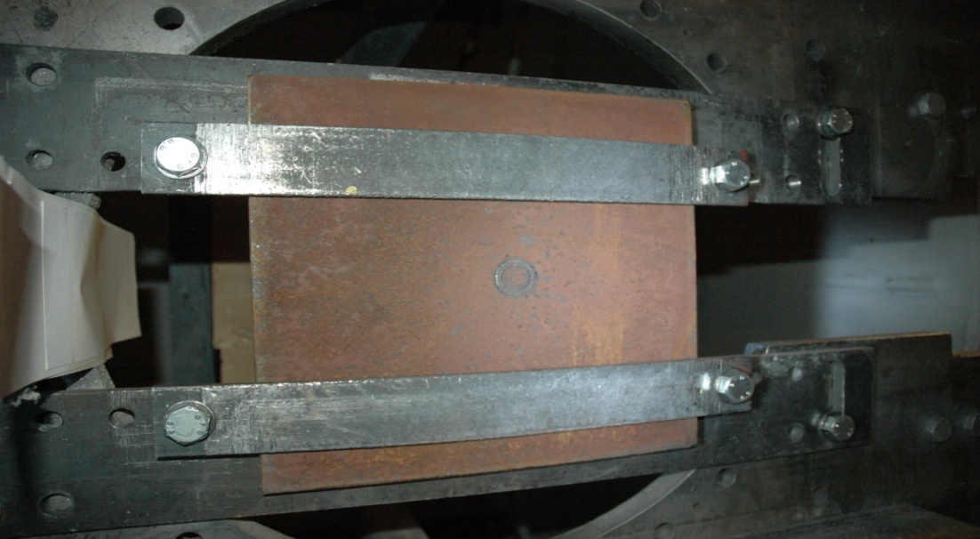

15 mm NVE 36

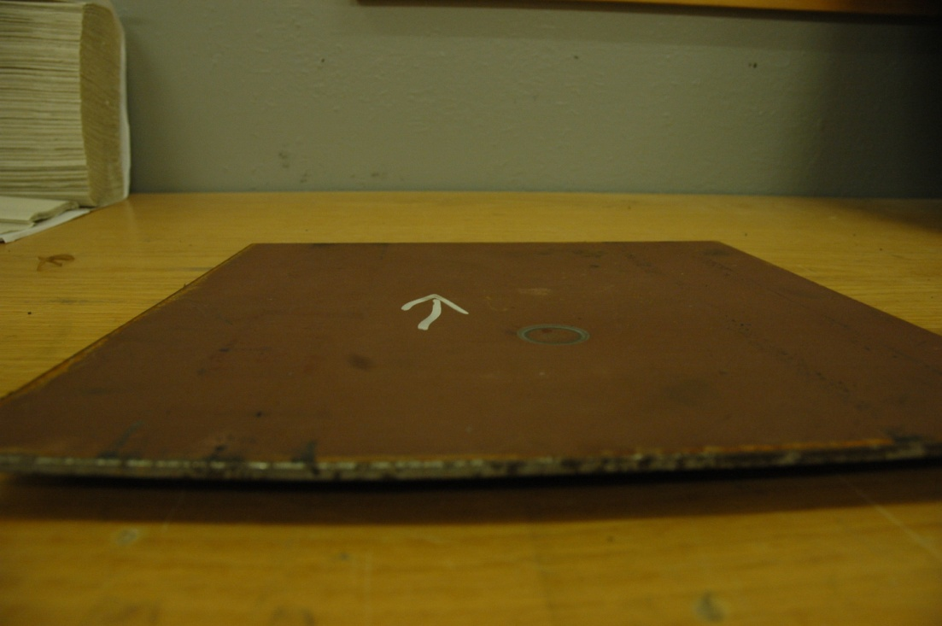

4 mm Hardox 450

Figure 6: Pictures of the projectiles and targets after the tests.

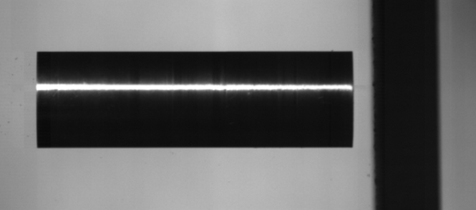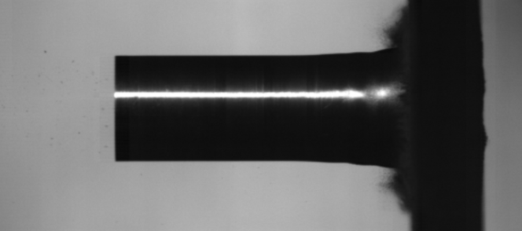

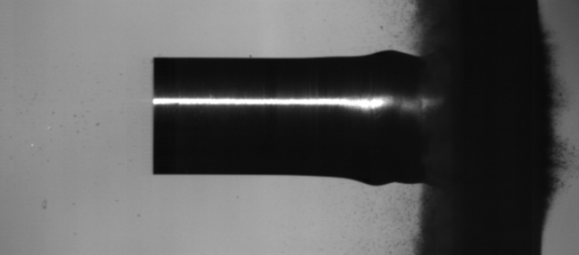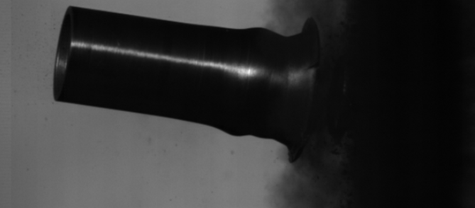

Figure 7: High-speed camera images showing the impact of a scaled pipe with  and  against a 15 mm thick NVE 36 plate.

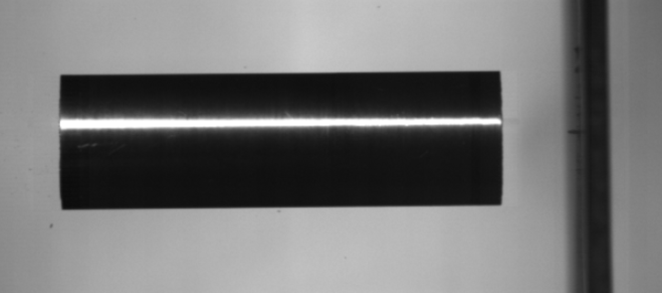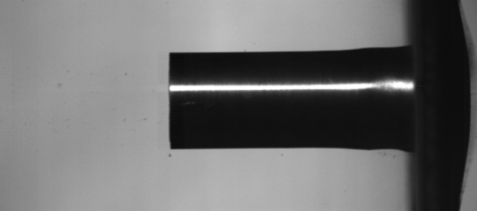

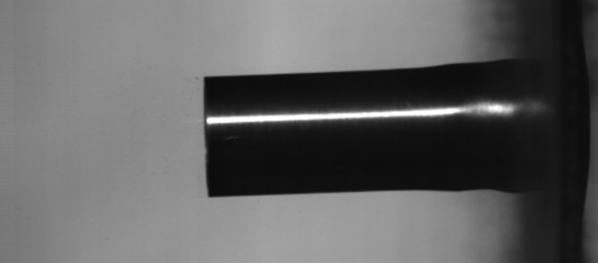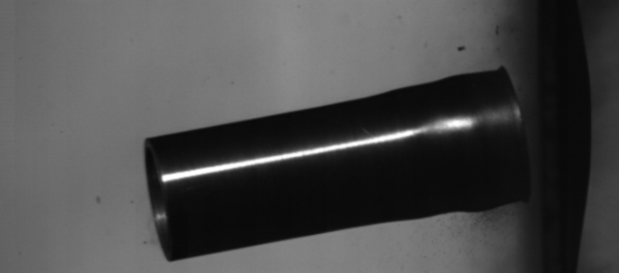

Figure 8: High-speed camera images showing the impact of a scaled pipe with  and  against a 4 mm thick Hardox 450 steel plate.

stiffness and a lot of kinetic energy was absorbed in this deformation mode. As a result, less plastic deformation was observed in the projectile, but still some initial cracking along the longitudinal axis was observed. However, as for the NVE 360 plate, the barrier made of a thin Hardox 450 steel plate is far from perforation. The only damage except for the modest global deformation is a similar mark in the target as in the former test.

From these introductory tests two very important conclusions can be drawn:

1) This is not a perforation problem. A projectile like the one given for Case-1 in will not be able to perforate a thick and strong barrier. Thus, the problem may be classified as an impact problem where the main task is to absorb the kinetic energy from the striker in a controlled way to avoid damages on the surrounding structures.

2) If a thick and strong barrier is chosen, most of the kinetic energy will be absorbed by plastic deformation and local buckling in the projectile. Thus, the barrier should be stronger than the projectile, and as thick as practically possible. The rest of the kinetic energy must be absorbed by some energy absorbers simultaneously as the surrounding structure is able to carry the force from the impact. This can be done by designing a crash-box system, similar to those used by the automotive industry to avoid damages to the car body during a collision.

As already indicated, it will be almost impossible to relate the design of such a crash-box system on full-scale tests. Thus, we have to base our design on advanced non-linear finite element (FE) simulations. To validate that the numerical models are able to predict the underlying physical mechanisms in the impact problem, some introductory simulations were carried out and compared to the scaled impact tests.

All simulations were carried out using the explicit solver of the non-linear finite element code LS-DYNA [7], and only barriers made of Hardox 450 steel were considered. The numerical model was similar to the scaled impact test, but with two exceptions. Firstly, the numerical model was not geometrically scaled. Thus, the projectile had the geometry, mass and kinetic energy of the projectile in Case-1 in . Secondly, the plate was fully clamped along all four sides in contrast to the test where two beams were used to keep the target in position (see ). The 3D FE models were meshed with 8-node constant-stress solid elements with one-point integration and stiffness-based hourglass control, while contact was modelled using a surface-to-surface algorithm available for SMP/MPP simulations in LS-DYNA. The element size in the target was equal to 8×8×8 mm3, giving 5 elements through the thickness of the plate, while an element size of approximately 5×5×5 mm3 was used in the projectile, giving 4 elements over the thickness of the tube. Thus, the model consisted of about 350 000 elements. A plot of the numerical model is shown in Figure 9. The CPU-time for a simulation was typically 10 hours using four 3 GHz Intel Pentium 4 processors.

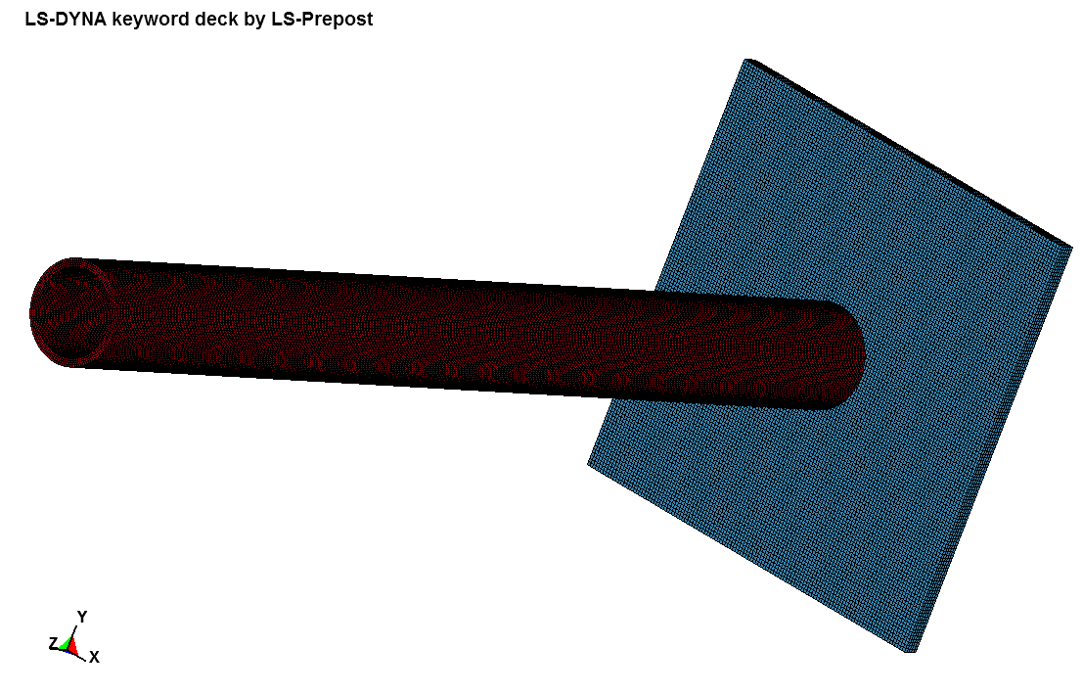

Figure : Plot of the 3D numerical model used in the introductory simulations.

Table 2: Material card used in the simulations for the Hardox 450 target material.



Table 3: Material card used in the simulations for the Incoloy 925 projectile material.



A modified version of the Johnson-Cook (MJC) constitutive relation, implemented as the thermo-elastic, thermo-viscoplastic material model 107 in LS-DYNA, was used to model all materials [6]. Here, the constitutive behaviour of the materials is assumed to be isotropic and modelled with the von Mises yield criterion. The equivalent stress is expressed as



where  is the equivalent plastic strain and *A*, *B*, *n*, *C* and *m* are material constants. The dimensionless plastic strain rate is given by , where  is a user-defined reference strain rate. The homologous temperature is defined as , where  is the absolute temperature,  is the ambient temperature and  is the melting temperature. The temperature change due to adiabatic heating is calculated as



where  is the material density,  is the specific heat and  is the Taylor-Quinney coefficient that represents the proportion of plastic work converted into heat. Possible failure is modelled using the Cockcroft and Latham (CL) criterion



where  is the major principal stress,  when  and  when . From Eq. it is seen that failure cannot occur when there is no tensile stress operating. The critical value of , denoted , can be determined from one simple uniaxial tensile test. It has been shown ([8][9][10]) that the one-parameter CL criterion gives equally good results as other failure criteria in LS-DYNA simulations of perforation of steel or aluminium plates under various stress states using different projectile nose shapes. In this study, failure is described by element erosion if  reaches its critical value  at a specific integration point. More details regarding the constitutive relation, the fracture criterion and the identification of material constants can be found in the original references. Material data for the Hardox 450 steel target were taken from [11] and are given in , while some material data for the Incoloy 925 steel projectile were taken from [12] and are given in . It should be noted that the material data for Incoloy 925 are highly unsure since very limited data are available.

A number of numerical simulations were carried out using the models described above. In the simulations, both the target thickness and the impact angle were varied to study the response of the barrier during impact. The impact angle  was varied between  and  to study the behaviour if the projectile of some reason impacts the plate with an oblique angle, and if special care should be taken to avoid this from happening.

Figure 10 shows some plots from a simulation of the Case-1 projectile during impact with a 40 mm thick Hardox 450 steel plate at normal impact . From this simulation it is quite clear that the projectile is not able to perforate the relatively thin barrier, and that most of the kinetic energy is absorbed as plastic deformation in the projectile and global deformation of the target. It is also seen that the main deformation mechanisms are similar to those observed experimentally (see ). However, since the kinetic energy is three times higher in the numerical simulation than in the corresponding experimental test due to the increased length (and mass) of the striker, the deformations become larger. Even so, no sign of perforation is observed in the target. A similar behaviour is observed in Figure 11, where the same projectile impacts the same plate, but now at an oblique angle . The effective plastic strain in the projectile is for both impact scenarios above 1.5, and cracking is likely. This was not captured in the simulations due to too limited material data, especially related to the fracture properties. As seen both from Figure 10 and Figure 11, the projectile has a residual velocity after impact (it rebounds in Figure 10 and it slides off and starts to rotate in Figure 11). However, the simulations show that about 90% of the initial kinetic energy is absorbed during the impact phase, and even though special care should be taken to protect against this residual translational and rotational energy, it should be rather easy to take this into account.

 

 

Figure : Plots from a FE simulation showing the Case-1 projectile during impact with a 40 mm thick Hardox 450 plate and . Plotted as fringes of effective plastic strain.



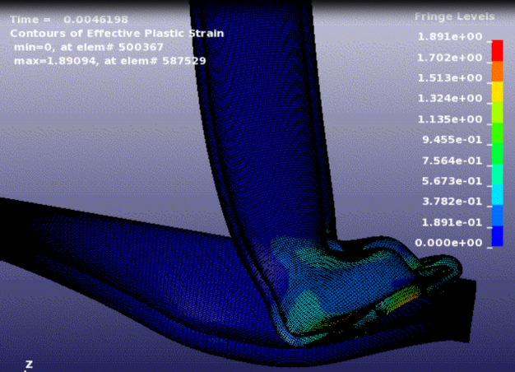

Figure : Plots from a FE simulation showing the Case-1 projectile during impact with a 40 mm thick Hardox 450 plate and . Plotted as fringes of effective plastic strain.

In any case, the main conclusion from these simulations is that the numerical models are able to predict (at least qualitatively) the main physical mechanisms observed experimentally during impact, and that we can base our design of the real system on suchlike simulations. However, in the real situation it will be impossible to fix the target plate as in the numerical simulation. Therefore and as already indicated, the kinetic energy during impact must be absorbed by plastic deformation in the striker and by a crash-box system that is able to absorb and distribute the kinetic energy in a controlled way.

# A short state-of-the-art on crash-box design

A great deal of research on tubes subjected to various load conditions have been carried out over the years. These studies origins in the automotive industry where the quest for safety of the passengers and structural integrity of the bearing structure in vehicles play an important role (see [13]-[16]). The ability to protect the passengers during possible collisions is of high focus. Hence, it is essential that the kinetic energy in a crash situation is dissipated in the structure so that the accelerations and forces imposed on the occupants are minimised. In order to absorb energy, several energy absorbers and energy-absorbing systems exist and are operational in cars today. In addition to national safety standards, different programmes exist that evaluate the crashworthiness of new cars. These programmes make it easier for the safety focused customer to choose a crashworthy car. For a vehicle to perform well in the New Car Assessment Programme (NCAP) test or in a real life impact, it is important that the energy absorption capabilities are predictable. Thus, these capabilities have to be evaluated in order to ensure the integrity of the passenger’s compartment.

Weight has been a motivation for the use of tubular members in the automotive industry, together with the fact that tubes have good energy-absorbing characteristics and the price is low. The tubes may be in different materials, and the cross-sections may vary. Extensive research (see [14]-[27]) has been carried out to study and understand how tubular members react and what the mechanisms for energy absorption are. It can be concluded from existing studies that the response of thin-walled extrusions to axial impact depends on several factors, such as [17]:

* Geometry: length, width and thickness of the member
* Material properties: elasticity modulus, yield stress and strain hardening
* Boundary conditions: clamped, pinned or free
* Impact velocity: strain rate and inertia effects
* Imperfections: amplitude and shape

When a tube is loaded axially, extensive buckling of the sidewalls may create several wrinkles or lobes successively. This collapse mode is often called progressive buckling (see a), and the forces oscillate around a mean force level where each peak corresponds to the creation of a new lobe. The progressive buckling of tubes is an efficient energy-absorbing mechanism, which makes tubes good energy absorbers. This is the preferable deformation mode as the energy absorption is at a maximum and the dynamic load shortening characteristics of the members can easily be predicted. However, when increasing the length of the members or changing the thickness, a change in response to either global buckling (b) or a mixed mode (c) may occur. This may lead to far less efficient energy absorption and transmission of large forces to other parts of the structure.

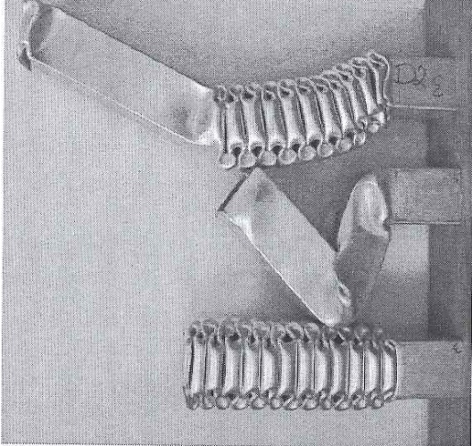

c)

b)

a)

Figure : Collapse modes for axially loaded thin-walled components; a) progressive, b) global and c) mixed mode [16].

The absorbed energy can easily be calculated from the force-displacement curve when the force and displacement have the same direction. Consequently, the energy absorption connected to structural collapse is influenced by material properties, structural geometry and collapse mode as mentioned earlier. A terminology has been developed to describe and compare the energy absorption performance of collapsing and crushing parts [14] and is illustrated in Figure 13.



Figure : Terminology applied for impact-loaded structures [14].

An absorber with a rectangular-shaped force-displacement curve (rigid-plastic) has crush force efficiency, AE, of 100 %. Lower values indicate an oscillating force-displacement curve. Ignoring global buckling, a short thin-walled member (circular or square) subjected to a static axial load may have force-displacement characteristics similar to that shown in . shows photos which correspond to the load-displacement curve.



Figure : Typical force-displacement curve. Points (a), (b), (c) and (d) correspond to the sequence of photos in [14].



Figure : Sequence of photos during axial deformation [14].

It is evident that the tube exhibits an unstable behaviour after reaching the first peak load. This load is defined as the capacity of the cross-section and is important parameter when designing thin-walled columns subjected to axial loading. As further axial deformation is applied, the load-carrying mechanism is changed from membrane compression to bending (folding). A repeated pattern of peaks is then observed in the load-displacement curve where each peak is associated with the development of a new fold. This phenomenon is known as progressive buckling. When a tube is used as an energy absorber the fluctuations in the load are often ignored and the mean load  is often used as a design parameter. This means that an ideal energy absorber is defined with AE = 100%. Thus, a constant resistance is assumed, and the absorber offers a constant deceleration throughout the entire stroke. An actual absorber will in most cases have AE << 100% due to high initial peak load and the subsequent oscillating force.

When subjected to an axial force, a thin-walled circular tube of mean radius R and thickness t may develop either axisymmetric buckles or a non-axisymmetric (diamond) pattern as shown in . The mode of deformation is sensitive to the support condition and hardening material as well as the R/t-ratio. For thin-walled square tubes two basic collapse elements may develop: Type I and Type II as shown in . These types of modes predict four different collapse modes. Two of the collapse modes are shown in , i.e. a symmetric mode and an extensional mode. The symmetric collapse mode is idealized by four Type I elements, while the extensional mode can be described by four Type II elements. The asymmetric mixed modes have a combination of the two types of basic collapse elements. The mean crushing force is found by equating the external work of the axial crushing force to the internal energy required to form a complete lobe. A lot of research has been performed on the collapse mode, both experimentally as well as analytically, and can be found in the literature (i.e. [14] and [21]).



Figure : Deformation modes of circular tubes: (a) axisymmetric /concertina and (b) non-axisymmetric / diamond [14].



Figure : Basic collapse elements [14].



Figure : Deformation modes [14].

In research, focus has often been placed on the structural geometry. However, as weight savings have become increasingly important in the automotive industry, the significance of the structural material has been realized. Aluminium and high-strength steel are examples of materials that can lower the weight considerably compared to structural steel. In Table A1 (in Appendix A) the mean force () and the total deformation () are given for different materials, geometries of the tube and impact velocities from studies on various crash-boxes found in the literature. The notations su, v, L, b, t are the ultimate strength, velocity, length, width, and thickness of the tube, respectively. Some of the results are pure experimental, while others have been compared with numerical simulations.

Table A1 illustrates that the parameters such as material properties, structural geometry and collapse mode highly influence the energy absorption capability. Further, it is shown that for DP800 steel and the AA6060-T6 aluminium the FEM tool LS-DYNA is capable to describe the experimental trend. This is illustrated in Figure 19 - Figure 21, where also the physical mechanism of the tubes is shown.

 

Figure : Comparison between experiments and LS-DYNA of final deformations modes of square DP800 steel tubes for both quasi-static (left) and dynamic analyses (right) [27].



Figure : Validation of the mean force-deformation curves for DP800 steel using LS-DYNA [27].





Figure : Comparison between experiments and LS-DYNA simulations of deformations modes of square AA6060-T6 aluminium tubes for both quasi-static (top) and dynamic (bottom) studies [16][17].

# Analytical considerations

 

Figure 22: Crash-box concept (left) and material behaviour of the plastic springs (right).

The task is to design a crash-box system able to absorb the kinetic energy from an impacting pipe and to distribute the load in a controlled way to the concrete wall in the pit. The proposed concept is sketched in (left). In the design impact case (referred to as Case-1), the projectile is defined as a steel pipe with a yield stress  of about 800 MPa, a mass  of 300 kg, an impact velocity  of 193 m/s, a length  of 2.75 m, an external diameter of 0.2445 m and an internal diameter of 0.2064 m. The proposed crash-box system consists of two rigid Hardox 450 (or similar) steel plates with a yield stress  of about 1200 MPa, thickness  m and side-lengths  m. Thus, the mass of each rigid plate in the crash-box is  kg. The plates are connected by a number of crash-boxes (or “plastic springs”) for energy absorption and energy transfer to the concrete pit. An idealized force-displacement behaviour of each crash-box is illustrated in (right), where  is the average crush force in the crash-box and  is the maximum deformation of the crash-box before it is fully compressed (often called bottom out).

The main assignment of the crash-box system is to control the kinetic energy of the projectile during impact while keeping the force level sufficiently low to avoid damage on the concrete wall of the pit. The absorption of the kinetic energy is controlled by plastic work in the crash-boxes, and is directly given from the area under the force-displacement curve in (right). If the crash-box design is good, the behaviour will be close to that of a perfectly plastic absorber showing a constant average force for the whole deformation process. In this case, the internal work is simply  which has to absorb the initial kinetic energy



The following assumptions are made in the subsequent analytical considerations: 1) The steel plates in the crash-box system are rigid during impact; 2) The impact is plastic with no restitution coefficient, i.e. ; 3) The “plastic springs” between the steel plates behave as an perfectly plastic material, i.e. elastic behaviour, strain hardening, strain-rate hardening, and possible cracking and fracture are neglected; 4) The concrete wall in the pit is able to carry the transferred load.

The restitution coefficient is defined as



where  is the restitution coefficient,  is the kinetic energy before impact,  is the kinetic energy after impact and  is the kinetic energy when the projectile and the target (in our case the impacting steel pipe and the first steel plate in the crash-box) have the same velocity . From Eq. we see that



Thus, the initial kinetic energy  is always larger or equal to the residual kinetic energy . For a fully elastic impact . This indicates that  so no energy is lost in the impact (i.e. the kinetic energy is conserved). For a fully plastic impact . According to Eq.  and consequently . This means that the materials get stuck together and move as one object with identical residual velocity  after impact. In most real situations , so  must be considered as an idealisation.

Based on the configuration shown in (left), conservation of momentum gives



Since  we have that , and Eq. becomes



The kinetic energy of the system when the projectile and plate have the same velocity  is



Inserting Eq. into Eq. gives



Note that  is the kinetic energy that must be absorbed by the “plastic springs” sandwiched between the two steel plates in the crash-box system. Two important results can be extracted from Eq. . Firstly, it is readily seen that the residual kinetic energy  is reduced with the ratio  compared to the initial kinetic energy . Thus,  for a fully plastic impact. This energy loss is absorbed as plastic work in the bodies and converted into heat. Secondly,  is linearly reduced as the mass  of the first steel plate in the crash-box is increased. Thus, it is possible to lower the kinetic energy that must be absorbed by the crash-box plastic springs by increasing the mass of the first steel plate.

Each plastic spring in the crash-box system is assumed to behave as a perfectly-plastic material as shown in (right). This may be achieved by using a steel or aluminium crash-box with a trigger to initiate the local deformation modes. For a square tube the average crush force  may be found from theoretical considerations as



where  is the yield stress of the material in MPa,  is the wall-thickness of the crash-box in mm,  is the width of the crash-box in mm and  is a dimensionless constant with a theoretical value of 13.06. If we now assume that  MPa,  mm and  mm, the average crush force becomes



If the mass of the first steel plate in the crash-box is 785 kg, we have from Eq.



This energy is as seen considerable lower than the initial kinetic energy from the pipe given in Eq. . If we further assume that each crash-box has a length  mm and is deformed  mm before  is reached, the energy absorption in each crash-box is



In order to absorb the kinetic energy from the impacting pipe



crash-boxes are required. Thus, a matrix with  high-strength crash-boxes behind the rigid steel plate is assumed sufficient to absorb and distribute the load. However, this needs to be validated through finite element simulations or experimental tests.

The “quasi-static” loading from the crash-box concept to the concrete wall of the pit during impact may now be found as



This load is distributed over an area of 1 m2 by the second plate of the crash-box, giving a compressive stress to the concrete wall of



However, the loading is not “quasi-static”. It is applied as a time-dependent dynamic load with a relatively long impulse. A long impulse implies that the maximum structural response takes place when the load is still acting, and that the dynamic magnification factor is normally



where  is the dynamic maximum response and  is the corresponding static response. To determine whether the impulse is long or short, we have to resolve the systems period



where  is the natural frequency. In order to do calculations, the following assumptions are made. First, the thickness of the concrete wall  of the pit is taken as 300 mm. It is further assumed to behave as a freely supported square plate with a width  equal to the height  of 1 m. The concrete has Young’s modulus of , Poisson’s ratio of  and density of . The stiffness of the concrete plate is found as



Note that this is a simplification, since the loading is only acting on a part of the larger plate. The natural frequency of the plate (taking the assumptions stated above into account) can be shown to be



where  indicates the wave number,  is the angular frequency and  is the mass per unit area (kg/m2). The period is now calculated from Eq. as



Figure 23: Single degree-of-freedom (SDOF) system of the crash-box.



In order to determine the duration of the loading, the dynamic equilibrium equation for the system must be solved. The crash-box system shown in (left) is simplified into the single degree-of-freedom (SDOF) system shown in , where it is assumed that the concrete wall is rigid during deformation (which is a reasonable assumption taking the large plate stiffness into account). The dynamic equilibrium equation can now be written as



where . By supposing constant acceleration (i.e. that the deformation velocity is a linear function of time), this differential equation can be solved applying the following boundary conditions



Then, by integration of Eq. , we find that



and





Figure 24: Displacement (left) and velocity (right) versus time of the dynamic system.

Inserting the known quantities, i.e.



in Eqs. and , the displacement versus time and the velocity versus time of the dynamic system may be plotted. This is shown in . As seen, the impact is in principle over at . Here, the displacement reaches its maximum and the velocity reaches zero. Thus, it seems safe to state that the impulse is long since



A long impulse implies that the dynamic magnification factor depends principally of the rate of increase of the load to its maximum value, and that a steep loading of sufficient duration produces a magnification factor of 2. This can be used in simplified calculations.

 

Figure 25: Force-time (left) and force-displacement (right) of the dynamic system.

However, in our case we can now plot the force-time and the force-displacement curves directly (see ). The impulse to the concrete wall, defined as the force integrated over the time, becomes



and the energy absorption is found as



which is equal to the kinetic energy of the crash-box after the initial impact (see Eq. ).

The calculation shown above is just an example for a typical crash-box system. Using these crash-boxes, the average crush force is 115 kN (Eq. ) and the total force on the concrete wall becomes as much as 7360 kN (Eq. ). It will be hard for the concrete wall to carry this loading during the crash. Therefore, the next step in the design is to tune the crash-box system so that the impact energy can be absorbed simultaneously as the force during the crash is distributed to the concrete wall in a controlled way. shows calculated  and  for a number of other crash-box systems based on the equations shown above and the Case-1 projectile from . In these calculations the front plate mass was first varied. Further, the strength of the crash-box material, the thickness of the crash-box, and finally the length of the crash-box were varied. For each parameter (and step), the best alternative, i.e. the alternative that gave the lowest , was taken in the next step. These calculations show that to get the lowest  the system requires the highest front plate mass and strength, but not necessarily the longest crash-box. Further, the system denoted Steel requires the highest thickness for the crash-boxes, while the system denoted Aluminium requires the lowest thickness for the crash-boxes. For instance, to reach  for system Steel it is required to use a front plate mass of 2355 kg, 25 crash-boxes with a strength of 600 MPa, with dimensions t = 2.0 mm, b = h = 100 mm and lc = 300 mm. To reach  for system Aluminium it is required to use a front plate mass of 2355 kg, 81 crash-boxes with a strength of 300 MPa, with dimensions t = 1.5 mm, b = h = 100 mm and lc = 300 mm. Some systems require more than 100 crash-boxes in order to absorb the energy, while others require about 36. *Ftot,64* gives the total force on the concrete wall for 64 crash-boxes. Hence, for systems that require more than 64 crash-boxes, the energy is not fully absorbed in the proposed system. These calculations give an illustration of how each parameter affects the energy absorption. The analytical model has its limitations as mentioned earlier. Here, the material is for instance perfectly plastic, and the hardening of the material is not considered.

Table 4: Some alternative crash-box systems.

|  |  |  |  |  |  |  |  |  |  |  |  |  |
| --- | --- | --- | --- | --- | --- | --- | --- | --- | --- | --- | --- | --- |
| System  # | Front plate | | | | Crash-box | | | | | | System | |
| (kg) | (m) | (kg) | (m/s) | (MPa) | (mm) | (mm) | (mm) | (mm) | (kN) | *Nmin*  (#) | *Fto*t, min (*Ftot,64*)  (kN) |
| Steel - 1 | 785 | 0.1 | 1085 | 53.4 | 600 | 2.0 | 100 | 300 | 219 | 115 | 64 | 7360 (7390) |
| Steel - 2 | 1570 | 0.2 | 1870 | 31.0 | 600 | 2.0 | 100 | 300 | 219 | 115 | 36 | 4140 (7390) |
| Steel - 3 | 2355 | 0.3 | 2655 | 21.8 | 600 | 2.0 | 100 | 300 | 219 | 115 | 25 | 2875 (7390) |
| Steel - 4 | 2355 | 0.3 | 2655 | 21.8 | 500 | 2.0 | 100 | 300 | 219 | 96 | 36 | 3456 (6144) |
| Steel - 5 | 2355 | 0.3 | 2655 | 21.8 | 400 | 2.0 | 100 | 300 | 219 | 77 | 49 | 3773 (4928) |
| Steel - 6 | 2355 | 0.3 | 2655 | 21.8 | 600 | 1.8 | 100 | 300 | 219 | 97 | 36 | 3488 (6200) |
| Steel - 7 | 2355 | 0.3 | 2655 | 21.8 | 600 | 1.5 | 100 | 300 | 219 | 71 | 49 | 3503 (4575) |
| Steel - 8 | 2355 | 0.3 | 2655 | 21.8 | 600 | 2.0 | 100 | 400 | 292 | 115 | 25 | 2887 (7390) |
| Steel - 9 | 2355 | 0.3 | 2655 | 21.8 | 600 | 2.0 | 100 | 500 | 365 | 115 | 16 | 1848 (7390) |
| Steel - 10 | 2355 | 0.3 | 2655 | 21.8 | 600 | 2.0 | 100 | 600 | 438 | 115 | 16 | 1848 (7390) |
|  |  |  |  |  |  |  |  |  |  |  |  |  |
| Alum - 1 | 785 | 0.1 | 1085 | 53.4 | 300 | 2.5 | 100 | 300 | 219 | 84 | 100 | 8374 (5360) |
| Alum - 2 | 1570 | 0.2 | 1870 | 31.0 | 300 | 2.5 | 100 | 300 | 219 | 84 | 49 | 4104 (5360) |
| Alum - 3 | 2355 | 0.3 | 2655 | 21.8 | 300 | 2.5 | 100 | 300 | 219 | 84 | 36 | 3015 (5360) |
| Alum - 4 | 2355 | 0.3 | 2655 | 21.8 | 200 | 2.5 | 100 | 300 | 219 | 56 | 64 | 3573 (3573) |
| Alum - 5 | 2355 | 0.3 | 2655 | 21.8 | 100 | 2.5 | 100 | 300 | 219 | 28 | 121 | 3378 (1787) |
| Alum - 6 | 2355 | 0.3 | 2655 | 21.8 | 300 | 2.0 | 100 | 300 | 219 | 58 | 64 | 3695 (3695) |
| Alum - 7 | 2355 | 0.3 | 2655 | 21.8 | 300 | 1.5 | 100 | 300 | 219 | 36 | 81 | 2895 (2288) |
| Alum - 8 | 2355 | 0.3 | 2655 | 21.8 | 300 | 1.5 | 100 | 400 | 292 | 36 | 64 | 2288 (2288) |
| Alum - 9 | 2355 | 0.3 | 2655 | 21.8 | 300 | 1.5 | 100 | 500 | 365 | 36 | 49 | 1752 (2288) |
| Alum - 10 | 2355 | 0.3 | 2655 | 21.8 | 300 | 1.5 | 100 | 600 | 438 | 36 | 49 | 1752 (2288) |

# Piston-projectile problem

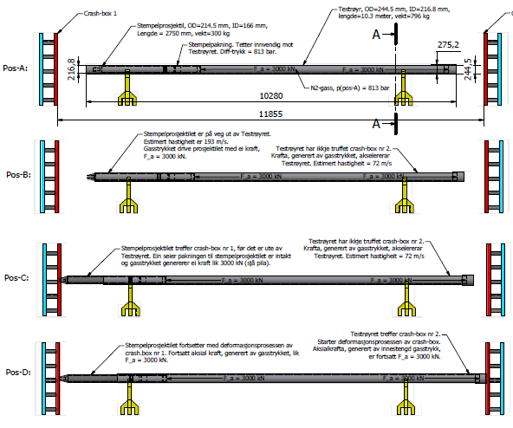

Figure 26: Illustration of the piston-projectile problem.

The possible piston-projectile problem is illustrated in and will be considered in the following. Here, the projectile (with a mass  of 300 kg) is launched from the test pipe at an impact velocity  of 193 m/s. Due to the short distance between the test rig and the crash-box system, the projectile impacts the crash-box before it leaves the test pipe. If it is assumed that the gaskets of the piston-projectile are intact, a static pressure  of 3000 kN is assumed present behind the projectile in addition to the kinetic energy caused by the acceleration (see Pos-C in ). This static pressure gives an elastic stress at the rear side cover plate of the projectile of .

Initially, IRIS requested a maximum load of 3000 kN on the concrete wall behind the crash-box system. This load may easily be achieved by adjusting the design of the crash-box system shown in Chapter 3. If, for example, the thickness of the front plate  is increased to 0.3 m, the yield stress  of the crash-boxes is decreased to 400 MPa, and the wall-thickness  of the crash-boxes is decreased to 1.5 mm (giving an average crush force  of 47 kN), the total force on the concrete wall from the crash-box system of 64 crash-boxes becomes





Figure 27: Dynamic equilibrium of piston-projectile problem.

The dynamic equilibrium of the piston-projectile problem may now be established (see also ) as



By integration the following expressions are established



with boundary conditions



which gives



With these boundary values Eq. turns into



Thus, if  kN, i.e. the maximum load from the crash-box to the concrete wall equals the static pressure behind the projectile, we get



Eq. shows that if  kN, the crash-box system deforms after trigging due to the static load at a velocity  without decelerating the projectile. When the crash-box is fully compressed at , the projectile impacts the crash-box/concrete wall with the same impact velocity/kinetic energy as if the barrier was not present. Thus, under these special conditions the proposed system does not work as expected since the quasi-static load equals the design load.

In order for the crash-box system to work properly, one of the following modifications must be done (see also the discussion in Chapter 9);

1) The test rig must be moved further back in the concrete pit so that the projectile can leave the test pipe and go into free flight before impacting the crash-box (see ). In this way the static pressure will be vented.

2) Apply venting of the static pressure if an accident occurs. This may be done by use of safety valves that are triggered if the projectile moves beyond a certain limit, or by venting areas applied to the test pipe.

3) The concrete wall must be allowed to take much more force than 3000 kN. This can be accomplished by increasing the thickness and the reinforcement of the concrete wall. In the next Chapter the concrete wall will be designed for a quasi-static loading of 6000 kN. Since the piston-projectile effect is not taken into account in the analytical calculations, this effect will be included and considered in the numerical simulations shown in Chapter 8.

# Simplified design of concrete wall behind the crash-box system

In the following a simplified, static design of the concrete wall behind the crash-box system will be given. It is important to note that this design is preliminary, and that this must be controlled and approved by the contractor (IRIS) since this is not a part of the contract. However, to make sure that the proposed system can be used, it is important to prove that the concrete wall in the pit can carry a quasi-static loading of minimum 6000 kN.

It is assumed that the loading is distributed over an area of 1 m2 (i.e. the crash-box system has side-lengths  m). The concrete wall is then simplified into a simply-supported beam of unit length (i.e. ) and length . This is shown in , where the shaded part illustrates the loaded area. The mathematical beam model and the corresponding moment diagram are given in .



Figure 28: Concrete wall simplified into a beam of unit length.



Figure 29: Mathematical model and moment diagram of the concrete beam.

Thus, from it is seen that the maximum moment for the given load the beam has to carry is 2250 kNm. The moment capacity of the compression zone is



where  is the design compressive strength of the concrete,  is the width and  is the efficient height of the beam. If it is assumed that a B45 ( MPa) concrete is used in the pit, the design compressive strength after Eurocode 2 becomes



The efficient height may now be calculated as



If we assumed a minimum coverage of 30 mm and a reinforcement bar diameter of 20 mm, the minimum thickness of the concrete beam becomes



Due to the large external moment, and the need for reinforcement bars in two layers, the necessary thickness is increased to minimum 1000 mm. Thus, the effective height  is taken equal to 900 mm. The necessary amount of reinforcement bars on the tensile side of the beam is calculated as



when B500C steel is used. If reinforcement bars with  is used (i.e. ), we will need  ribbed reinforcement bars in two layers per meter width. On the compression side, a minimum reinforcement of



where  for  is used. This can be taken by 6 ribbed reinforcement bars of  per meter width. A sketch of the moment reinforcement of the concrete beam is shown in .



Figure 30: Sketch of the moment reinforcement (without shear reinforcement bars) of the concrete beam.

Finally, the shear capacity must be checked. From and the shear force is found as



The shear stress capacity of the beam is given as



where







Thus,



We see that , i.e. shear reinforcement is required. Let now the shear reinforcement take all the shear force. The capacity of the shear force reinforcement is



so that



where the shear force reinforcement is made of B500C steel bars with  mm and a yield stress of 500 MPa. The area of the reinforcement bars is  mm2, so that the centre distance between the reinforcement bars becomes



A preliminary design of the concrete wall behind the crash-box system in the pit is shown in . Note that minimum distances, anchorage lengths, various controls required in EC2, adjustment of the efficient height  of the cross-section, etc, have not been carried out, but must be done in the final, detailed design phase. However, the preliminary design of the concrete pit shows that a sufficiently thick, heavily reinforced concrete wall will be able to carry the applied load from the projectile if an accident occurs. Note also that the safety of the whole system increases with concrete wall thickness and reinforcement content.



Figure 31: Preliminary design of the concrete wall behind the crash-box in the pit.

# Alternative design of crash-box system

One major challenge using the proposed crash-box system with a number of square high-strength steel or aluminium tubes is to design a proper trigger to lower the initial peak force during impact. An alternative design is to use vertical steel pipes instead of the horizontal squares presented in Chapter 3. The advantage by using vertical pipes instead of horizontal crash tubes is that there is no need for a trigger in the former. In a pipe the force level will increase monotonically until a constant crushing force, and no initial peak appears. This system will be investigated closer in the following.

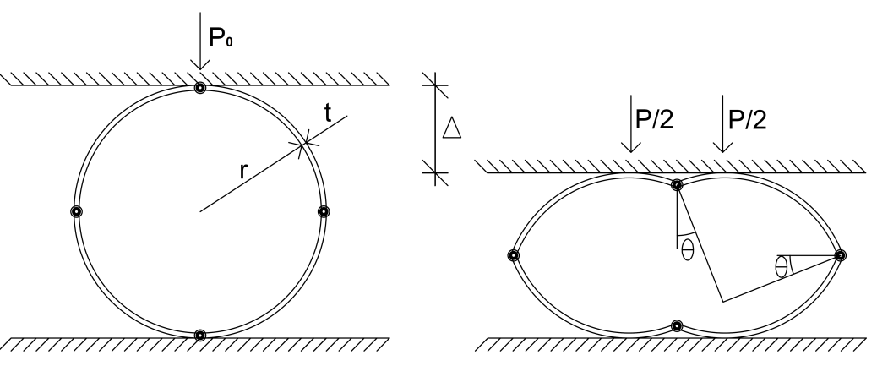

Figure 32: Rigid - perfectly plastic deformation of a ring.

The ovaling of a pipe can be studied by a simple ring model. The model is shown in . The model consists of a ring compressed between two rigid plates (i.e. the steel plates in the crash-box system). Two plastic hinges develop under the initial contact points between the plates and the ring, and two plastic hinges develop at the other two quarter points. From the following kinematic relation can be found



or



The external and internal virtual work for the system reads



and



where  is the plastic moment capacity of the pipe wall and can be found as



where  is the initial yield strength (in MPa) of the material and  is the length of the pipe. By using the principle of virtual work, i.e. that the internal virtual work is equal to the external virtual work, the relation between the load  and the displacement  is given as



The initial yielding load can be found by inserting  in Eq. . Thus,



where  is the diameter of the pipe. Note that the simplified deformation model described above is only valid when the length of the pipe is short and the pipe deforms as a ring.

Assume now that a steel pipe with yield stress  MPa, wall-thickness 4 mm, initial diameter  mm and length  mm is used in the crash-box instead of the square tubes. The plastic moment capacity is found from Eq. as



and the initial yielding load is



If it is further assumed that the pipe is compressed  before maximum displacement is reached, the energy absorption in each pipe becomes



In order to absorb the kinetic energy from the impacting projectile (see Chapter 3)



pipes with a length of 1 m are required. Fully compressed, the maximum number of pipes per square meter is 6. Thus,  layers of pipes are required to absorb the kinetic energy, and it is rather obvious that this concept cannot be used under the given impact conditions.

# Numerical simulations

It has been shown in previous Chapters that it is difficult, if not impossible, to design and validate the final crash-box system solely based on full-scale tests, small-scale tests and/or analytical considerations. Thus, we have to turn our attention towards full-scale non-linear finite element simulations to take all the complexity of the problem into account (such as the non-linear material behaviour, piston-projectile effect, interaction effect between crash-boxes, etc). In the following, the modelling and the main results of these studies will be presented in some detail.

In a similar way as for the introductory analyses shown in Chapter , all simulations were carried out using the explicit solver of the non-linear finite element code LS-DYNA [7]. The materials were modelled using the modified Johnson-Cook constitutive relation and the Cockcroft-Latham fracture criterion defined by Eqs. - . The parts in the 3D FE models were meshed with 8-node constant-stress solid elements with one-integration point and stiffness-based hourglass control, except for the crash-boxes that were modelled using shell element with 5 integration points over the thickness and 1 integration point in the plane. In addition, some parts were modelled as rigid bodies. The crash-boxes were modelled with shells to save computational time, since previous simulations have shown that the difference in results between shells and solids in dynamic crushing of profiles are in general small. Contact was modelled using different algorithms. Between the projectile and the front plate a surface-to-surface contact was used, while between the front plate and the crash-boxes a single-surface contact was used [7]. A stone-wall contact was used between the rear plate and the concrete wall, which in all simulations were assumed to be rigid. The number of elements varied quite significantly, from less than 20.000 elements in the first simulations to almost 5 million in the final simulations of the complete system. The CPU-time for the simulations was typically from 15 minutes to more than 1000 hours, depending on the model size, using four 3 GHz Intel Pentium 4 processors. The numerical simulations were carried out in a number of different steps that will be presented in the following.

In Step 1 a single crash-box was impacted by a rigid body with mass 1085/64 = 16.96 kg and impact velocity of 53.4 m/s, which is equal to the residual velocity after the first impact using a front plate thickness of 0.1 m (see Chapter 4 and in particular Eq. ). The reason for starting with these simulations was to confirm that the crash-box behaved as expected for the relatively high impact velocity and to validate the analytical calculations in Chapter 4. The material model in this simulation was somewhat simplified, applying an elastic-plastic constitutive relation with linear hardening (*MAT­_3 in LS-DYNA), while strain-rate effects and fracture were neglected. Both the moving front plate and the stationary back plate were modelled as rigid bodies, while the steel crash-box was modelled with shell elements having  MPa (yield stress), MPa (tangent modulus),  mm,  mm and mm (i.e. similar as for the calculations in Chapter 4). Plots of the crushing of the profile are shown in , while corresponding fringe plots of the effective plastic strain are shown in . The crash-box seems to behave as expected during crushing.





Figure 33: Plots of the crushing of a single profile.





Figure 34: Fringe plots of the effective plastic strain during crushing of a single profile.

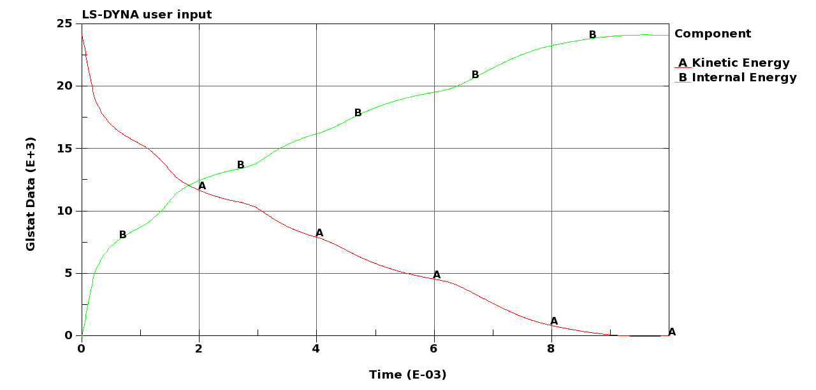

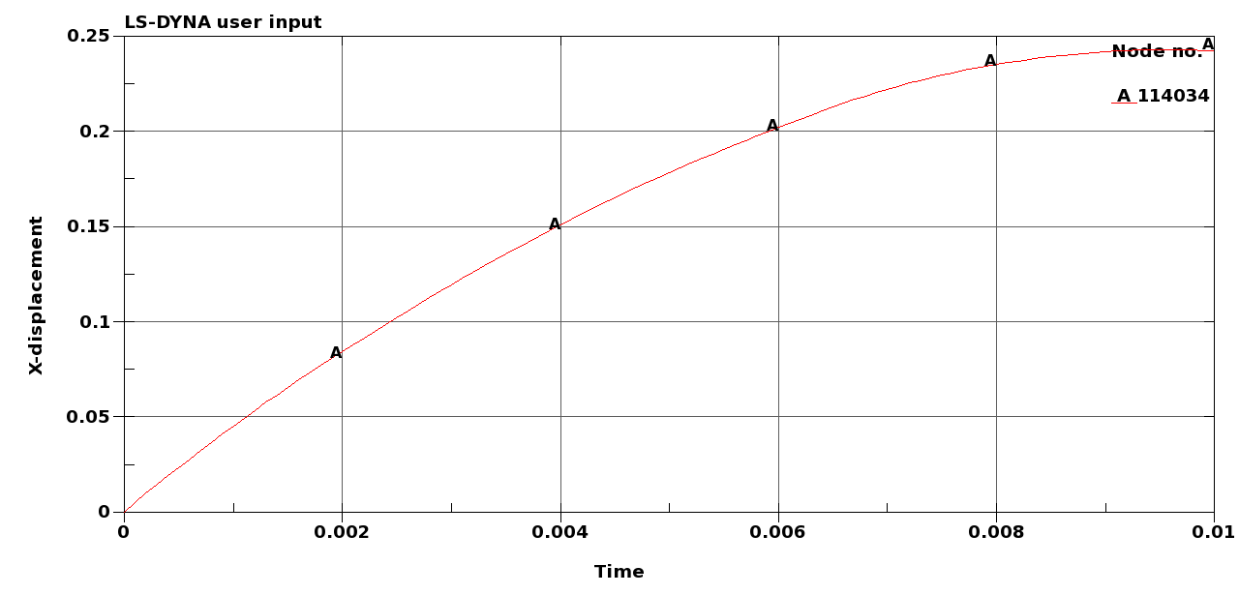

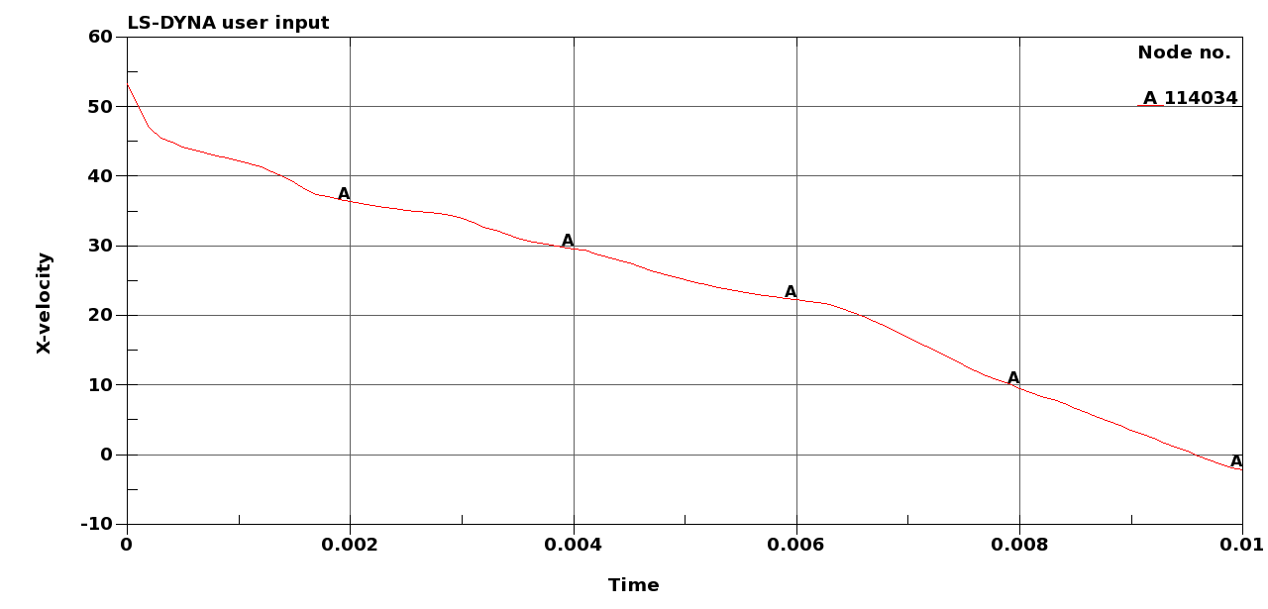

Figure 35: Plots of the energies (top), crash-box displacement (middle) and projectile velocity (bottom) during crushing of a single profile.

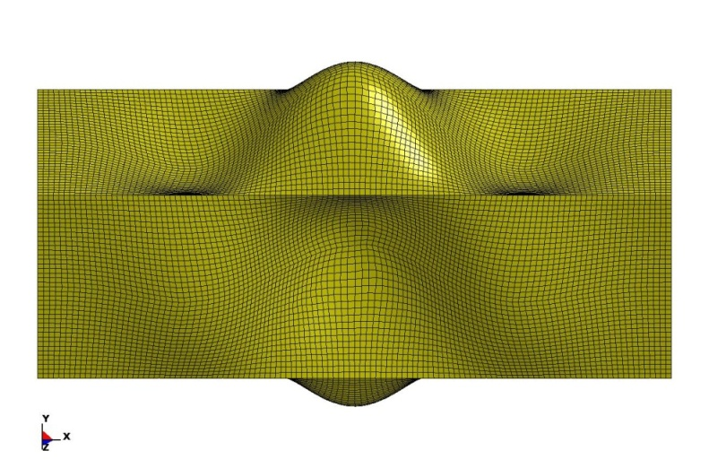

Figure 36: Geometry of trigger used for the profile in the simulations.

Plots of the energies (kinetic and internal), crash-box displacement and projectile velocity during crushing of a single profile are given in . All the kinetic energy is as seen absorbed as internal energy during crashing, the displacement of the profile stops up and becomes constant and the velocity changes sign, indicating rebound of the projectile. Thus, the impact energy is absorbed. If these values are compared to the analytical calculations shown in Chapter (and in particular in ), we see that the agreement between the results is very good. Thus, these simulations validates the analytical models and vice versa.

Finally, shows the geometrical trigger used for the profile in these simulations. Note that the displacements in are scaled by a factor 10 to better show the dents. The dents are modelled using three sinus waves () over the length of the profile and one sinus wave () over the width. The force-time plot against the modelled rigid back wall (here illustrating the concrete wall in the pit) is shown in Figure 37.

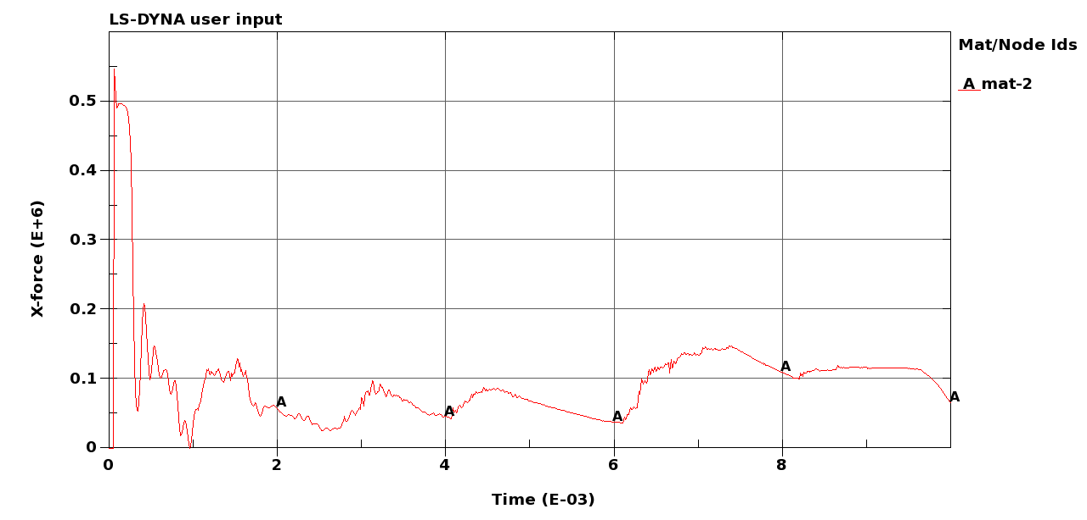

Figure : Force-time plot against the concrete wall.

As seen, the average crush force oscillates around 100 kN (while the analytical value was found to be 115 kN – see Eq. ), while the initial peak is rather large. Even so, this trigger will be used in the bulk of the simulations in this study since the modelled dents are known to give the natural folding modes of the profile.

In Step 2 of the study, the single profile model presented above was used to carry out a limited parametric study on the behaviour of different crash-boxes during impact. The material, the initial kinetic energy and the geometry of the crash-boxes were varied in the simulations in an attempt to find an optimal crash-box for energy absorption. Two materials were considered, DP800 steel [13] and AA6060-T6 aluminium [16], and the material cards for these two materials are given in . In these analyses it was assumed that the full system consist of 64 crash-boxes. Hence, in order to get the correct kinetic energy, transferred to one crash-box, the impacting masses have been divided by 64. The different parameters that were varied for each simulation are listed in and are given with the achieved mean force taken from the simulations. It is seen that DP800 gives in overall a higher mean force than AA6060-T6. From the combinations tested, an optimal solution for DP800 steel would be to use a crash-box of 300 mm length with a thickness of 1.2 mm. The front plate of steel should be of 300 mm in thickness. This gives a mean crush force of about 75 kN. For AA6060-T6 aluminium, an optimal solution obtained is to use a crash-box of 500 mm in length and a thickness of 2.5 mm. Here, the front plate of steel needs to be 200 mm thick. In order to decrease the thickness of the crash-box, the length and the thickness of the front plate need to be increased. Similar to the plots given for Step 1, some plots of the crushing of the profile are given in Figure 39 and Figure 42, fringe plots of the effective plastic strain are shown in Figure 40 and Figure 43, while crash-box displacement, projectile velocity, plots of energies and force-time plot against the modelled rigid back wall are given in and , for typical simulations of DP800 and AA6060-T6, respectively. The main difference between the two materials is shown in the plots of the crushing mode.

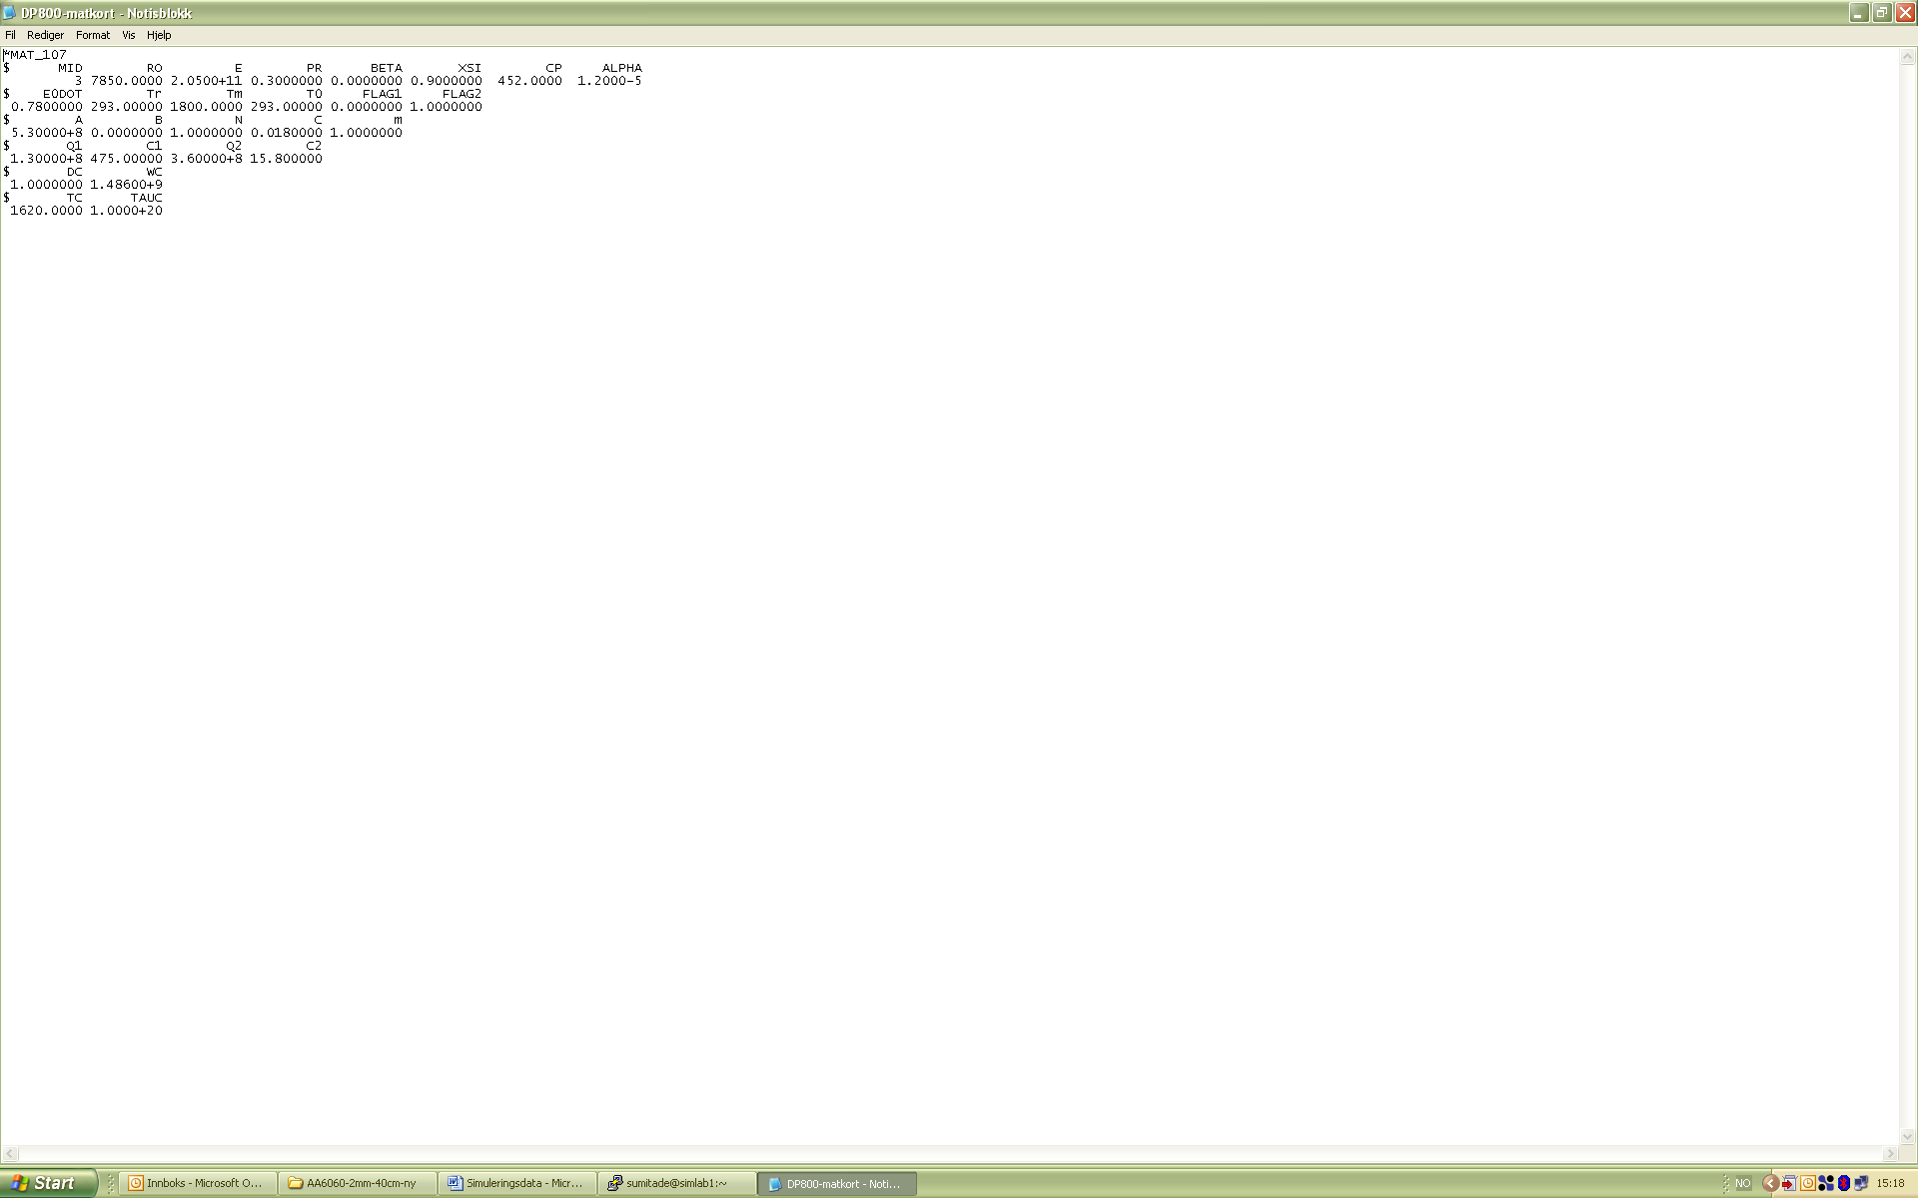 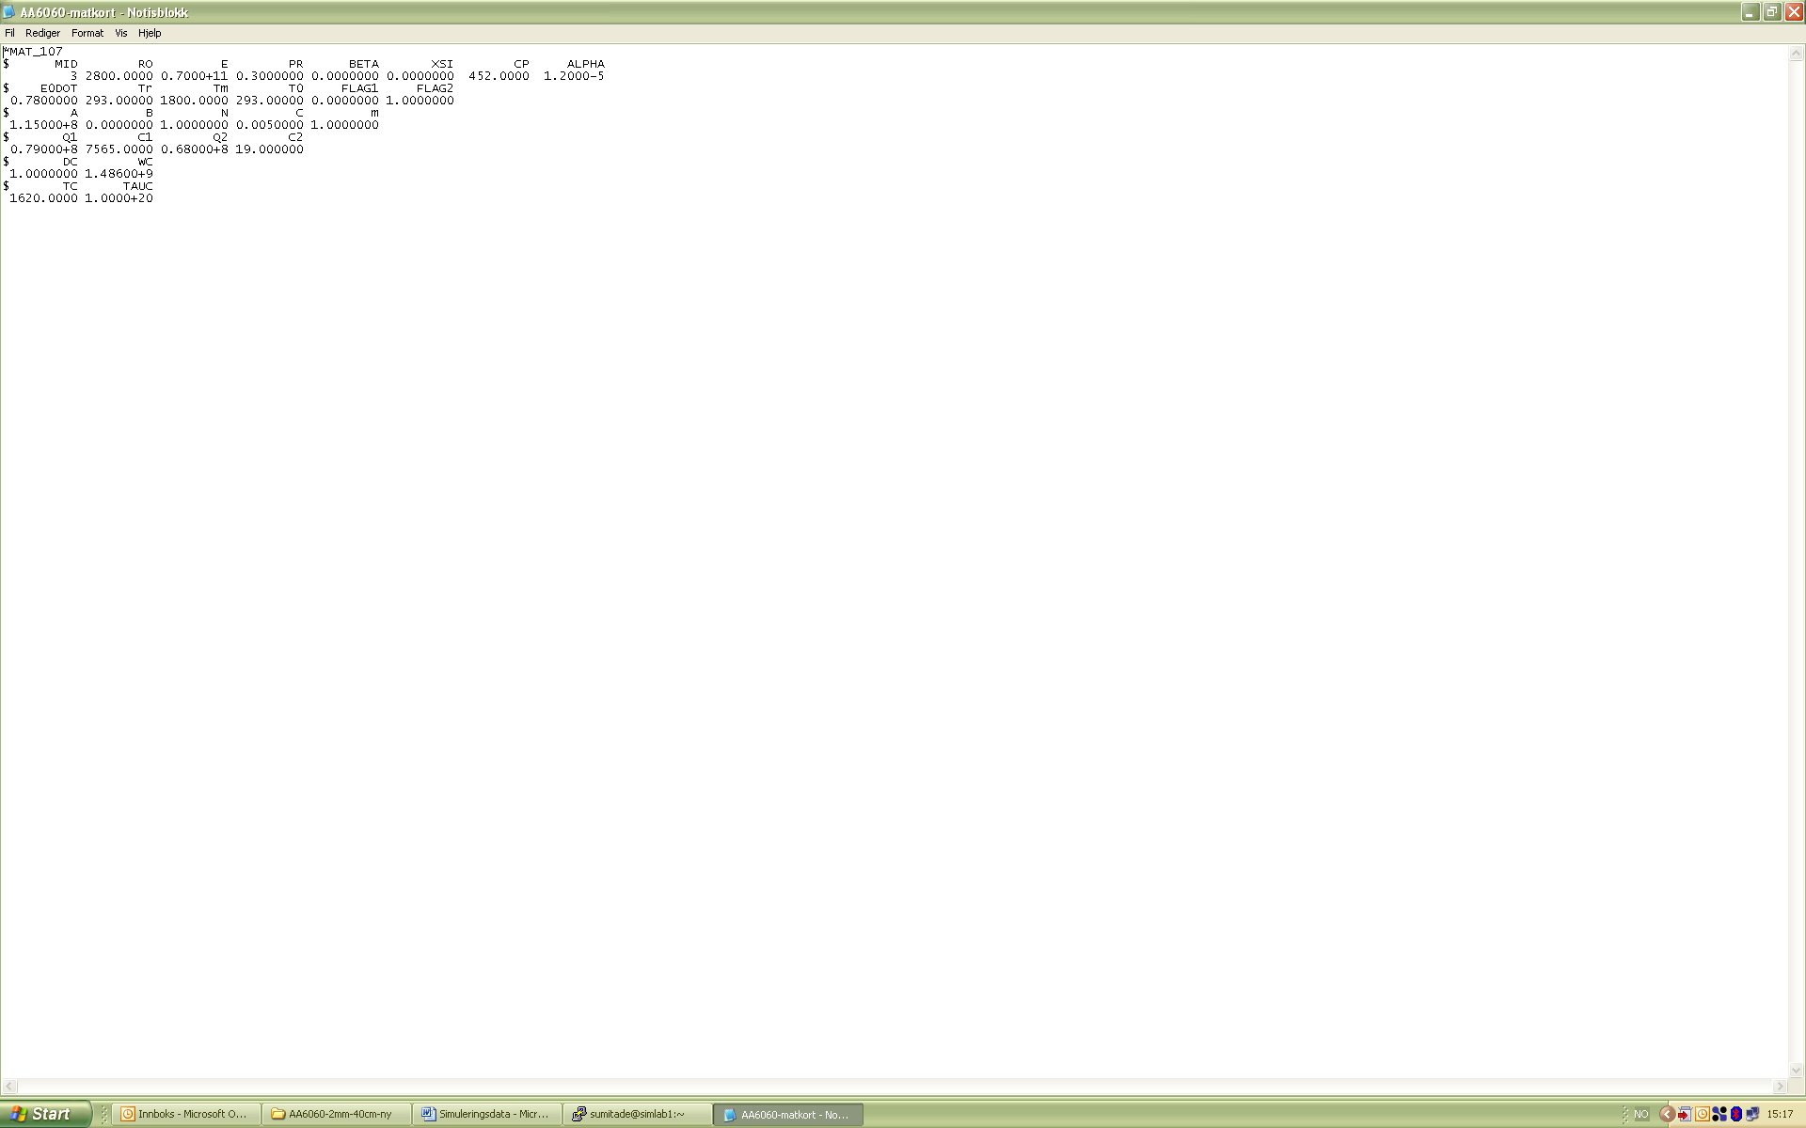

Figure : Material cards for the two materials that were used in the simulations; DP800 steel (top) and AA6060-T6 aluminium (bottom).

Table 5: Some crash-box systems.

|  |  |  |  |  |  |  |  |  |  |  |
| --- | --- | --- | --- | --- | --- | --- | --- | --- | --- | --- |
| System  # | Front plate | | | | Crash-box | | | | | |
| (kg) | (m) | (kg) | (m/s) | (MPa) | (mm) | (mm) | (mm) | (mm) | (kN) |
| DP800 - 1 | 785 | 0.1 | 1085 | 53.4 | 530 | 2.0 | 100 | 300 | 160 | 100 |
| DP800 - 2 | 785 | 0.2 | 1870 | 31.0 | 530 | 2.0 | 100 | 300 | 108 | 100 |
| DP800 - 3 | 785 | 0.3 | 2655 | 21.8 | 530 | 2.0 | 100 | 300 | 87 | 90 |
| DP800 - 4 | 785 | 0.1 | 1085 | 53.4 | 530 | 1.8 | 100 | 300 | 207 | 100 |
| DP800 - 6 | 785 | 0.1 | 1085 | 53.4 | 530 | 1.5 | 100 | 300 | * |  |
| DP800 - 7 | 785 | 0.2 | 1870 | 31.0 | 530 | 1.5 | 100 | 300 | 177 | 75 |
| DP800 - 8 | 785 | 0.2 | 1870 | 31.0 | 530 | 1.2 | 100 | 300 | * |  |
| DP800 - 9 | 785 | 0.3 | 2655 | 21.8 | 530 | 1.2 | 100 | 300 | 187 | 75 |
| DP800 - 10 | 785 | 0.3 | 2655 | 21.8 | 530 | 1.0 | 100 | 300 | * |  |
| DP800 - 11 | 785 | 0.3 | 2655 | 21.8 | 530 | 1.0 | 100 | 400 | * |  |
|  |  |  |  |  |  |  |  |  |  |  |
| AA6060-T6 - 1 | 785 | 0.1 | 1085 | 53.4 | 115 | 2.0 | 100 | 300 | * |  |
| AA6060-T6 - 2 | 1570 | 0.2 | 1870 | 31.0 | 115 | 2.0 | 100 | 300 | * |  |
| AA6060-T6 - 3 | 2355 | 0.3 | 2655 | 21.8 | 115 | 2.0 | 100 | 300 | * |  |
| AA6060-T6 - 4 | 3140 | 0.4 | 3440 | 16.8 | 115 | 2.0 | 100 | 300 | * |  |
| AA6060-T6 - 5 | 785 | 0.1 | 1085 | 53.4 | 115 | 2.5 | 100 | 300 | * |  |
| AA6060-T6 - 6 | 3140 | 0.4 | 3440 | 16.8 | 115 | 2.5 | 100 | 300 | 164 | 50 |
| AA6060-T6 - 7 | 2335 | 0.3 | 2655 | 21.8 | 115 | 2.5 | 100 | 300 | 206 | 50 |
| AA6060-T6 - 8 | 1570 | 0.2 | 1870 | 31.0 | 115 | 2.5 | 100 | 300 | * |  |
| AA6060-T6 - 9 | 1570 | 0.2 | 1870 | 31.0 | 115 | 2.5 | 100 | 400 | 294** | 55 |
| AA6060-T6 - 10 | 1570 | 0.2 | 1870 | 31.0 | 115 | 2.5 | 100 | 500 | 304 | 40 |
| AA6060-T6 - 11 | 2335 | 0.3 | 2655 | 21.8 | 115 | 2.0 | 100 | 400 | * |  |
| AA6060-T6 - 12 | 2335 | 0.3 | 2655 | 21.8 | 115 | 2.0 | 100 | 500 | * |  |
| AA6060-T6 - 13 | 2335 | 0.3 | 2655 | 21.8 | 115 | 1.8 | 100 | 400 | * |  |

* l exceeds 0.73lc, the crash-box is not able to absorb the wanted energy

** l exceeds just 0.73lc in this system; the system is at the limit of what is needed

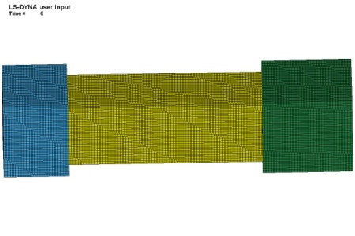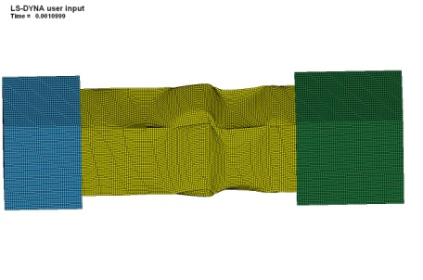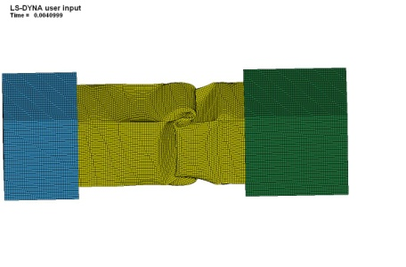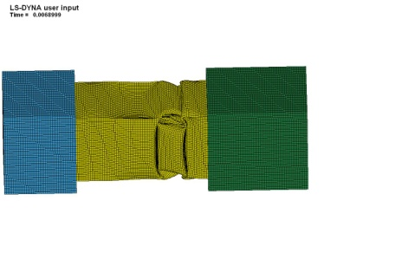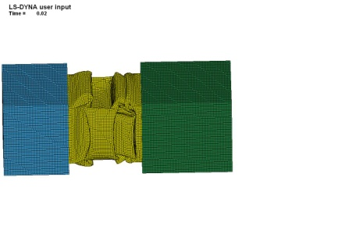

Figure : Plots of the crushing of a single DP800 steel profile where = 30 cm and  = 1.2 mm (noted as DP800-9 in ).

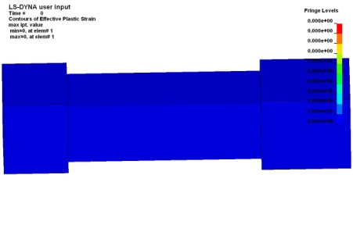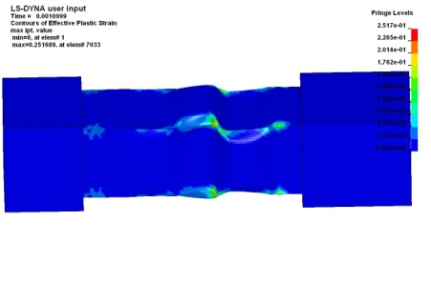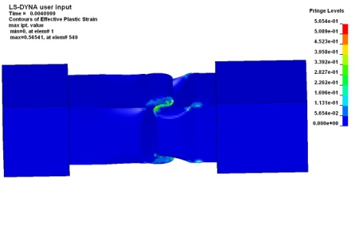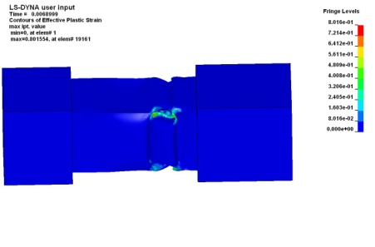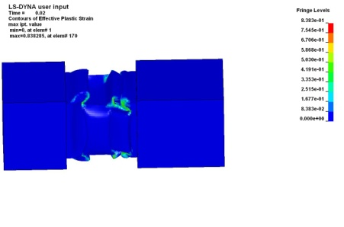

Figure : Fringe plots of the effective plastic strain during crushing of a single DP800 steel profile where = 30 cm and = 1.2 mm (noted as DP800-9 in ).

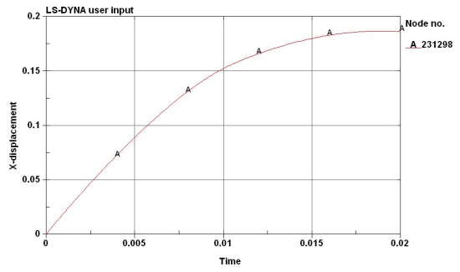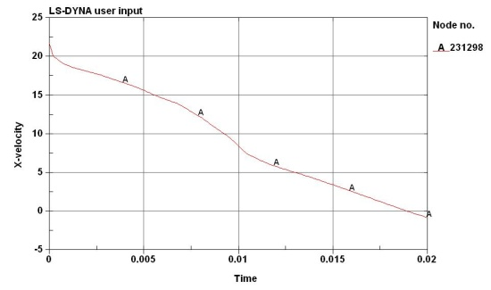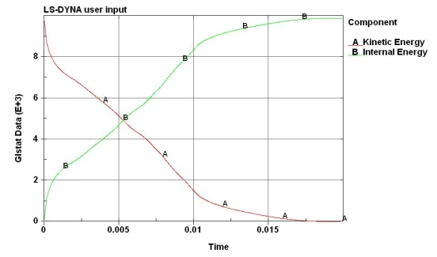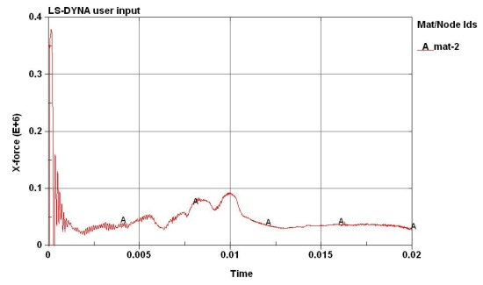

Figure : Plots of the crash-box displacement (top-left), projectile velocity (top-right), energies (bottom-left) and the force-time plot against the concrete wall (bottom-right) for a single DP800 steel profile where = 30 cm and  = 1.2 mm (noted as DP800-9 in ).

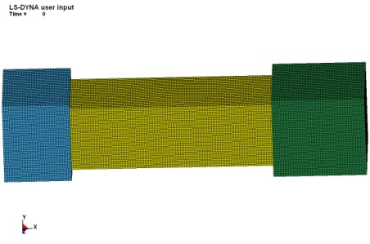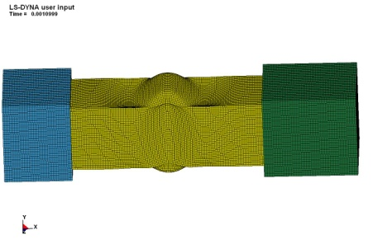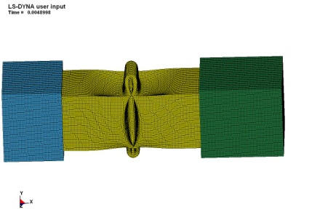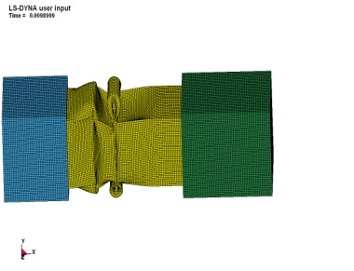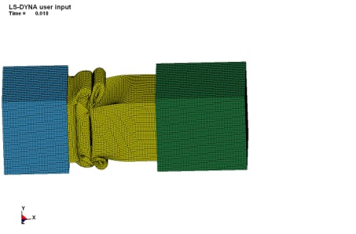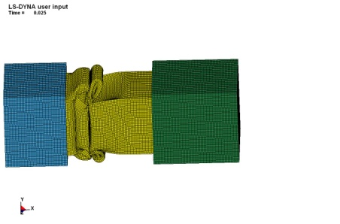

Figure : Plots of the crushing of a single AA6060-T6 aluminium profile where = 40 cm and = 2.5 mm (noted as AA6060-T6-6 in ).

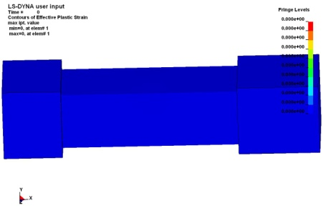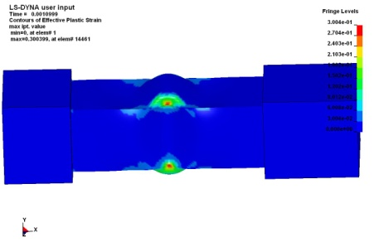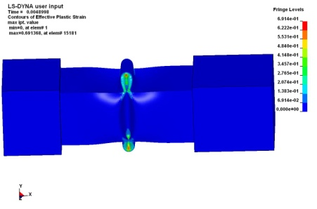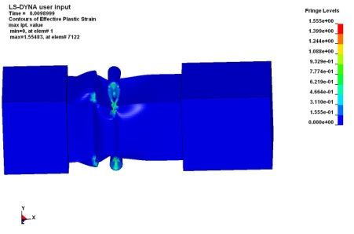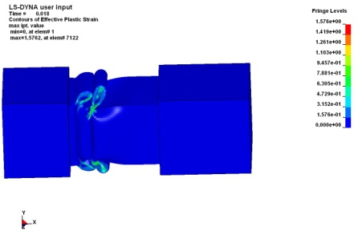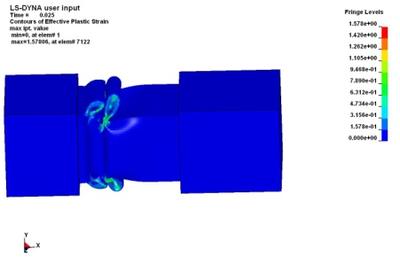

Figure : Fringe plots of the effective plastic strain during crushing of a single AA6060-T6 aluminium profile where  = 40 cm and  = 2.5 mm (noted as AA6060-T6-6 in ).

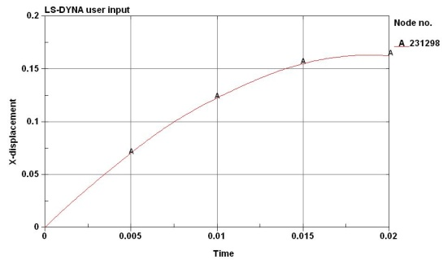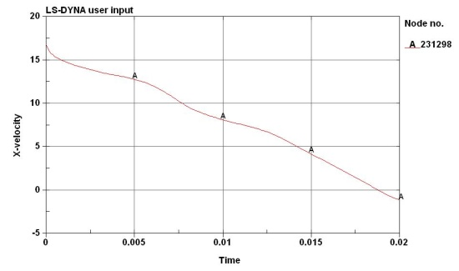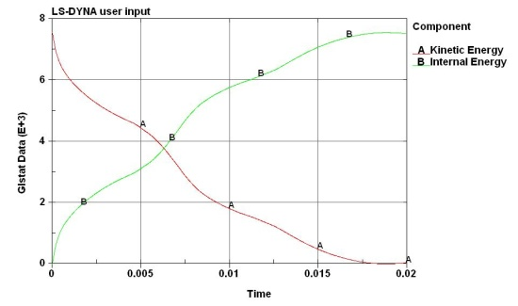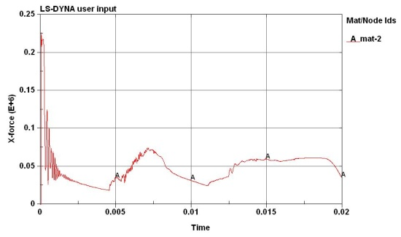

Figure 44: Plots of the crash-box displacement (top-left), projectile velocity (top-right), energies (bottom-left) and the force-time plot against the concrete wall (bottom-right) for a single AA6060-T6 aluminium profile where = 40 cm and = 2.5 mm (noted as AA6060-T6- 6 in ).

In Step 3 the whole crash-box system was modelled to see if a system of crash-boxes behaved as expected during impact. The numerical model consisted of 4 parts: A rigid wall as the back plate (Part 1), 64 steel crash-boxes with similar properties as the single crash-box in Step 1 (Part 2), a 100 mm thick Hardox 450 steel front plate with  m (Part 3) and a projectile modelled as a steel pipe in Incoloy 925 (Case-1 - ) with  and  m/s (Part 4). Part 2 was modelled with shells, while Part 3 and 4 were modelled with solid elements. The various parts are shown in Figure 45, the whole model is revealed in Figure 46, while the material cards used for the different parts are given in Figure 47. Note that the crash-boxes are still modelled using *MAT_3, while the steel front plate and the steel pipe are modelled using *MAT_107 (see Eqs. - ). The numerical model consisted of 1 388 800 shell element and 3 224 000 solid elements, giving a total of 4 612 800 elements.



Figure : Parts used in the numerical model of the whole system.

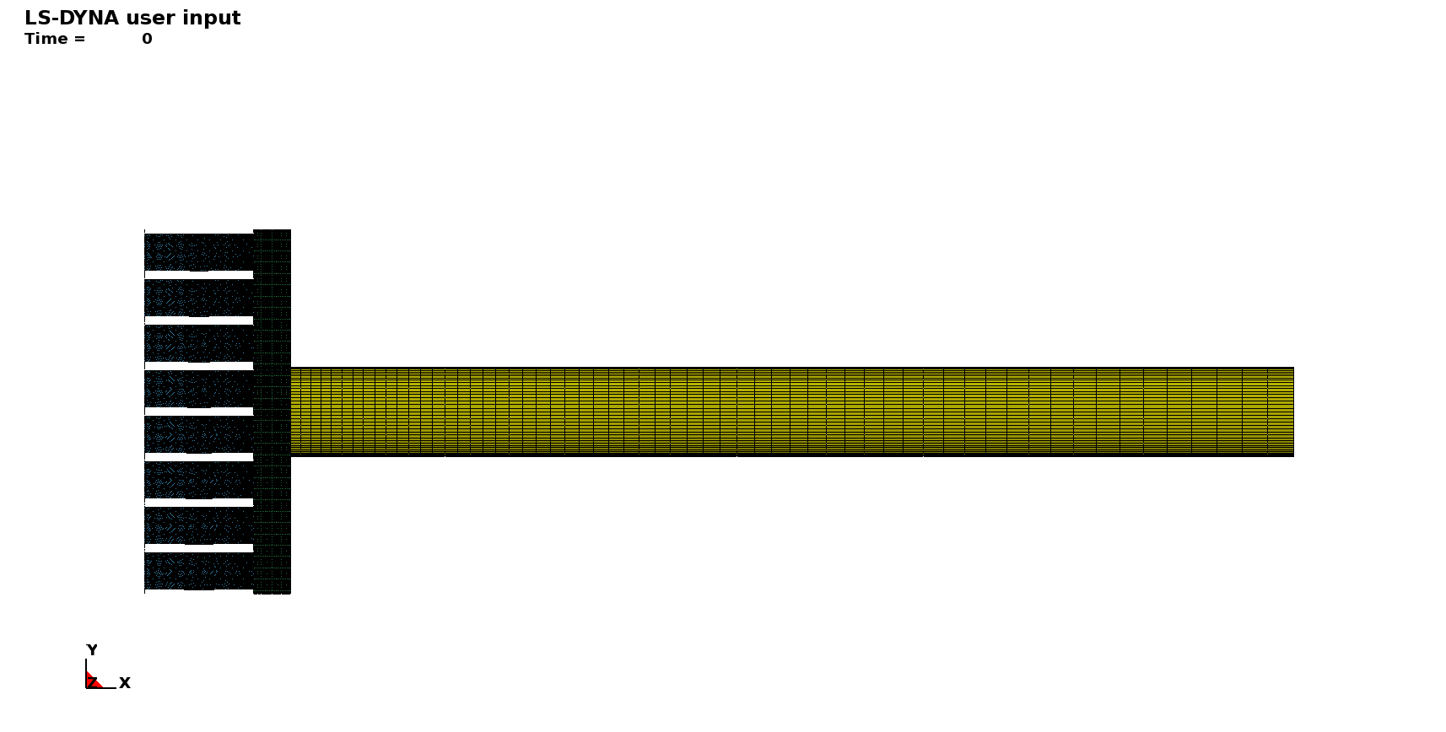

Figure : Numerical model of the whole system.



Figure : Material cards used in the numerical model of the whole system.

Some plots of the deformation process, both of the projectile and the crash-boxes, during impact are shown in Figure 48, while Figure 49 gives fringe plots of the crushing of only the crash-boxes (as function of the effective plastic strain). The maximum plastic strain is as seen high, and this may cause cracking at the corners of the crash-box, but this is assumed to be of minor importance for the energy absorption. Finally, Figure 50 gives fringe plots of the projectile and target after impact. Large plastic deformations take place in the projectile and a lot of energy is absorbed in this deformation mode. For the 0.1 m thick steel front plate, the only damage is a mark (ring) indicating the point of impact with a plastic strain of only a few percentage. This behaviour is very similar as that seen for the small-scale test in .



Figure : Deformation of the crash-box system during impact.



Figure : Fringe plots of the deformation of the crash-boxes during impact.

 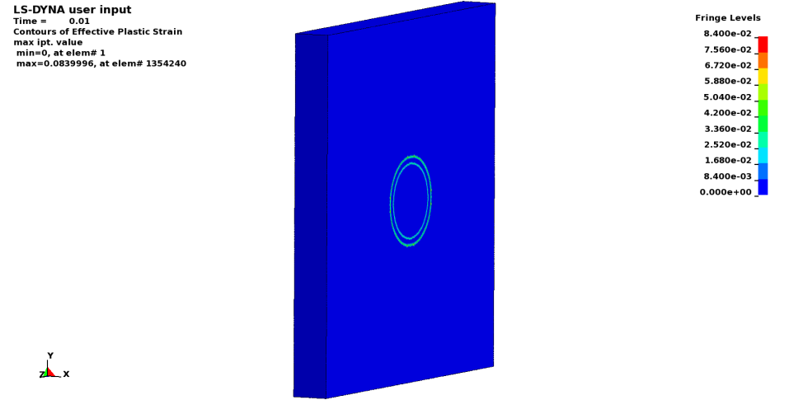

Figure : Fringe plots of the projectile and front plate after impact.

The kinetic and internal (work) energies in the various parts during impact is shown in Figure 51. The kinetic energy of the projectile (curve H) is absorbed mainly as internal energy in the projectile (curve D) and in the crash-boxes (curve B). Note also that a part of the projectile’s kinetic energy is used to accelerate the front plate, but this kinetic energy is rapidly absorbed as internal energy. Thus, the impact is in principle over after about 7 ms. Figure 52 shows the crash-box displacement and velocity of part 2-4 during impact. The maximum displacement of the crash-box is less than 150 mm, i.e. considerably smaller than the crash-length of  mm. Thus, the full potential of the crash-box is not explored. Further, the plotted velocities indicate that after about 3 ms, the velocity of the front plate (curve B) becomes higher than the actual velocity of the projectile (curve C). Then the contact between the front plate and the projectile will be lost for some time. Due to resistance by the crash-boxes, the front plate will slow down again, and the projectile will re-impact the front plate after 8.5 ms. The projectile will then rebound due to the elastic strain energy in the system. Finally, Figure 53 shows the force-time curve exposed to the concrete wall of the pit as a result of the impact. The initial peak force is as seen very high (approximately 25 000 kN), before it starts to fluctuate. The initial peak is however not as distinct as for a single profile. This value is much higher than the design load of 6 000 kN for the concrete wall. Thus, the main conclusion from this simulation is that the modelled system transfers too much force to the concrete wall. In the following, the system must be modified. It also seems important to model all the details in the system to have reliable result, and an acceptable force transfer.

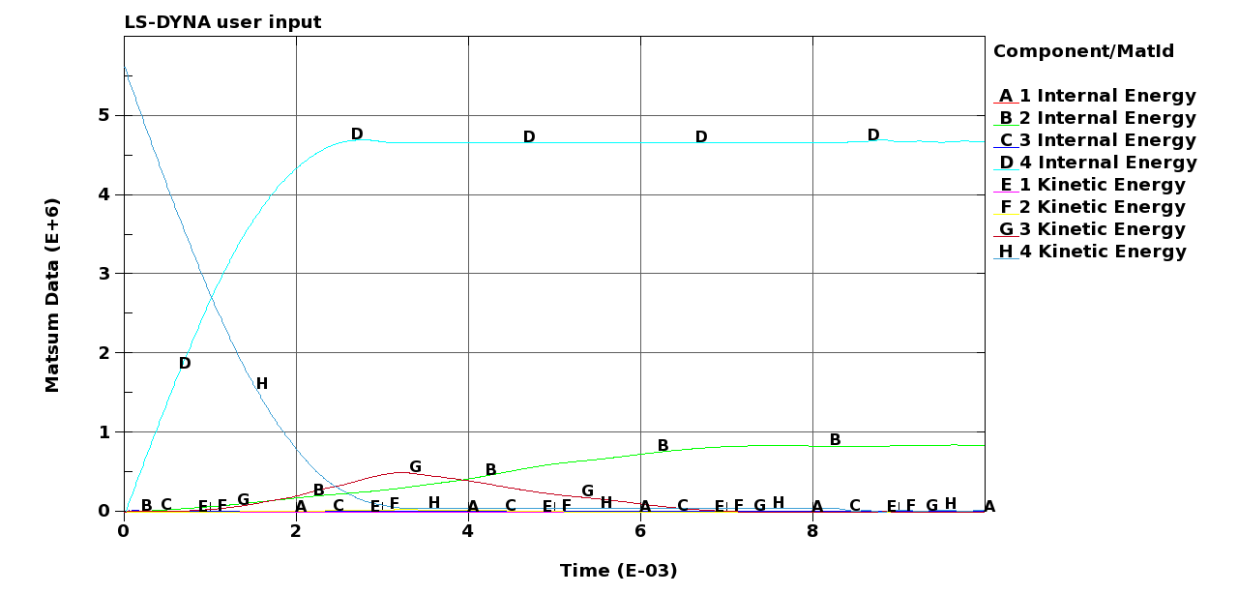

Figure : Kinetic and internal energy in the various parts during impact.

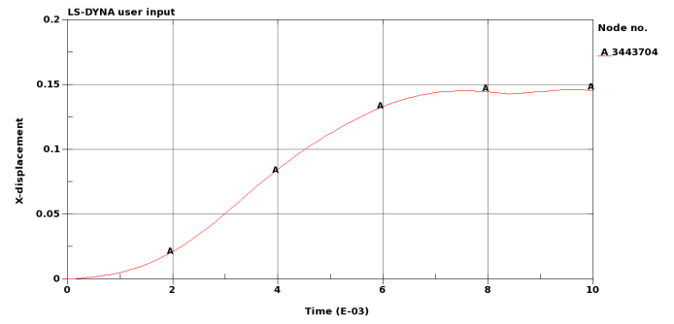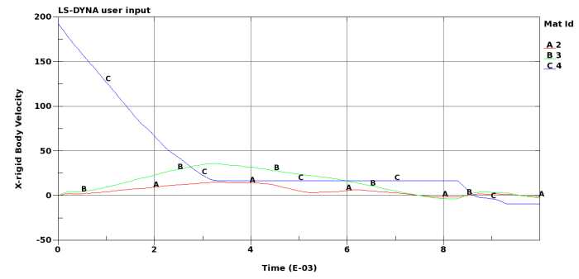

Figure : Crash-box displacement (left) and velocities of part 2-4 (right) during impact.

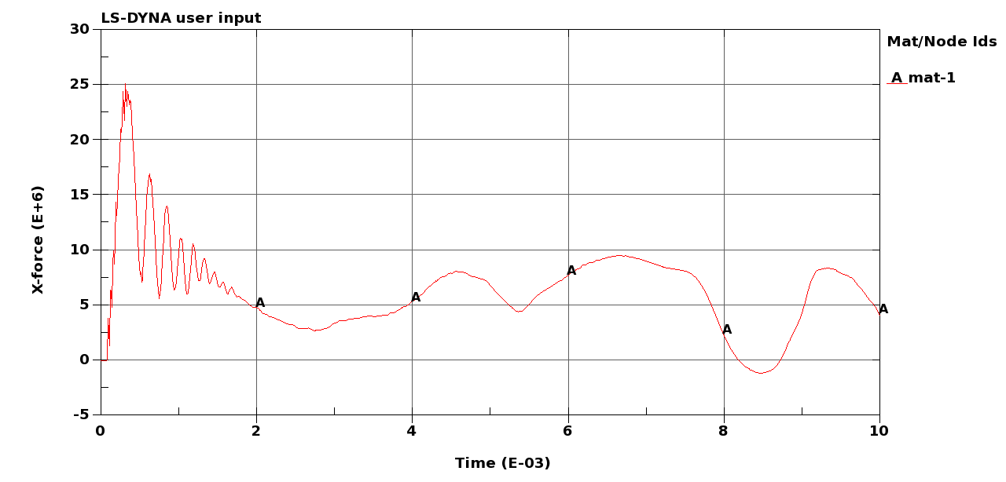

Figure : Force-time curve on the concrete wall in the pit caused by the impact.

In the next step (Step 4), the crash-box system was modelled in full detail, since previous steps have indicated that the system works as expected if the correct design is used. Five parts were used in the model, i.e. the back plate (Part 1), the crash-boxes (Part 2), the front plate (Part 3), the projectile (Part 4) and the rigid (concrete) wall (Part 5). The front steel plate was modelled as a 300 mm thick plate in Hardox 450 using *MAT_107. The thickness (and mass) of this plate was increased to lower the kinetic energy after the first impact (see Eq. ). The back steel plate was modelled as a 100 mm thick plate in Hardox 450 using *MAT_107, while the concrete wall was modelled as a rigid wall. The projectile was modelled in detail with a truncated conical nose using *MAT_107 and material data for Incoloy 925 (see Figure 54). This represents a typical projectile used in HPHT tests at IRIS (Case-1). Finally, the 64 crash-boxes in DP800 steel were modelled with  mm, mm and mm using *MAT_107. The material cards used in the numerical simulations are given in Figure 55, and material data for DP800 steel were taken from [13][27]. To save computational time, only a quarter-model was simulated due to symmetry. A plot of the quarter-model is shown in Figure 56. The model consisted of 307201 shell elements and 2646500 solid elements, giving a total of almost 3 million elements. In addition to the initial kinetic energy of the projectile, a static pressure of 3000 kN acted on the rear side of the projectile throughout the simulation to reproduce the piston-projectile problem (Chapter 5).

Figure 57 shows the deformation of the crash-box system and the projectile during impact, while the permanent deflection of the DP800 steel crash-boxes after the impact is shown in Figure 58. Figure 59- Figure 63 give some results from the simulation.



Figure : Numerical model of a typical projectile used in HPHT tests.



Figure : Material cards used in Step 4.



Figure : Quarter model used in the numerical simulations.



Figure : Deformation of crash-box system and projectile during impact (Step 4).



Figure : Deformation of the DP800 steel crash-boxes during impact (Step 4).

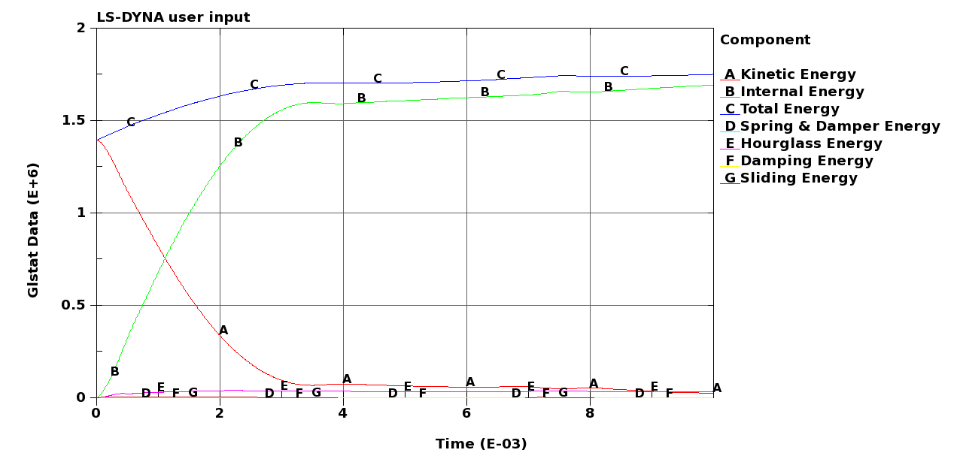

Figure : Global energies in the system during impact (Step 4) – quarter model.

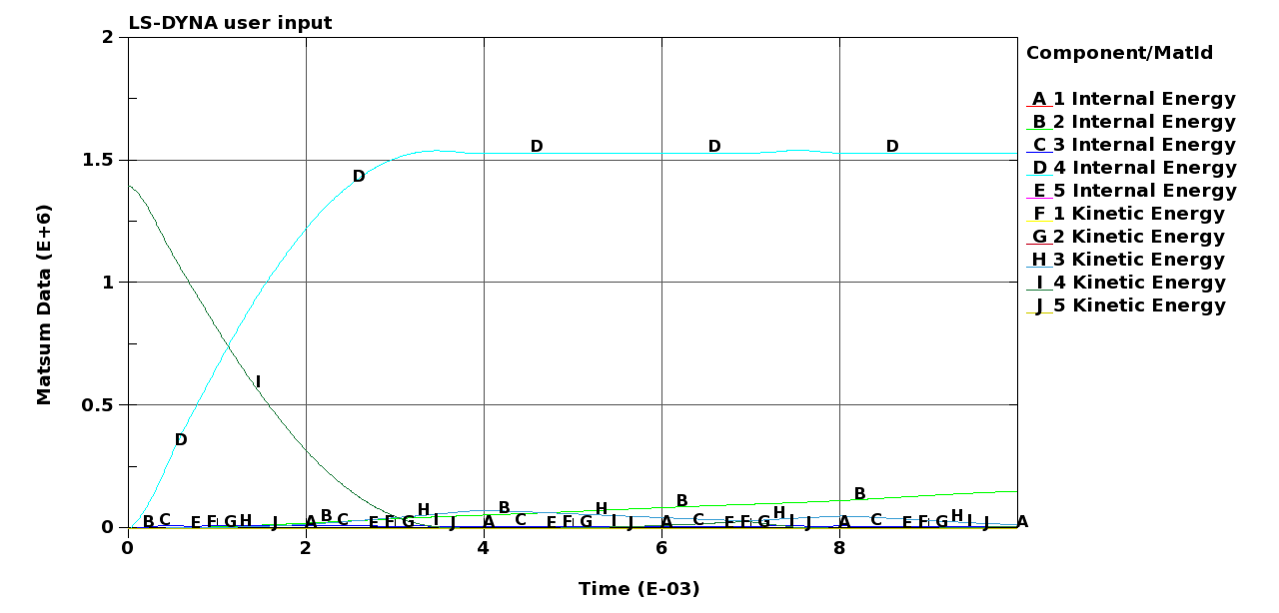

Figure : Energies in the various parts during impact (Step 4) – quarter model.

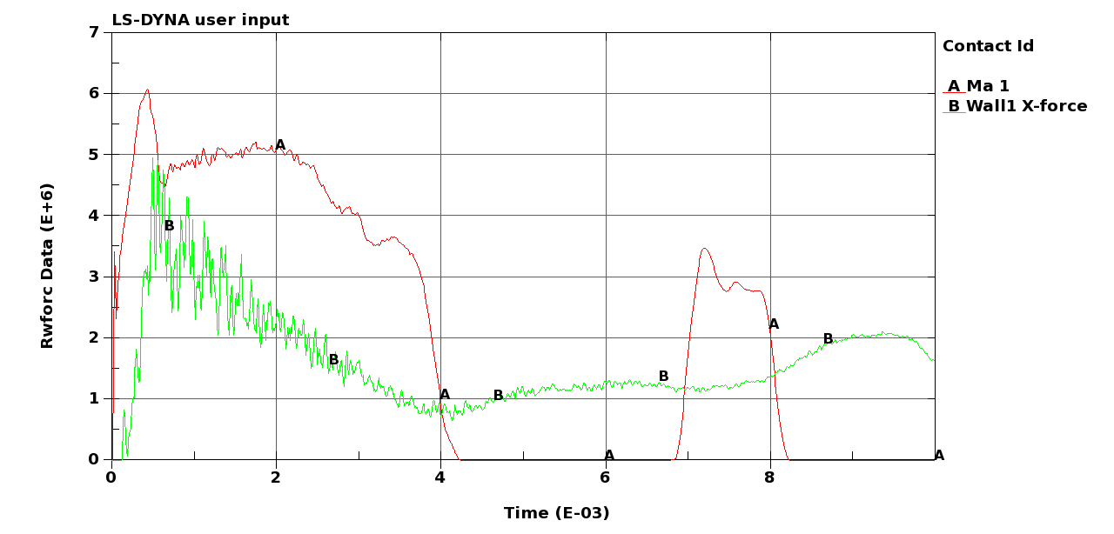

Figure : Force-time curves between the projectile and the front steel plate (curve A) and the crash-box system and the concrete wall (curve B) during impact (Step 4) – quarter model.

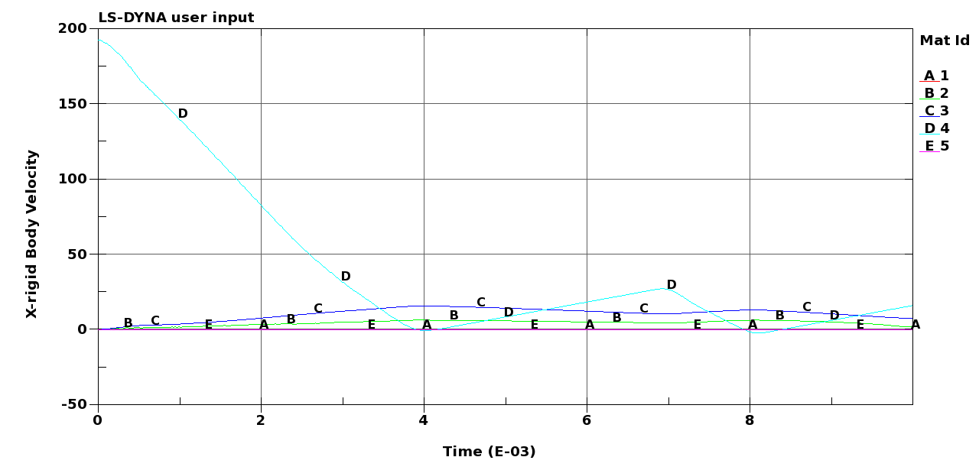

Figure : Velocity-time curves for the different parts during impact (Step 4).



Figure : Displacement-time curves for the different parts during impact (Step 4).

From these curves and plots a lot of information can be extracted. Note that all energies must be multiplied by 4 since only a quarter-model is simulated. First, Figure 57 indicates that the projectile will be considerably deformed during impact, while the DP800 steel crash-boxes are only moderately deformed. This is further confirmed in Figure 58 that shows a fringe plot of the permanent deformation of the crash-boxes. Figure 59 shows the global energies in the system during impact. It can be seen that the total and internal energies (curve B and C) continue to increase throughout the whole simulation. This is caused by the piston-projectile effect, i.e. the static pressure of 3000 kN that acts on the rear side of the projectile throughout the simulation. Figure 60 shows the energies in the various parts during impact. Most of the energy is as seen absorbed by plastic deformation in the projectile (curve D – Part 4), while only a small portion of the energy is absorbed in the crash-boxes. The crash-boxes continue to absorb energy until the termination of the simulation due to the piston-projectile effect.

The most interesting plots from this simulation are shown in Figure 61. This figure shows the force-time curves between the projectile and the front steel plate (curve A) and the crash-box system and the concrete wall (curve B) during impact. Keep in mind that the forces must be multiplied by 4 due to the quarter-model. At impact between the projectile and the front steel plate (curve A), a peak in the contact force () is seen. Then the front steel plate is accelerated, and after some time the contact is lost and the force falls to zero. However, due to the piston-projectile effect, contact is re-established after a while and a new force increase is seen due to this second impact (see also Figure 62). In these explicit finite element simulations without damping, the elastic waves are “trapped” inside the system so that it will continue to oscillate until the simulation terminates. In the real situation these oscillations are believed to be damped out, and the problem is reduced. It was tried to run simulations with damping included to reduce these oscillations, but since the damping coefficients are unknown this turned out to be more involved than first assumed. Thus, this is left out for further studies. Of more interest is the force transferred from the crash-box system to the concrete wall (curve B). As seen, the force to the concrete wall is nearly as high as the force between the projectile and the front steel plate at impact (almost ). This is much more than the force of 6000 kN the concrete wall is design for (see Chapter 6). After the initial impact the force drops to an average crush force of about 6000 – 8000 kN. Based on these curves, and the fact that the deformation of the crash-boxes are very limited (see Figure 58 and Figure 63), it may be concluded that the applied 64 crash-boxes of DP800 steel are too strong and stiff. Thus, to lower the strength of the crash-boxes, we have to introduce another more complex trigger, replace the steel crash-boxes with aluminium crash-boxes or to decrease the thickness and/or the number of steel crash-boxes in the system. In a first attempt, the DP800 steel crash-boxes will be replaced by AA6060-T6 aluminium crash-boxes.

Thus, in Step 5 the DP800 steel crash-boxes were replaced by 2 mm thick AA6060-T6 aluminium crash-boxes. Except for this the numerical model was exactly similar to that used in Step 4 (see Figure 56). The used material card for the AA6060-T6 aluminium crash-boxes is given in Figure 64. Material cards for the other parts are given in Figure 55.



Figure : Material card for the AA6060-T6 aluminium crash-boxes used in Step 5.

Figure 65 shows the deformation of the crash-box system and the projectile during impact, while Figure 66 - Figure 69 give some data from this simulation. Note that Figure 65 indicates that the 64 aluminium crash-boxes are completely compressed during impact before all the kinetic energy in the system is fully absorbed (see Figure 66).

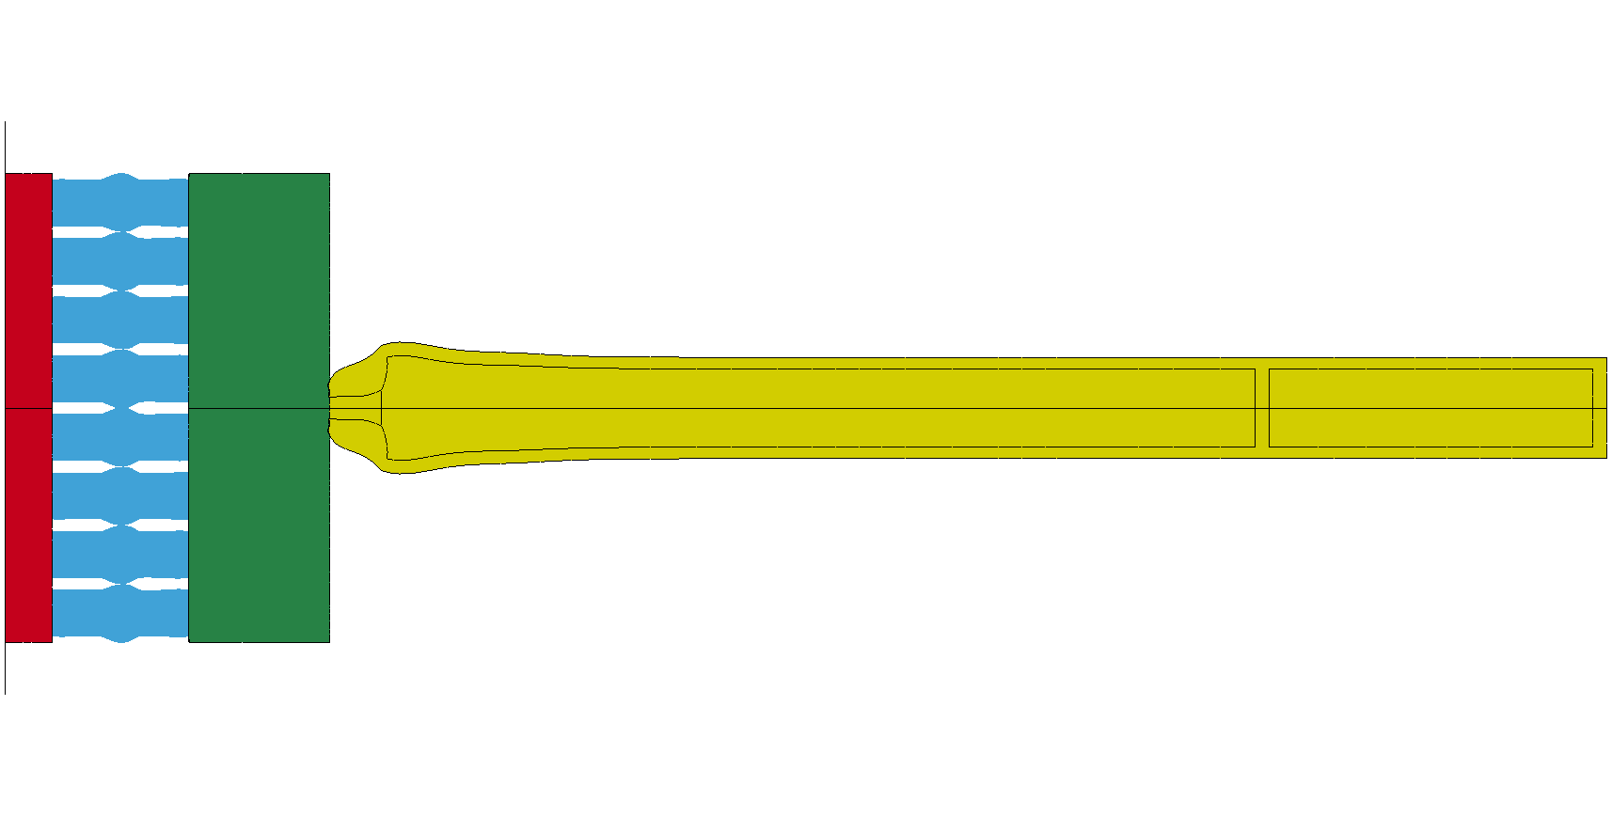 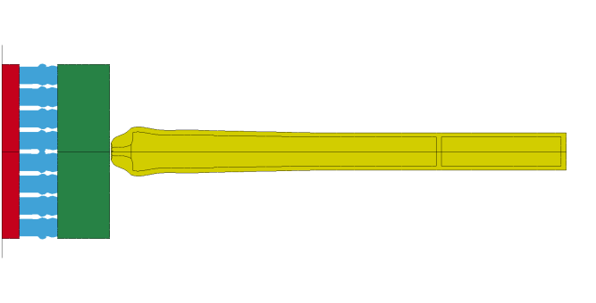

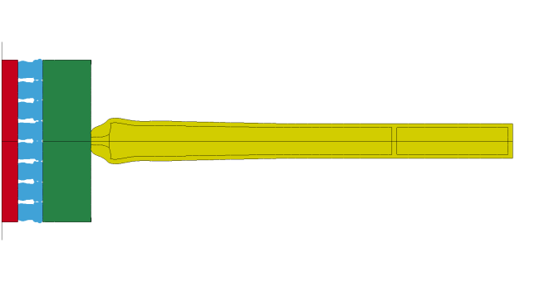 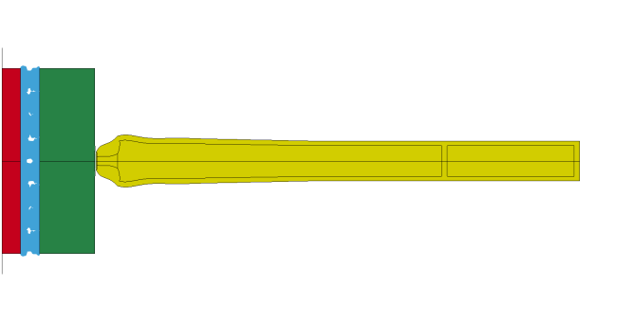

Figure : Deformation of crash-box system and projectile during impact (Step 5).

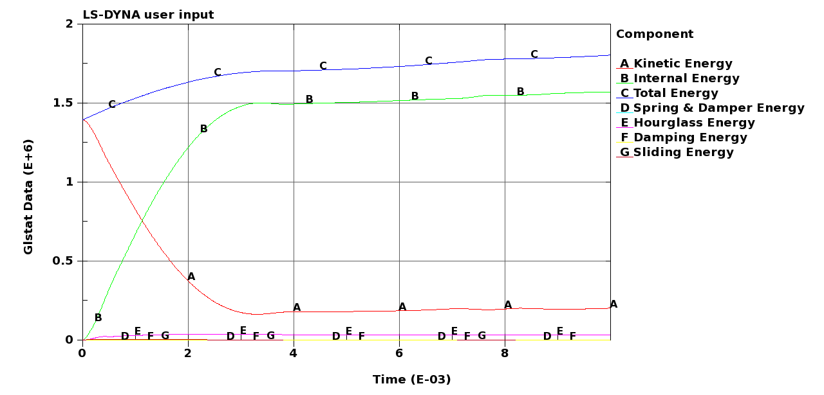

Figure : Global energies in the system during impact (Step 5) – quarter model.

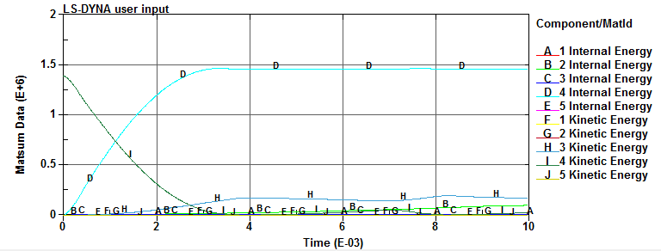

Figure : Energies in the various parts during impact (Step 5) – quarter model.

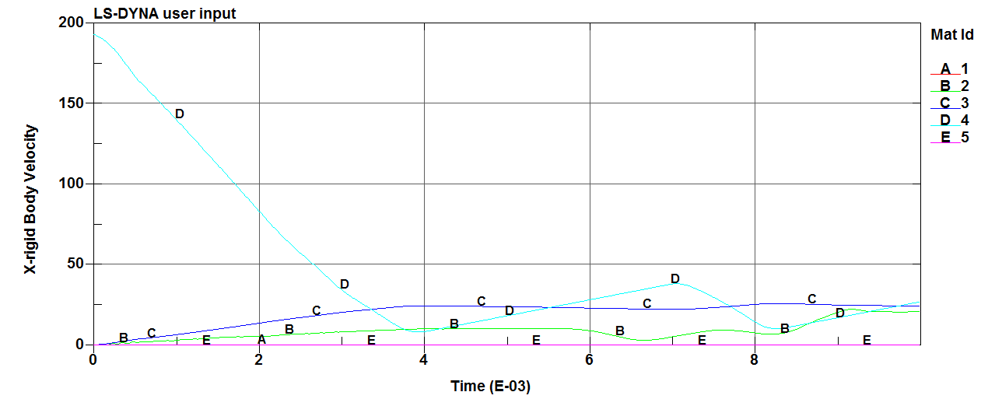

Figure : Velocity-time curves for the different parts during impact (Step 5).

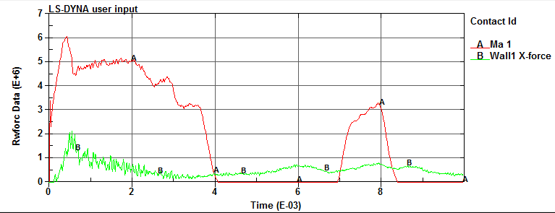

Figure : Force-time curves between the projectile and the front steel plate (curve A) and the crash-box system and the concrete wall (curve B) during impact (Step 5) – quarter model.

In the same way as for Step 4, the most interesting plots from this simulation are the force-time curves between the projectile and the front steel plate (curve A) and the crash-box system and the concrete wall (curve B) during impact (see Figure 69). Since the crash-boxes now are properly activated, they absorb and distribut the kinetic energy from the projectile to the concrete wall in a controlled way. Thus, curve B is considerably lower than curve A, the initial peak in the load curve is reduced, the maximum load to the concrete wall is about 8000 kN, and the average crush force is less than 3000 kN. The force-time curve is therefore almost ideal. However, there are still two problems with the design. Firstly, the maximum load is above the design load for the concrete wall, even though this is only for a short period of time. Secondly, the crash-boxes are fully compressed and not able to absorb all the kinetic energy in the system (see Figure 68).

In an attempt to absorb all the energy, the length of the crash-boxes was increased from 300 mm to 500 mm in step 6, and a new simulation was run. Due to the increased crush length, the computational time was also increased. The main results from this simulation are shown in Figure 70. As for case 5, the mean crush force is well below the capacity of the concrete wall, but the initial peak force is somewhat increased. The main reason for this is that the long crash-boxes became unstable during the buckling phase. Thus, they deformed globally instead of showing progressive collapse as the shorter crash-boxes. This is shown in Figure 71.

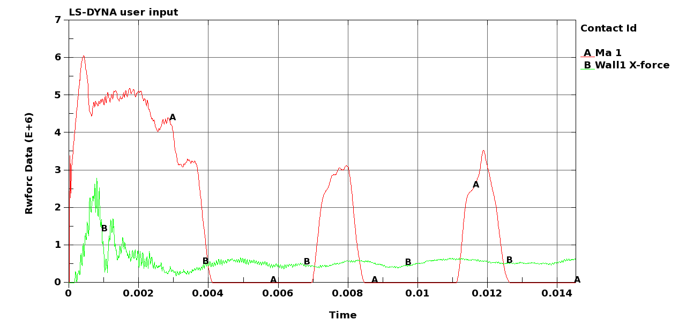

Figure : Force-time curves between the projectile and the front steel plate (curve A) and the crash-box system and the concrete wall (curve B) during impact (Step 6) – quarter model.

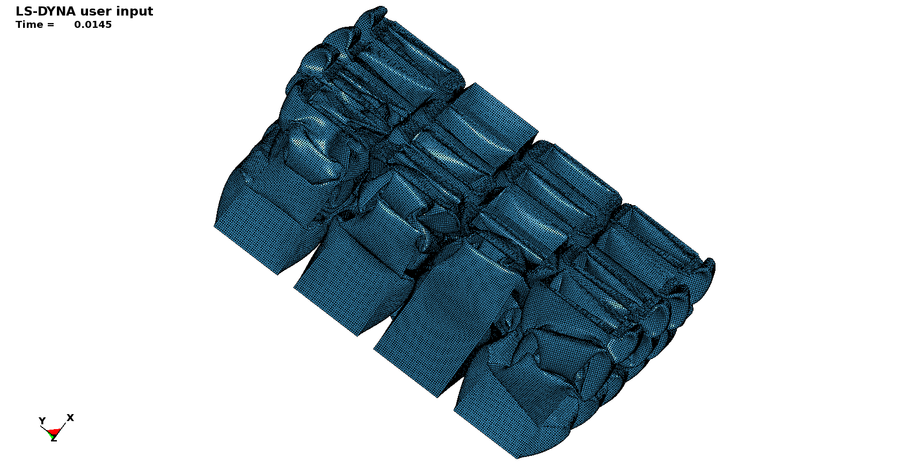

Figure : Final deformation of the crash-boxes after impact (Step 6).

To avoid global deformation of the crash-boxes, the length was reduced from 500 mm to 400 mm in Step 7. Also, in an attempt to reduce the initial peak force on the concrete wall seen both in Step 5 (Figure 69) and Step 6 (Figure 70), the number of crash-boxes was reduced to7×7 = 49. Since it is more difficult to exploit symmetry using 49 crash-boxes, a new numerical model of the whole system was generated. A plot of the numerical model is shown in Figure 72. The model consisted of 1 254 401 shell elements and 3 638 672 solid elements (i.e. a total of nearly 5 million elements), and a typical simulation took 22 CPU-hours running on eight 3 GHz Intel Pentium 4 processors (i.e. a total of 176 CPU-hours). The material input in the model is the same as in Step 5 and 6. The deformation of the crash-box system and the projectile during impact is shown in Figure 73, while Figure 74 - Figure 77 give additional data from the simulation.

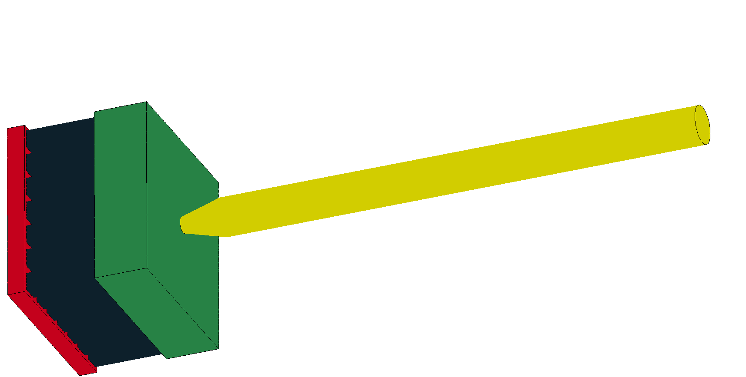

Figure : Numerical model used in Step 7 (49 crash-boxes of 400 mm length).



Figure : Deformation of crash-box system and projectile during impact (Step 7).

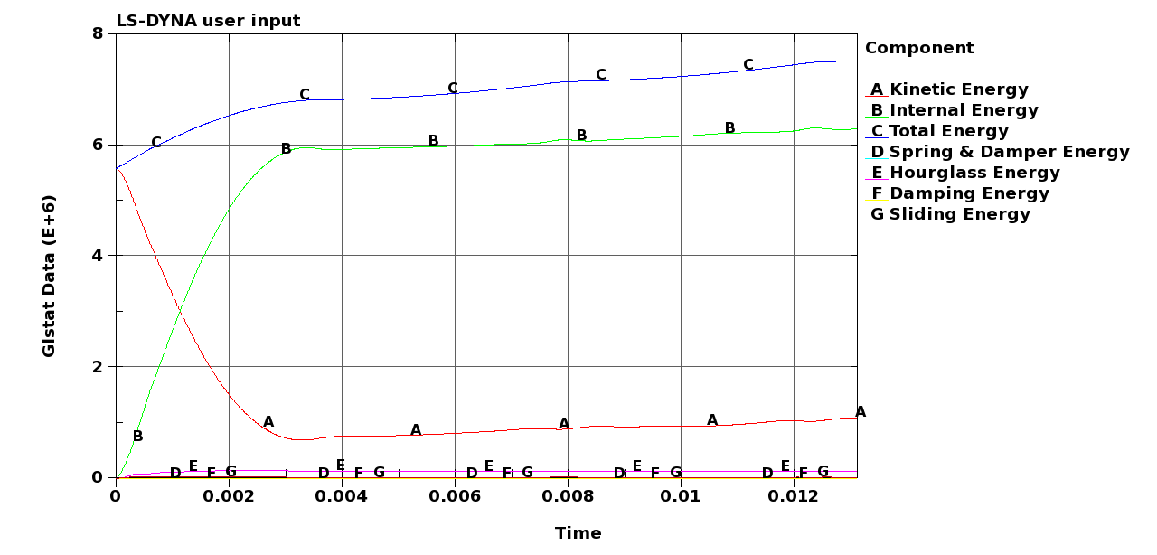

Figure : Global energies in the system during impact (Step 7).

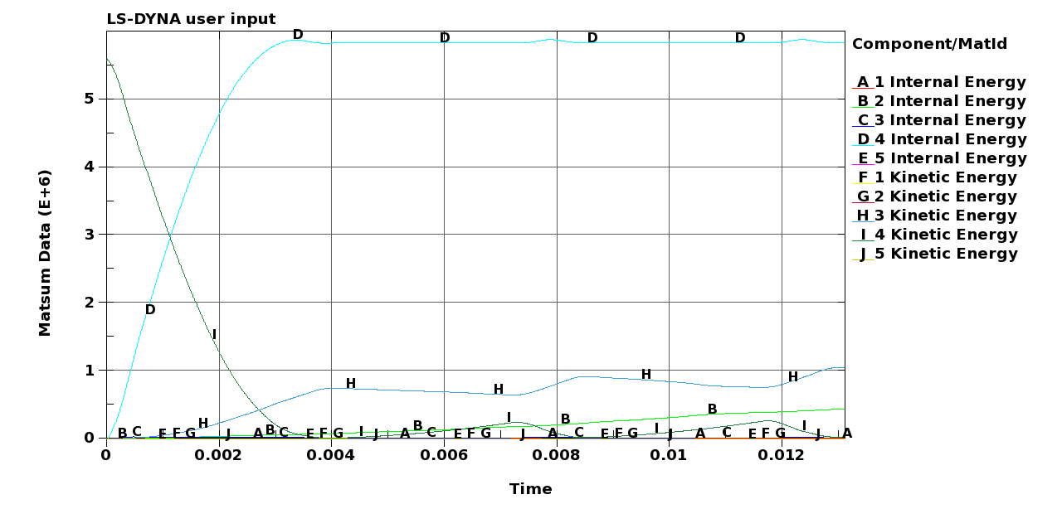

Figure : Energies in the various parts during impact (Step 7).

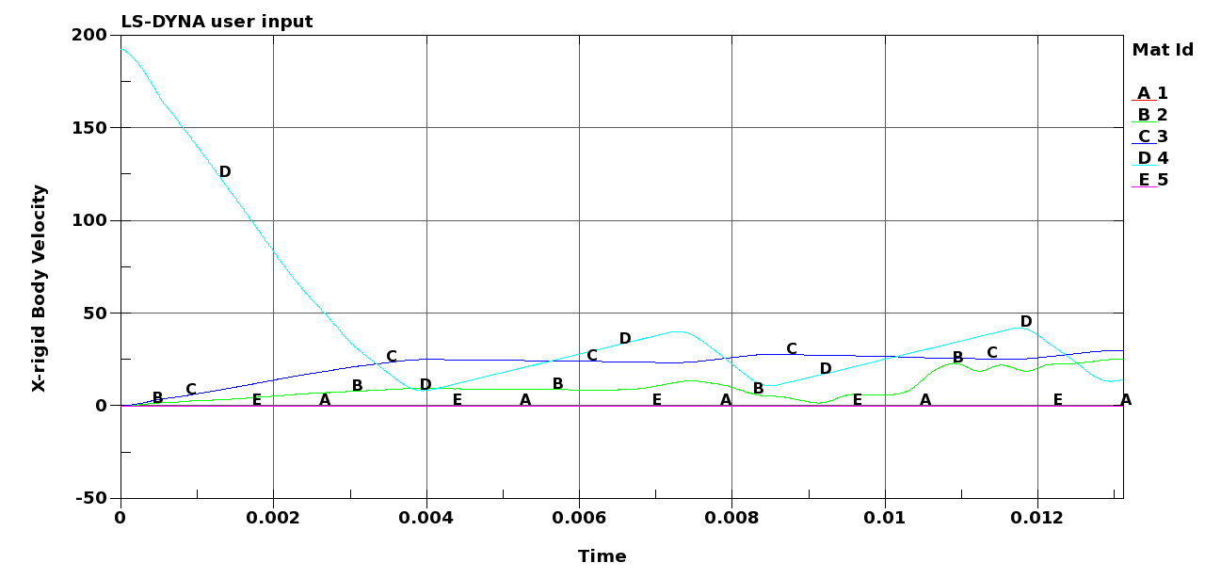

Figure : Velocity-time curves for the different parts during impact (Step 7).

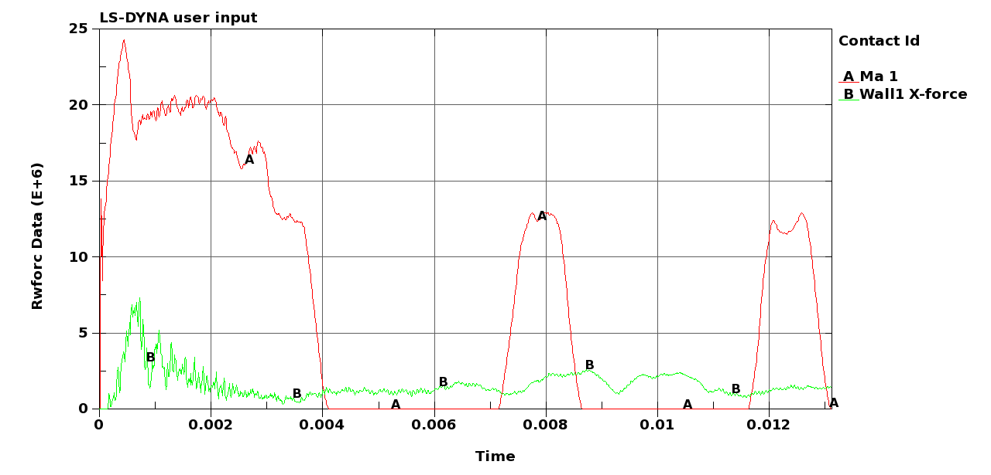

Figure : Force-time curves between the projectile and the front steel plate (curve A) and the crash-box system and the concrete wall (curve B) during impact (Step 7).

As for previous simulations, Figure 77 gives the most interesting results. Note that since the whole system is modelled (i.e. no symmetry planes), the energies should not be multiplied by 4 in this plot. The initial peak force against the concrete wall is about 7000 kN, but this period of time is so short that it is assumed to be of minor importance. It is also believed that by introducing a proper trigger in the crash-boxes (instead of the one used in these simulations, see ) the peak force will be further reduced. A more appropriate trigger can be introduced by deforming the profiles a few millimetres in a hydraulic testing machine prior to installation in the crash-box system. Such a pre-compression will introduce the natural deformation modes of the profiles, and the initial peak force is expected to drop significantly. A well-defined mechanical or thermal trigger can also be used. It is possible to include more advanced triggers in these simulations, but this will cause much additional work outside the scope of the project. After the initial peak the mean crush force drops to less than 3000 kN, and the energy absorption seems to be ideal.

However, the piston-projectile effect (see curve A in Figure 77) still causes problems. The continuous impacts between the projectile and the front plate induce energy in the system (see curve C in or curve H in ). The crash-boxes absorb energy until they bottom out (i.e. descend to the lowest point possible). Afterwards the force must increase, because the crash-boxes are fully compressed, and the rest of the energy must be taken by the concrete wall. The bottoming out of the crash-boxes is illustrated in Figure 73. The problem is further illustrated in Figure 78, showing velocity-time curves for some nodes both in the projectile and the front plate during impact. Initially, the velocity of the projectile drops and changes sign (rebounds), while the front plate velocity increases. Due to the piston-projectile effect, the projectile is forced back, the velocity changes sign again, and contact between the bodies are re-established. The new impact gives a velocity increase to the front plate. This continues throughout the simulation as long as damping is not applied, and the impacts are almost elastic (i.e. no energy dissipation). This effect may be damped out in the real problem (as previously discussed). It should be kept in mind that the loading in these simulations is a worst-case load scenario (see ) and that the quasi-static pressure behind the projectile is constant (this load must drop as the volume is increased when the projectile moves through the test pipe – ). The latter is further discussed in Chapter 9.

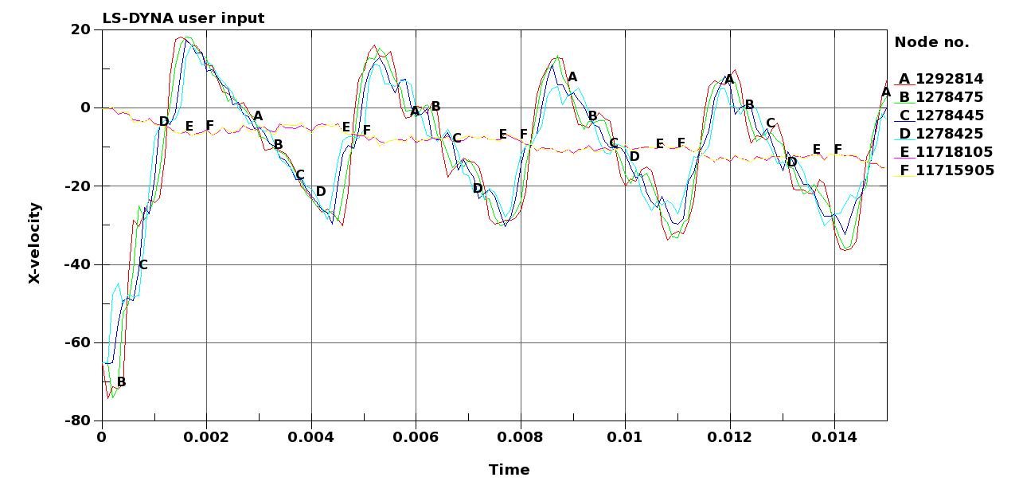

Figure : Velocity-time curves for some nodes in the projectile (curve A, B, C and D) and some nodes in the front plate (curve E and F).

To confirm that the system is able to absorb the applied load when the piston-projectile effect is omitted without damaging the concrete wall, a new simulation was run in Step 8. In this simulation the numerical model was exactly similar to the one used in Step 7 (see Figure 72), but the piston-projectile effect was removed and the termination time was increased.

The deformation of the crash-box system and the projectile during impact is shown in Figure 79. As in step 7, the crash-boxes are fully compressed, but since the piston-projectile effect is omitted, the projectile rebounds after impact. Further, Figure 80 and Figure 81 show that the energies are absorbed, while Figure 82 shows that the velocities of the various parts become zero. However, due to the bottoming out of the crash-boxes, the force towards the concrete wall increases and reach about 6000 kN (i.e. slightly above the design load) in the final stage of the impact (see Curve A in Figure 83) before it falls down to zero. Thus, the system absorbs the applied loading barely, but there is no rest capacity after this impact.



Figure : Deformation of crash-box system and projectile during impact (Step 8).

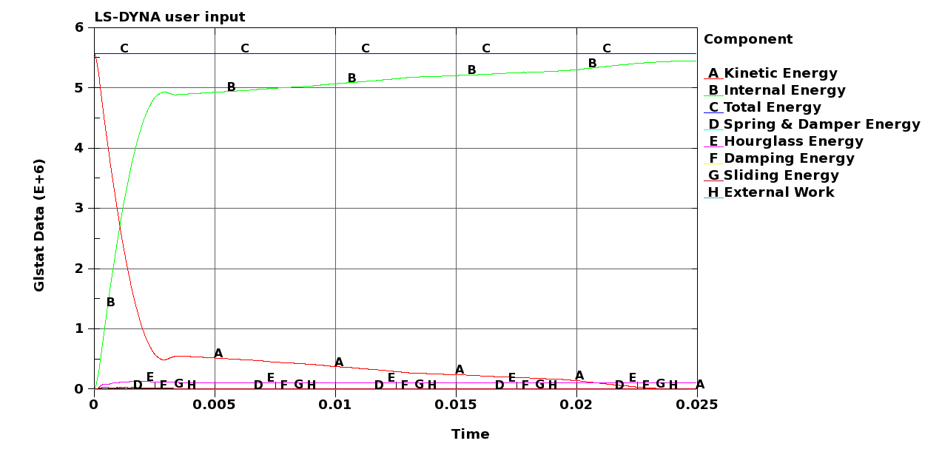

Figure : Global energies in the system during impact (Step 8).

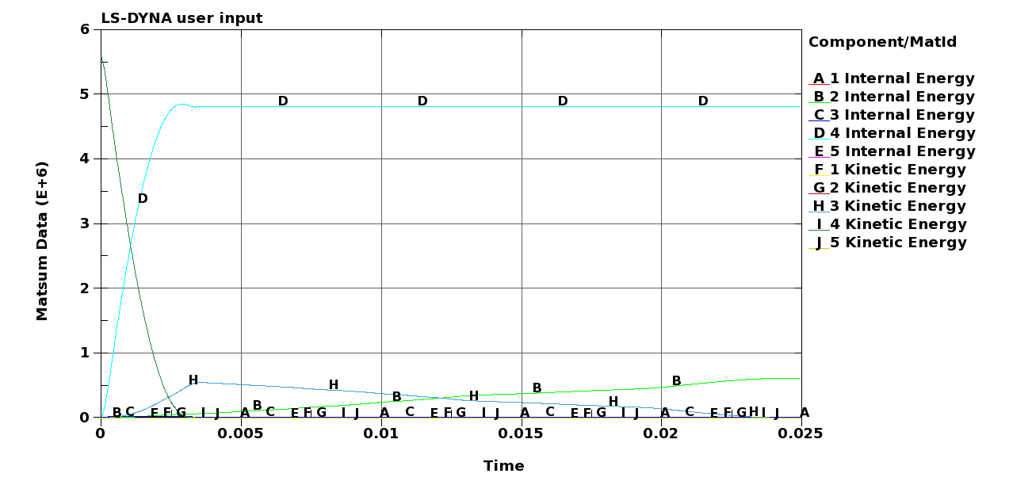

Figure : Energies in the various parts during impact (Step 8).

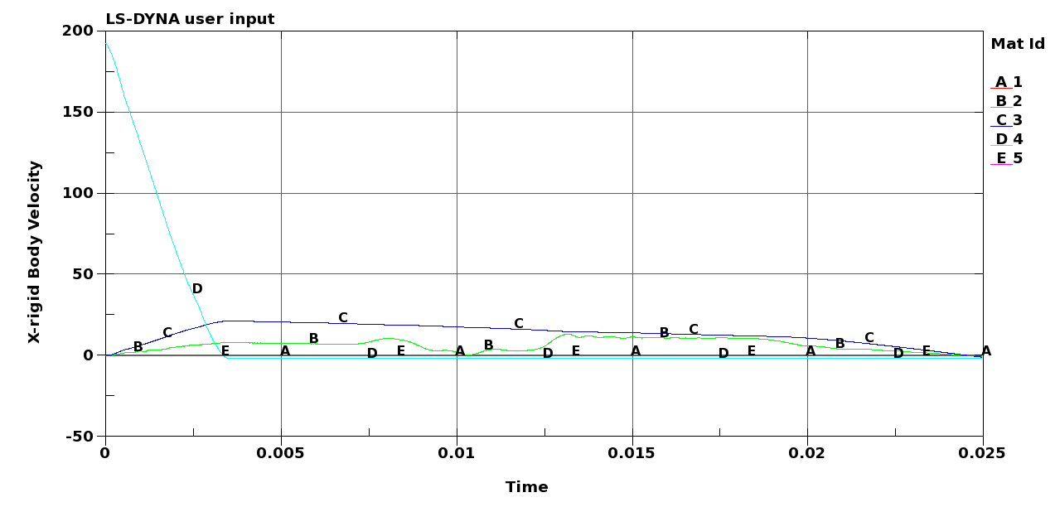

Figure : Velocity-time curves for the different parts during impact (Step 8).

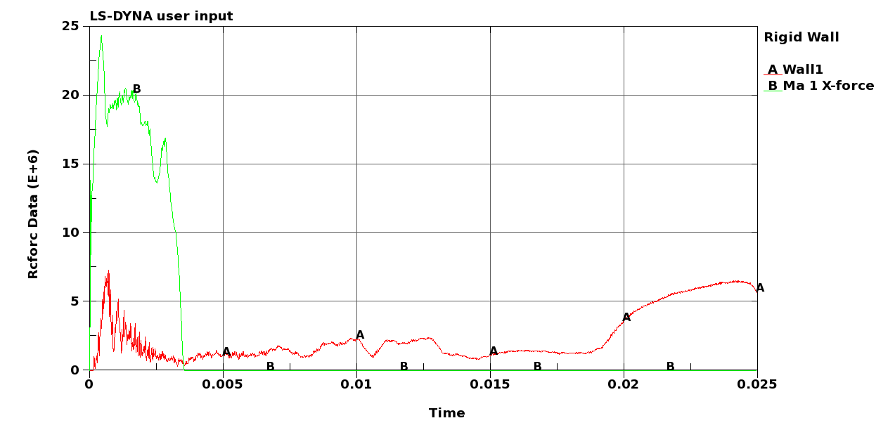

Figure : Force-time curves between the projectile and the front steel plate (curve A) and the crash-box system and the concrete wall (curve B) during impact (Step 8).

A final check (Step 9) was carried out to confirm that the crash-boxes triggered properly if the loading is reduced. Here, the kinetic energy from case-initiell in was used together with the static pressure of 3000 kN from the piston-projectile effect (i.e. a large reduction in loading compared to the worst-case scenario). The crash-boxes after these simulations are shown in Figure 84, while Figure 85 - Figure 87 give some additional data. Figure 88 shows the energy transformed to the concrete wall at these loadings. As seen, the crash-boxes have triggered as expected, the peak load is about the same as in Step 8, and the average crush force to the concrete wall is well below the design load of 6000 kN. Thus, it seems safe to state that the crash-box system also will work for lower loadings than the worst-case scenario used in the design of the system. In fact, the crash-boxes are designed to have a crush force of approximately  (see Chapter and ). If they do not trigger, the loading could not have been above this value, indicating that the design load of 6000 kN for the concrete wall will not be violated. However, due to the constant projectile-piston effect, the crash-boxes will continue to deform until they bottom up, but this is unrealistic.



Figure : Deformation of crash-box system and projectile during impact (Step 9).

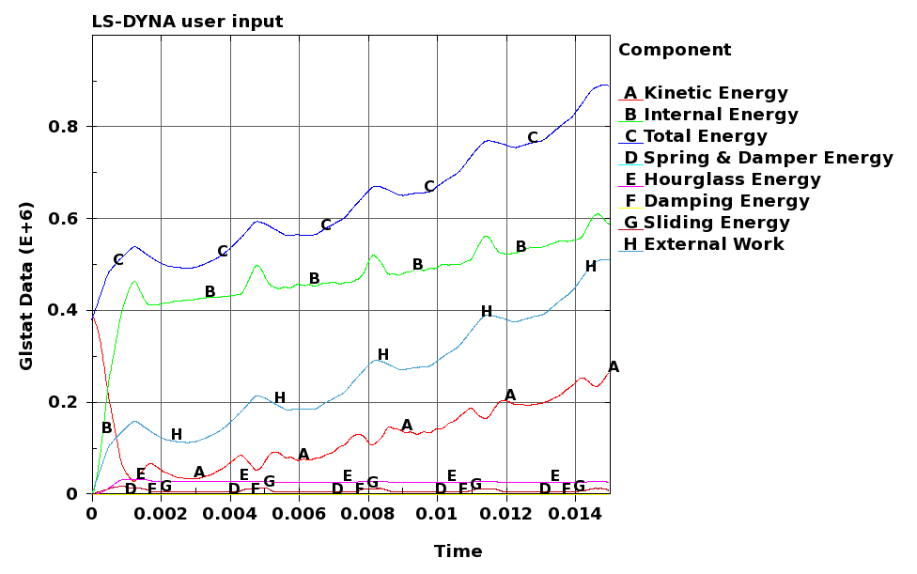

Figure : Global energies in the system during impact (Step 9).

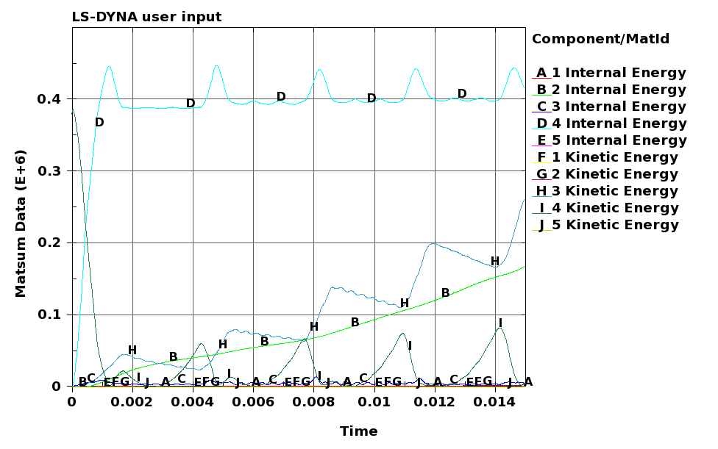

Figure : Energies in the various parts during impact (Step 9).

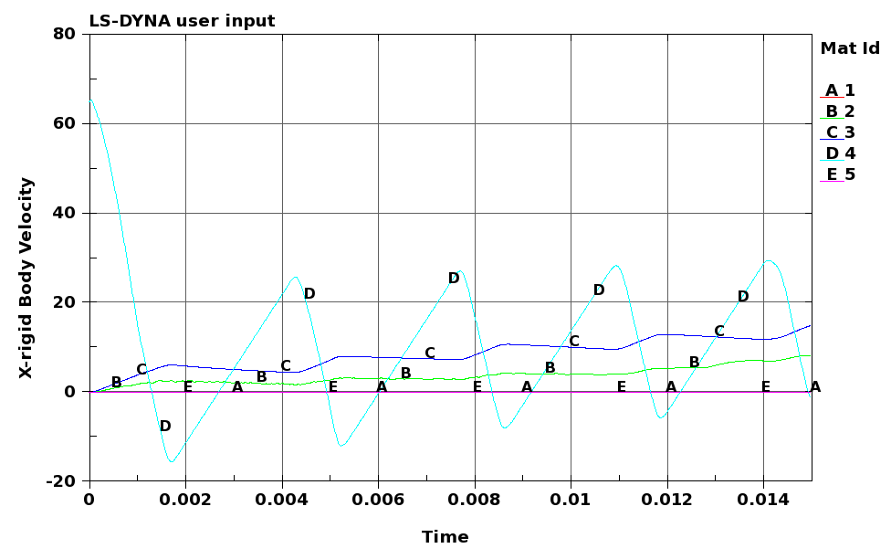

Figure : Velocity-time curves for the different parts during impact (Step 9).

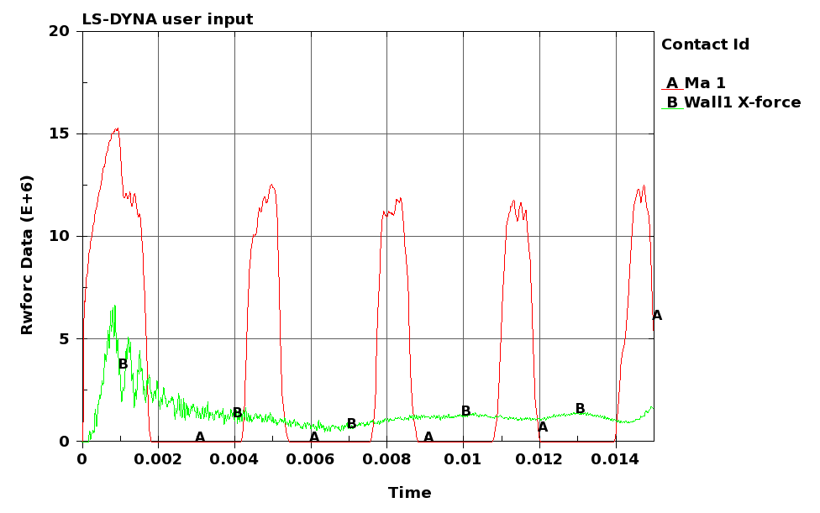

Figure : Force-time curves between the projectile and the front steel plate (curve A) and the crash-box system and the concrete wall (curve B) during impact (Step 9).

# Discussion

From previous Chapters we have seen that to absorb the energy from the impacting projectile the following principles must be fulfilled in the design;

1. To lower the kinetic energy of the impacting projectile, it is important to use a thick and heavy steel front plate in the crash-box system. Such a thick steel plate will also prevent perforation and maximise the plastic deformation in the projectile. In this study, a 300 mm thick high-strength steel front plate (consisting of Hardox 450 plates mounted together) was chosen. However, momentum is conserved during impact and this must in any case be absorbed by the crash-boxes.
2. The main purpose of the crash-boxes is to distribute the energy from the impact in a controlled way to the supporting concrete pit, simultaneously as the energy is absorbed by plastic dissipation in the crash-boxes. Here, the concrete wall behind the crash-box system was designed to carry a quasi-static loading of maximum 6000 kN.
3. In the initial stage of impact, a peak appears in the transmitted force-time curve. This peak, which may be higher than the design load and thus cause damage to the concrete wall, vanish when the buckling load is reached and the crash-boxes start to absorb energy by progressive buckling. The initial peak force may be reduced by introducing a proper trigger, by reducing the strength of the crash-boxes or by reducing the number of crash-boxes in the system.
4. A rather simple geometrical trigger is used in the bulk of the simulations. This trigger is known to introduce the natural buckling modes of the profile, but a more well-defined mechanical trigger may have given better results. This has not been studied in detail in this project.
5. After a number of simulations, it was decided to use aluminium crash-boxes instead of steel crash-boxes. The main reason for this was that the proposed steel tubes were too strong, transmitting too much force to the concrete wall. However, to compensate for the reduced energy absorption in the crash-boxes, the length of the profiles was somewhat increased. Note that these should not be too long to prevent global buckling in the profiles using a geometrical trigger. Thus, there is a clear interaction between peak force, profile length, profile strength, number of profiles and energy absorption. It is possible to further optimise the energy absorption in the crash-boxes using computer-aided design, but this is time consuming. Here, it was finally decided to use 49 crash-boxes in AA6060-T6 with ,  and  to absorb the kinetic energy.
6. In addition to the kinetic energy of the free-flying projectile, a piston-projectile effect may be present if the gaskets in the test cell are intact during impact. This effect was stated to give an additional quasi-static pressure of 3000 kN acting on the rear side of the projectile throughout the impact process. According to IRIS, it is difficult to get rid of this pressure if an accident occurs by use of venting, etc.
7. The piston-projectile effect causes problems. Since the simulations are carried out without damping, elastic impacts between the projectile and the front plate continuous until the simulation terminates. These impacts induce energy in the system, and the crash-boxes will deform until they bottom out. When this occurs, the force level increases and the rest of the energy must be absorbed by the concrete wall. It is difficult to get rid of the piston-projectile effect in the numerical simulations without introducing artificial damping.
8. A numerical simulation confirmed that the proposed crash-box system without the piston-projectile effect was able to absorb the loading, but the crash-boxes could have been slightly longer in order to have some rest capacity.

Since the piston-projectile effect causes problems in the numerical simulations, it requires some additional considerations. The problem is illustrated in and discussed in Chapter 5, while a sketch is given in Figure 89. The initial volume behind the projectile is  litres, and this volume is compressed to  bars [3]. If the gripping devise fails for some reason under this static pressure, the projectile will be launched towards the crash-box system. After an acceleration of about 7.2 m, the projectile impacts the crash-box system. The final volume behind the projectile is now  litres. Note that this is a conservative estimate since the volume will continue to increase as the crash-boxes deform. If we now assume that the gaskets are intact during impact and that the expansion of the gas takes place under adiabatic conditions (i.e. no heat exchange with the surroundings), the ideal gas law and the first law of thermodynamics can be used to show that



where  is the pressure,  is the volume and  is the ratio of specific heats. For



Figure : Sketch of projectile-piston problem [3].

nitrogen () . By use of Eq. , the pressure after adiabatic expansion is found as



This gives a (conservative) “quasi-static” force behind the projectile of



Let us now assume that all work done by the gas during the expansion process is used to accelerate the projectile. Under the constraint of adiabatic conditions, i.e. , the work integral becomes



which gives



The velocity of the projectile at impact is found as



This impact velocity is slightly lower than the impact velocity given in the requirements (see ). Thus, both the impact velocity and the quasi-static load used in previous simulations should be regarded as conservative.

These rather simple calculations proof one important thing, namely that it is impossible to have a quasi-static loading of 3000 kN simultaneously as an impact velocity of 193 m/s under the present impact conditions. Such a load combination is unphysical and will give far too conservative results. Based on Eqs. - it is possible to establish pressure-volume and velocity-load curves. Figure 90 (left) shows the pressure drop versus volume increase as the projectile moves down the test pipe, while Figure 90 (right) gives the corresponding projectile velocity versus quasi-static loading on the rear side of the projectile. As seen, if a high impact velocity is requested, the quasi-static loading must be low. The velocity drops significantly as the quasi-static load is increased, and to have a quasi-static loading of 3000 kN, the impact velocity must be zero.



Figure : Pressure-volume (left) and projectile velocity – quasi-static loading (right) curves for the piston-projectile problem.

# Final validation

In this Chapter a final numerical validation of the crash-box system is carried out taking several of the effects discussed above into account. Step 7 in Chapter 8 was used as a starting point, but then the following modifications were done:

1. The high-quality Hardox 450 steel plates in the front plate (except for the two first plates) and the back plate were replaced by cheaper steel plates. Several different steels may be used. Typical examples are Weldox 500E (NOK 11,70/kg), S355 (NOK 8,50/kg) or NVA (NOK 7,80/kg). Note that the prices are approximate values from Norsk Stål AS. It was chosen to use NVA32 plates with yield stress of 315 MPa. Since no material data are readily available for this particular alloy, we decided to use material data for Weldox 500E [11] with only the yield stress adjusted to NVA32.
2. The length of the AA6060-T6 crash-boxes was increased to 500 mm. To avoid global buckling, a mechanical trigger was included (see Appendix C for details). This trigger may not be optimal, but assumed sufficient to avoid global buckling and to secure progressive collapse of the profiles.
3. The impact velocity of the projectile was chosen equal to 193 m/s, while the quasi-static loading was reduced to 216 kN (see Chapter 9).

Except from these modifications, the numerical model was identical to Step 7 in Chapter 8. The numerical model used in the final validation step is shown in Figure 91. In this model some of the Hardox 450 steel plates in the crash-box system are replaced by cheaper NVA32 plates, the quasi-static pressure behind the projectile is reduced to 216 kN and the crash-boxes are made longer (500 mm) with a mechanical trigger (see Figure 92). The wedge-shaped dents were only placed on two of the sides (to avoid corner effects), and they had a depth of 5 mm. The numerical model consisted of 3638672 solid elements and 1568001 shell elements, and a typical simulation took more than 1200 CPU-hours. The deformation of the crash-box system during impact is shown in Figure 93. The projectile first impacts the front plate, before it rebounds. Since the static force behind the projectile now is considerably lowered compared to previous simulations (see e.g. step 7), it takes much longer time before the projectile is forced back so that the second impact can occur. The amount of energy in this impact is also much lower than in previous simulations. Thus, the crash-boxes are able to absorb the energy of the projectile. The deformation of the crash-boxes after impact is shown in Figure 94.



Figure : Numerical model used in the final validation step.

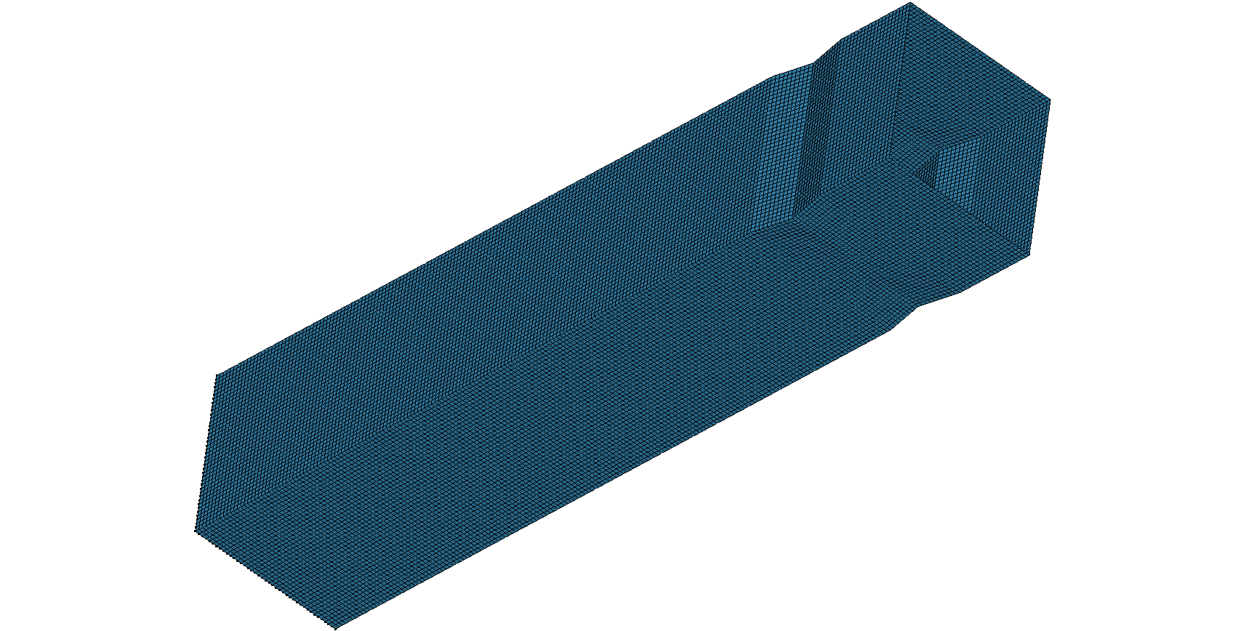

Figure : 500 mm long crash-box with mechanical trigger used in the final validation step.



Figure : Deformation of crash-box system and projectile during impact (validation step).

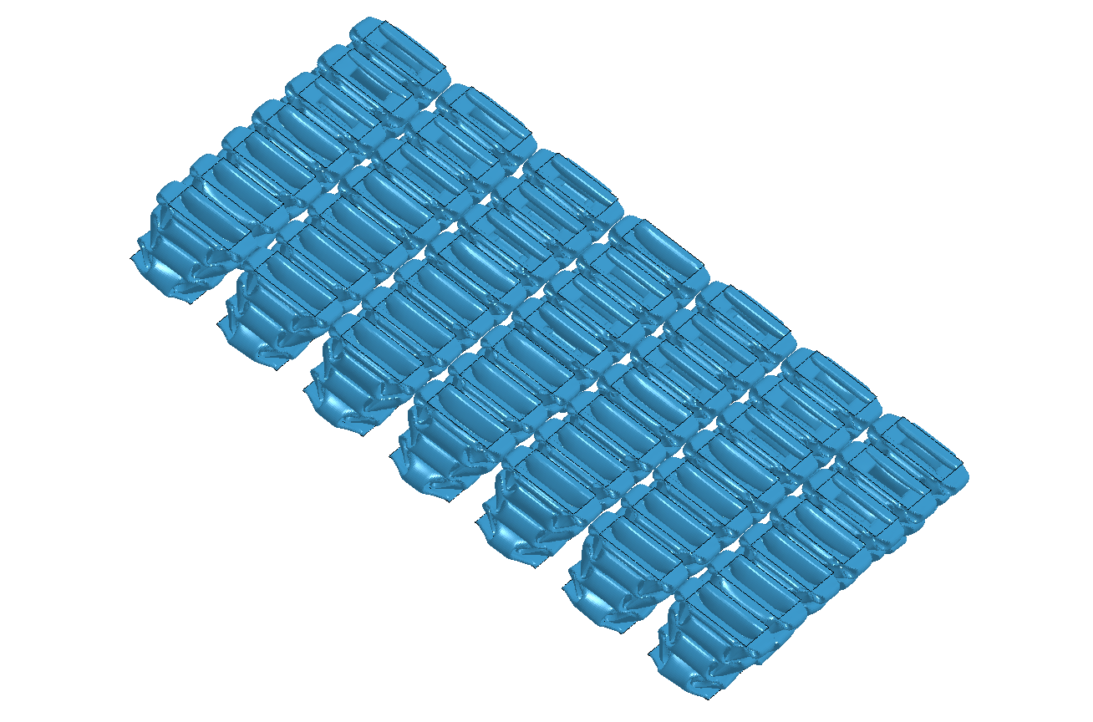

Figure : Final deformation of the crash-boxes after impact (validation step)

That the energy during impact is converged is further illustrated in Figure 95 - Figure 98, giving some additional data from the simulation. Especially Figure 98, showing the force-time curves from the impact, is of interest. It shows that due to the proposed trigger, long profiles and reduced static pressure behind the projectile, the force to the concrete wall is always below the design load of 6000 kN. Also after the second impact caused by the static pressure behind the projectile, the peak in the load curve is well below the design load. Thus, based on these finite element simulations it seems like the proposed crash-box system is able to absorb the kinetic energy simultaneously as the force is distributed to the concrete wall in a controlled way. This is further confirmed in Figure 99 that shows the velocity-time curves for some nodes in the projectile and target from this simulation (corresponding to Figure 78 from step 7). Now the new impacts are not strong enough to increase the velocity of the front plate, and this velocity goes towards zero. Thus, the kinetic energy from the front plate is absorbed in the numerical simulation.

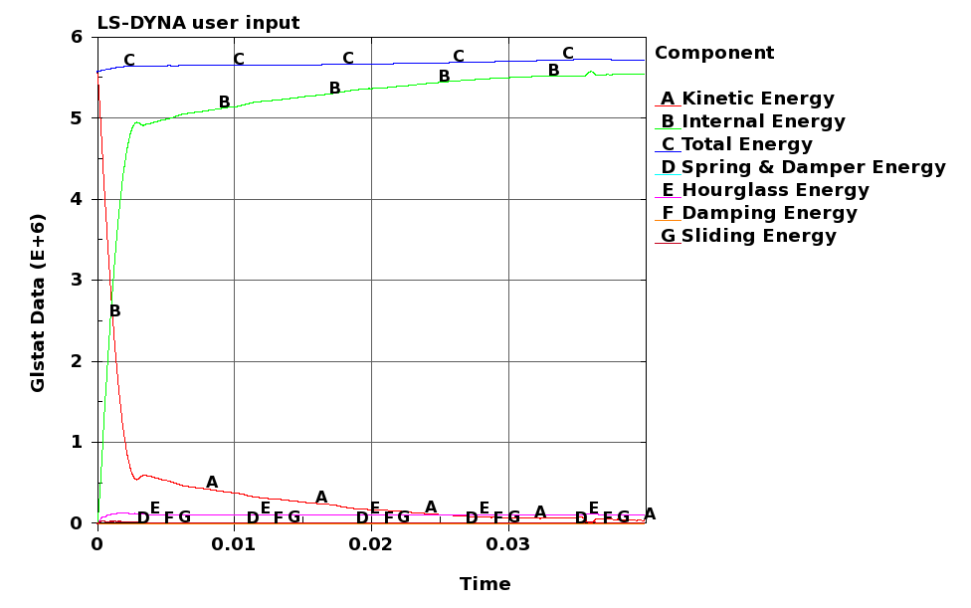

Figure : Global energies in the system during impact (validation step).

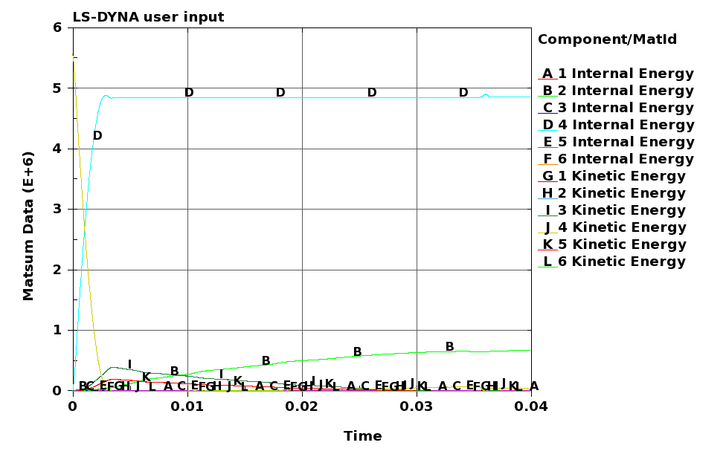

Figure : Energies in the various parts during impact (validation step).

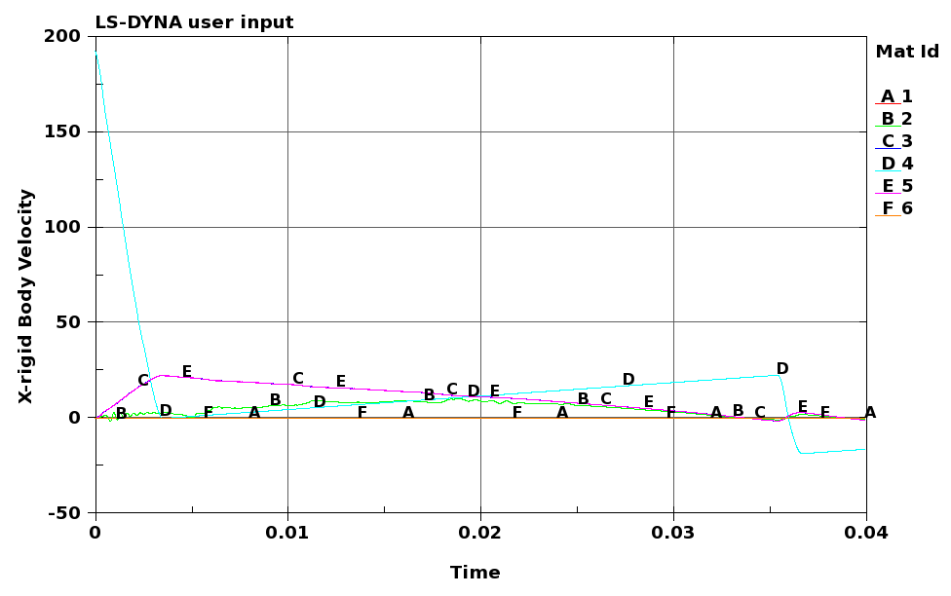

Figure : Velocity-time curves for the different parts during impact (validation step).

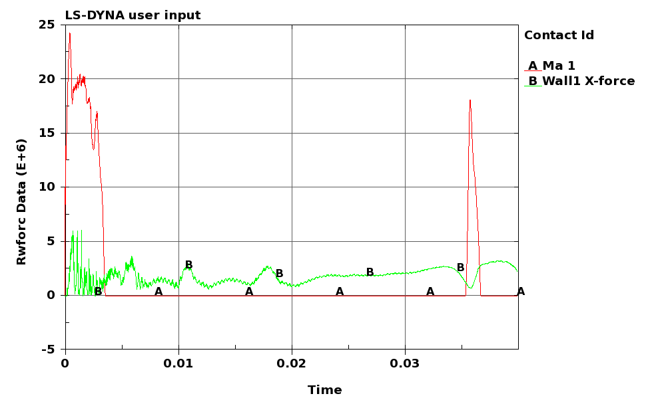

Figure : Force-time curves between the projectile and the front steel plate (curve A) and the crash-box system and the concrete wall (curve B) during impact (validation step).

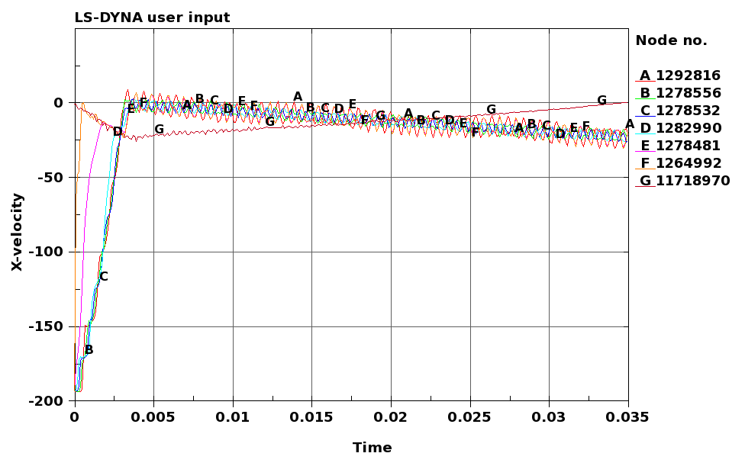

Figure : Velocity-time curves for some nodes in the projectile (curve A - F) and a node in the front plate (curve G).

# Final design

Based on the analytical calculations and the numerical simulations presented in previous Chapters, a final design of the crash-box system has been proposed. The system is shown in Figure 100, while an exploded view showing all the details is given in Figure 101. The final design consists of a 100 mm thick back plate (item 1 in Figure 101) with side-lengths of 1 m in Hardox 450 or similar. A 25 mm thick base steel plate (item 2) is fixed to the back plate and supported by two columns (item 4). This steel plate acts as support for the crash-boxes



Figure : Final design of crash-box system.

** **

7

6

5

4

3

2

1

Figure : Details of the proposed crash-box system.

and the front plates. Two flat bar steels (item 3) mounted along the length of the base are used as guidance for the crash-boxes and the front plates. The 49 crash-boxes in aluminium alloy AA6060-T6 with  mm, mm and mm (item 5) are then placed on the support. A wedge-shaped mechanical trigger (see Figure 92) should be deployed for the crash-boxes to secure progressive buckling of the rather long profiles and to reduce the initial peak force. To keep the crash-boxes in position, two stamped aluminium plates ( mm) have been made to match the profiles (item 6). The six 50 mm thick steel plates in Hardox 450 or similar are finally inserted (item 7). To keep everything together, 4 through bolts are fixed to the threads in the back plate (not shown). In appendix B, two offers from Smith Stål in Trondheim are given regarding the costs for the steel plates used in the crash-box system.

# Concluding remarks

Due to malfunction in the gripping system of an expandable downhole offshore tool exposed to high pressures, an accident occurred during prototype testing in one of the test cells at IRIS in October 2009. As a consequence of this malfunction, a high-strength steel pipe with a total mass of 180 kg was launched out of the test cell at an initial impact velocity of 65 m/s. This projectile eventually impacted and perforated the exterior concrete wall of the test lab. Based on this accident IRIS defined some load cases that are typical during HPHT testing. The worst-case scenario was identified to be a projectile of mass 300 kg and length 2.75 m being launched at an initial velocity of 193 m/s. To prevent similar accidents to take place in the future, the task has been to design a barrier capable of absorbing the impact energy in case of a new accident.

Motivated by the automotive industry, the basic idea has been to design a crash-box system capable of absorbing the kinetic energy from the impacting pipe and to distribute the load in a controlled way to the rear-side wall in a free floating concrete pit. Based on a combination of scaled impact tests, analytical considerations and non-linear finite element simulations, a possible design of a crash-box system has been proposed.

The scaled impact tests proved that if the front plate is strong enough, most of the kinetic energy will be absorbed as plastic deformation in the projectile, and that perforation will not take place. Finite element simulations of the corresponding tests confirmed that the numerical models are able to predict the main physical mechanisms observed experimentally during impact, and that we can base our design of the real system on suchlike simulations. However, in the real situation it will be impossible to fix the target plate as in the numerical simulation, and the kinetic energy of the projectile must be absorbed by a crash-box system that is able to absorb and distribute the kinetic energy in a controlled way.

The analytical considerations showed that it is possible to design a crash-box system based on simple theoretical models using several steel or aluminium profiles as energy absorbers. To lower the kinetic energy of the impacting projectile, it was found important to use a thick and heavy steel plate in front of the crash-boxes. The remaining energy is supposed to be absorbed by progressive buckling of the crash-boxes (calculated as an average crush force). Based on EC2, a simplified static design of the concrete wall behind the crash-box system was also given. The concrete wall was designed to carry a quasi-static loading of maximum 6000 kN.

However, to fully take the complexity of the problem into account, we have to turn our attention towards full-scale non-linear finite element simulations. In this study, all simulations were carried out using 3D FE models and the explicit solver of the finite element code LS-DYNA was used. Firstly, the behaviour of a single profile was studied to confirm that the kinetic energy could be absorbed during impact in the present velocity regime. The results from this simulation were compared to the analytical calculations, and the agreement was in general very good. This validated both the analytical models and the numerical simulations. Secondly, a large number of numerical simulations on single profiles (using two different crash-box materials, namely DP800 steel and AA6060-T6 aluminium) were conducted in a parametric study. These simulations showed that the crash-box details are crucial in order to have an efficient and optimal energy absorber. Then, the whole system was modelled using 64 crash-boxes, confirming that the crash-box system behaved as expected. It was however found that crash-boxes made of DP800 steel were too strong and stiff, transferring too much force to the concrete wall. It was thus decided to replace the steel crash-boxes with weaker ones. After some tuning, it was finally decided to use 49 crash-boxes in aluminium alloy AA6060-T6. In all these studies, a rather simple geometrical trigger of the crash-box was used. Due to this, the length of the crash-box was limited to 400 mm to avoid global buckling, so the system was barely able to absorb the energy. It was also shown that the crash-box system will work as expected for lower loadings than the worst-case scenario, as long as the force is above the trigger load of approximately 3000 kN.

A lot of attention was spent on the piston-projectile effect. This effect is stated to give an additional quasi-static pressure of 3000 kN acting on the rear side of the projectile throughout the impact process if the gaskets are intact. However, a theoretical/analytical study showed that this additional loading is far too conservative and directly unphysical, since there is a direct relation between projectile impact velocity and the gas pressure acting on the projectile during impact. Thus, the piston-projectile effect which have caused a lot of problems in the un-damped numerical simulations, are in fact not that critical.

A final validation simulation was carried out using 500 mm long profiles with a wedge-shaped mechanical trigger and a reduced quasi-static pressure, to confirm that the energy during impact could be absorbed. It was found that the force-time curve from this simulation is almost ideal with a very low initial peak force, and always below the design load for the concrete wall in the pit. Based on this a final and numerically validated design was proposed. However, it should be kept in mind that the crash-box system is solely based on computer aided design, and that experimental validation of the numerical design is lacking.

# References

1. Dey, S. *Barrierevurdering*, Forsvarsbygg Futura Report 120/2010 (restricted), pp. 42, April, 2010.
2. Service Order from Futura to IRIS. Dated 2011-01-07, marked P7709113/JaaR.
3. Working package “Barrierevurdering” from IRIS to Futura. Dated 2009-12-08, Phase I.
4. Børvik T, Langseth M. *An investigation of the scaling laws for metal plates penetrated by projectiles*, Forsvarets bygningstjeneste, Fortifikatorisk Notat Nr. 237/96, August, 1996.
5. Børvik T, Hopperstad OS, Langseth M, Malo KA. Effect of target thickness in blunt projectile penetration of Weldox 460E steel plates. International Journal of Impact Engineering 2003;28:413-464.
6. Børvik T, Hopperstad OS, Berstad T, Langseth M. A computational model of viscoplasticity and ductile damage for impact and penetration. European Journal of Mechanics – A/Solids 2001;5:685-712.
7. LSTC. LS-DYNA Keyword User’s Manual, Version 971. Livermore Software Technology Corporation, California, 2007.
8. Dey S. High-strength steel plates subjected to projectile impact. Ph.D.-thesis 2004:38 (ISBN 82-471-6282-2). Department of Structural Engineering, Norwegian University of Science and Technology, Norway, 2004.
9. Dey S, Børvik T, Hopperstad OS, Langseth M. On the influence of fracture criterion in projectile impact of steel plates. Computational Materials Science 2006;38:176-191.
10. Kane A, Børvik T, Berstad T, Benallal A, Hopperstad OS. Failure criteria with unilateral conditions for simulation of plate perforation. Accepted for publication in European Journal of Mechanics – A/Solids, 2011.
11. Børvik T, Dey S, Clausen AH. [Perforation resistance of five different high-strength steel plates subjected to small-arms projectiles](http://www.sciencedirect.com/science?_ob=ArticleURL&_udi=B6V3K-4V4VY5D-3&_user=10&_coverDate=07%2F31%2F2009&_alid=1722252122&_rdoc=4&_fmt=high&_orig=search&_origin=search&_zone=rslt_list_item&_cdi=5733&_sort=r&_st=13&_docanchor=&view=c&_ct=18&_acct=C000050221&_version=1&_urlVersion=0&_userid=10&md5=125ec10f89186c8a04fa1aae05cf801f&searchtype=a). International Journal of Impact Engineering 2009;36:948-964.

1. <http://www.specialmetalswiggin.co.uk/products/incoloy-alloy-925> [cited 04072011].
2. Tarigopula V. Crashworthiness of dual-phase high-strength steel: Material and component behaviour. PhD-thesis, Dept of Structural Eng, Norwegian University of Science and Technology, 2007:230.
3. Langseth M, Hanssen A G. Lecture notes on Crashworthiness of aluminium structures. SIMLab, Dept of Structural Eng, Norwegian University of Science and Technology 2002; Report no R-18-02.
4. Reyes A G R. Oblique loading of aluminium crash components. PhD-thesis, Dept of Structural Eng, Norwegian University of Science and Technology, 2003:15.
5. Jensen Ø. Behaviour of aluminium extrusion subjected to axial loading. PhD-thesis, Dept of Structural Eng, Norwegian University of Science and Technology, 2005:7.
6. Jensen Ø, Langseth M, Hopperstad OS. Experimental investigations on the behaviour of short and long square aluminium tubes subjected to axial loading. Int J Impact Eng 2004; 30(8-9):973-1003.
7. Wierzbicki T, Abromowicz W. On the crushing mechanics of thin-walled structures. J Appl Mech 1983; 50(4A): 727-34.
8. Abromowicz W, Jones N. Dynamic axial crushing of square tubes. Int J Impact Eng 1984;2(2):179-208.
9. Abromowicz W, Jones N. Dynamic progressive buckling of circular and square tubes. Int J Impact Eng 1986;4(4):243-70.
10. Jones N. Structural impact. Cambridge: Cambridge University Press: 1989 [Paperback ed. 1997].
11. Langseth M, Hopperstad O S. Static and dynamic acial crushing of square thin-walled aluminium extrusions. Int J Impact Eng 1996;18(7-8):949-68.
12. Langseth M, Hanssen A G, Hopperstad O S. Static and dynamic crushing of square aluminium extrusions with aluminium foam filler. Int J Impact Eng 2000;24:347-83.
13. Reyes A, Langseth M, Hopperstad OS. Crashworthiness of aluminum extrusions subjected to oblique loading: experiments and numerical analyses. Int J Mech Sci 2002;44:1965-84.
14. Peixinho N, Jones N, Pinho A. Experimental and numerical study in axial crushing of thin walled sections made of high-strength steel. J Phys IV: JP 2003;110:717-22.
15. Schneider F, Jones N. Impact of thin-walled high-strength steel structural sections. Proc Inst Mech Eng, Part D. J Automobile Eng 2004;218(2):131-58.
16. Tarigopula V, Langseth M, Hopperstad O S, Clausen A H. Axial crushing of thin-walled high-strength steel section. Int J Impact Eng 2006;32:847-82.

# APPENDIX A

Table A1: Mean force () and total deformation () for some square tubes for different materials, geometries and velocities that are found in the literature.

|  |  |  |  |  |  |  |  |  |  |
| --- | --- | --- | --- | --- | --- | --- | --- | --- | --- |
| Material | su [MPa] | v  [m/s] | L [mm] | b [mm] | t  [mm] | , exp  [mm] | ,  LS-DYNA [mm] | , exp [kN] | ,  LS-DYNA [kN] |
|  |  |  |  |  |  |  |  |  |  |
| Mild steel | 277 | qs | 350 | 60 | 1.2 | - | - | 14 | - |
|  | 277 | 8 | 350 | 60 | 1.2 | 285 | - | 25 | - |
| IFHS | 405 | qs | - | 60 | 1.2 | - | - | 20 | - |
| HSLA | 412 | qs | 350 | 60 | 1.2 | 257 | - | 20 | - |
|  | 412 | 8 | 350 | 60 | 1.2 | 276 | - | 26 | - |
|  |  |  |  |  |  |  |  |  |  |
| Steel A | 503 | 6 | 48 | 9 | 1.3 | - | - | 7 | - |
|  | 503 | 5 | 100 | 9 | 1.3 | - | - | 9 | - |
| Steel D | 413 | 7 | 48 | 18 | 0.9 | 28 | - | 14 | - |
|  | 413 | 5 | 100 | 18 | 0.9 | 59 | - | 14 | - |
|  | 413 | 10 | 100 | 18 | 0.9 | 67 | - | 13 | - |
|  | 413 | 6 | 200 | 18 | 0.9 | 112 | - | 13 | - |
|  | 413 | 6 | 300 | 18 | 0.9 | - | - | 6 | - |
| Steel E | 332 | 7 | 180 | 37 | 1.6 | 48 | - | 54 | - |
|  | 332 | 7 | 222 | 37 | 1.6 | 145 | - | 45 | - |
|  | 332 | 10 | 270 | 37 | 1.6 | 98 | - | 41 | - |
|  | 332 | 7 | 270 | 37 | 1.6 | 67 | - | 49 | - |
|  | 332 | 11 | 290 | 37 | 1.6 | 97 | - | 48 | - |
|  | 332 | 7 | 290 | 37 | 1.6 | 64 | - | 51 | - |
|  |  |  |  |  |  |  |  |  |  |
| DP800 steel | 765 | qs | 310 | 60 | 1.2 | 201 |  | 36 | 37 |
|  | 765 | 5 | 310 | 60 | 1.2 | 199 |  | 41 | 38 |
|  | 765 | 10 | 310 | 60 | 1.2 | 163 |  | 43 | 45 |
|  | 765 | 15 | 310 | 60 | 1.2 | 107 |  | 49 | 50 |
|  |  |  |  |  |  |  |  |  |  |
| AA6060-T4 | 71 | 9 | 310 | 80 | 1.8 | 89 |  | 23 |  |
|  |  | 10 | 310 | 80 | 1.8 | 123 |  | 23 |  |
|  |  | 13 | 310 | 80 | 1.8 | 198 |  | 24 |  |
|  | 76 | 9 | 310 | 80 | 2.0 | 86 |  | 29 |  |
|  |  | 12 | 310 | 80 | 2.0 | 128 |  | 30 |  |
|  |  | 14 | 310 | 80 | 2.0 | 180 |  | 31 |  |
|  | 82 | 11 | 310 | 80 | 2.5 | 74 |  | 46 |  |
|  |  | 13 | 310 | 80 | 2.5 | 120 |  | 41 |  |
|  |  | 16 | 310 | 80 | 2.5 | 154 |  | 42 |  |
| AA6060-T6 | 186 | 10 | 310 | 80 | 1.8 | 82 |  | 36 |  |
|  |  | 12 | 310 | 80 | 1.8 | 116 |  | 36 |  |
|  |  | 15 | 310 | 80 | 1.8 | 165 |  | 39 |  |
|  | 187 | 11 | 310 | 80 | 2.0 | 74 |  | 41 |  |
|  |  | 13 | 310 | 80 | 2.0 | 117 |  | 42 |  |
|  |  | 16 | 310 | 80 | 2.0 | 183 |  | 38 |  |
|  | 192 | 17 | 310 | 80 | 2.5 | 119 |  | 69 |  |
|  |  | 20 | 310 | 80 | 2.5 | 173 |  | 62 |  |
|  |  |  |  |  |  |  |  |  |  |
| AA6060-T4 | 74 | qs | 245 | 80 | 1.9 | 185 |  | 19 |  |
|  |  | 13 |  |  | 1.9 | - |  | 27 |  |
|  | 71 | qs | 245 | 80 | 2.5 | 176 |  | 28 |  |
|  |  | 15 |  |  | 2.5 | - |  | 80 |  |
| AA6060-T6 | 195 | qs | 245 | 80 | 1.5 | 191 |  | 23 |  |
|  |  | 14 | 245 | 80 | 1.5 | - |  | 27 |  |
|  |  |  |  |  |  |  |  |  |  |
| AA6060-T6 | 205 | 13 | 1198 | 80 | 2.0 | 676* | 840 | 37 | 26T |
|  |  |  | 1359 |  |  | 848* | 952 | 38 | 27 |
|  |  |  | 1437 |  |  | 898* | 1008 | 39 | 24T |
|  |  |  | 1520 |  |  | 982* | 1064 | 31T | 23T |
|  |  |  | 1597 |  |  | 934* | 1120 | 33T | 23T |
|  |  | 20 | 638 |  | 2.0 | 316* | 434 | 41 | 30 |
|  |  |  | 799 |  |  | 375* |  | 38T |  |
|  |  |  | 800 |  |  | 530* | 539 | 42T | 30 |
|  |  |  | 879 |  |  | 465* | 591 | 36 | 29 |
|  |  |  | 1119 |  |  | 572* | 784 | 36 | 29T |
|  |  |  | 1279 |  |  | 535* | 896 | 35T | 29T |
|  |  |  | 1438 |  |  | 822* |  | 31T |  |
|  |  |  | 1440 |  |  | 848* | 1008 | 42 | 24T |
|  | 196 | 13 | 1120 |  | 2.5 | 689* | 784 | 57 | 41 |
|  |  |  | 1197 |  |  | 736* | 840 | 56 | 42 |
|  |  |  | 1280 |  |  | 787* | 896 | 56 | 42 |
|  |  |  | 1360 |  |  | 751* | 952 | 57T | 41 |
|  |  |  | 1598 |  |  | 951* | 1120 | 51T | 32T |
|  |  | 20 | 639 |  |  | 368* | 427 | 58 | 46 |
|  |  |  | 799 |  |  | 453* | 528 | 57 | 45 |
|  |  |  | 1117 |  |  | 706* | 784 | 56 | 43 |
|  |  |  | 1280 |  |  | 614* | 896 | 53 | 43T |
|  |  |  | 1359 |  |  | 684* | 952 | 56T | 43T |
|  |  |  | 1438 |  |  | 480* | 1008 | 59T | 42 |
|  | 199 | qs | 639 |  | 3.5 | 456 | 447 | 85 | 41G |
|  |  |  | 802 |  |  | 595 | 549 | 87 | 31G |
|  |  | 13 | 798 |  | 3.5 | 357* | 560 | 104 | 73 |
|  |  |  | 880 |  |  | 434* | 616 | 91 | 74 |
|  |  |  | 1120 |  |  | 666* | 784 | 95 | 73 |
|  |  |  | 1201 |  |  | 680* | 840 | 94 | 73 |
|  |  |  | 1358 |  |  | 705* | 952 | 96 | 62T |
|  |  |  | 1440 |  |  | 903* | 1008 | 86 | 53T |
|  |  |  | 1598 |  |  | 904* | 1120 | 98T | 62T |
|  |  | 20 | 639 |  | 3.5 | 345* | 409 | 102 | 84 |
|  |  |  | 800 |  |  | 431* | 560 | 97 | 84 |
|  |  |  | 960 |  |  | 588* | 672 | 95 | 79 |
|  |  |  | 1120 |  |  | 724 | 784 | 91 | 78 |
|  |  |  | 1440 |  |  | 794* | 1008 | 92 | 74 |
|  |  |  | 1519 |  |  | 976* | 1064 | 88 | 64T |
|  |  |  | 1600 |  |  | 928* | 1120 | 66T | 63T |
|  |  |  | 1760 |  |  | 1088* | 972 | 89 | 69T |
|  |  |  | 1839 |  |  | 1169* | 1288 | 93T | 63T |
|  |  |  | 1919 |  |  | 1251* | 1344 | 72T | 57T |
|  | 206 | qs | 400 |  | 4.5 | 211 | 277 | 146 | 143 |
|  |  |  | 454 |  |  | 223 | 318 | 147 | 137 |
|  |  |  | 480 |  |  | 251 | 239 | 81G | 90G |
|  |  |  | 560 |  |  | 375 | 276 | 144 | 77G |
|  |  |  | 639 |  |  | 244 | 439 | 75G | 62G |
|  |  |  | 799 |  |  | 236 | 180 | 60G | 76G |
|  |  |  | 1280 |  |  | 76 | 635 | 99G | 33G |
|  |  | 13 | 878 |  | 4.5 | 221* | 550 | 90G | 140? |
|  |  |  | 958 |  |  | 515* | 637 | 159 | 136 |
|  |  |  | 1118 |  |  | 290* | 784 | 151T | 134 |
|  |  |  | 1199 |  |  | 393* | 840 | 86G | 133 |
|  |  |  | 1361 |  |  | 462* | 916 | 85G | 109T |
|  |  |  | 1598 |  |  | 309* | 1082 | 99G | 93T |
|  |  | 20 | 640 |  |  | 348* | 383 | 170 | 141 |
|  |  |  | 800 |  |  | 430* | 516 | 161 | 134 |
|  |  |  | 959 |  |  | 546* | 649 | 151 | 131 |
|  |  |  | 1437 |  |  | 834* | 912 | 146 | 126 |
|  |  |  | 1602 |  |  | 848* | 951 | 142 | 126 |
|  |  |  | 1761 |  |  | 788* | 947 | 155 | 126 |
|  |  |  | 1840 |  |  | 854* | 914 | 143 | 131 |
|  |  |  | 1920 |  |  | 415* | 907 | 153T | 132T |

IFHS – interstitial-free high-strength steel

HSLA – high-strength low-alloyed steel

T- transition mode between progressive and global buckling

G – global buckling

* - deformation at the time the impacting mass hits the buffer system

# APPENDIX B





# APPENDIX C

